Equipment Communication Specifications HSMS Type Ver 1.6 for LG Display ToE Counter Specification
Ver 1.0

- Revision History -

Version | Date | Person | Contents
1.0 | 2021.07.28 | 박효근 | Version 1.0 for LG Display ToE

목차
1 장비구성 5
2 전기적 인터페이스 및 통신 규약 5
2.1 Frame Type 5
2.2 Connector 5
2.3 Ethernet Media 5
2.4 Signal Pins 5
2.5 HSMS Message Format 6
2.5.1 Message Format 6
2.6 Message Header 6
2.7 The method of communication 7
2.7.1 통신연결 7
2.7.2 Parameter 설정 7
2.7.3 Transaction 7
2.7.4 Procedures Description 8
3 SECS - II 9
3.1 Abort Transaction (S*FO) 9
3.2 Conversation Timeout 9
3.3 Interleaved Requests Interaction 9
4 Interface 10
5 Communication Protocol 10
6 지원되는 Steam Function 11
7 Message 구조 13
7.1 Standard Message Structure 13
7.2 Exception Message Structure 57
8 ECS 통신시 상태, 모드 시점 77
8.1 Alarm 발생 및 해제 시점 77
8.2 장비상태 77
8.2.1 Glass 상태 보고 77
8.2.2 장비 상태 보고 77
8.2.3 시간 동기화(S2F17) 77
8.2.4 Loopback Test(S2F25) 77
8.2.5 Conversation Timeout(S9F13) 77
9 Transaction Sequence 78
9.1 Glass Loading 78
9.1 Glass Exchange 79
9.1 Glass Unloading 80
10 Alarm List 81
11 Recipe 88
12 Scenario 89
12.1 Control State and Equipment Operation Mode Change 89
12.1.1 Are You There Request 89
12.1.2 Offline → Online Remote 90
12.1.3 Offline → Online Local 91
12.1.4 Online Remote → Online Local 92
12.1.5 Online Local → Online Remote 92
12.1.6 Online(Remote or Local) → Offline 93
12.1.7 Equipment Operation Mode Change (Under same Control State) 93
12.1.8 ECS Restart 94
12.2 Loop Back Diagnostics 95
12.2.1 Equipment initiates Loop Back Test (ECS ← EQP) 95
12.2.2 ECS initiates Loop Back Test (ECS → EQP) 95
12.3 Glass Transfer Sequence 96
12.3.1 Glass Move State ‘LR’ Request(Load Request) 96
12.3.2 Glass Move State ‘UR’ Request - Only Unload Stage Type 98
12.3.3 Glass Move State ‘ER’ Request 99
12.3.4 Glass Move State ‘CR’ Request(Cancel Request) 104
12.3.5 Load Glass Data Change Case 106
12.3.6 Glass Transfer In Online Local Control State 119
12.4 LOT Control Sequence 121
12.4.1 LOT End Data Send To Equipment 121
12.4.2 Local LOT Status Change Request on Online Local Control State 122
12.5 Status Report 123
12.5.1 Equipment Status Change Report 123
12.5.2 All Equipment Status Report 123
12.5.3 All Equipment Status Request 123
12.5.4 OCR( or VCR ) Status Report 123
12.5.5 Ionizer Status Report 123
12.6 Recipe Management 124
12.6.1 Recipe ID List Request 124
12.6.2 Current Recipe ID Group List Request 124
12.6.3 Current Recipe ID List Request by Group 124
12.6.4 Recipe ID Confirm Request 124
12.6.5 Recipe Body Request 124
12.6.6 Recipe ID Confirm & Sampling Data Send 125
12.7 Date and Time Data Send 126
12.7.1 Date and Time Request 126
12.7.2 Date and Time Set 126
12.8 Alarm Occurrence and Clear 127
12.8.1 Heavy Alarm 127
12.8.2 Light Alarm 127
12.9 Scrap Occurrence and Report 128
12.10 All Glass Position Data Report 128
12.11 Cycle Stop Status Report 129
12.12 Rework Request 130
12.13 Dummy Lot Request 131
12.14 Glass Data Request 131
12.15 Chemical Change 131
12.16 Normal Operation 132
12.17 Lot Abort Scenario 137
12.17.1 The case where glass would be loaded is exist 137
12.17.2 The case where glass would be loaded is not exist 139
12.18 Error Messages 140
12.18.1 Message fault due to unrecognized Device ID 140
12.18.2 Message fault due to unrecognized Stream Type 140
12.18.3 Message fault due to unrecognized Function Type 140
12.18.4 Message fault due to Illegal Data Format 140
12.18.5 Message fault due to Transaction Timer Timeout 140
12.18.6 Message fault due to data too long 141
12.18.7 Message fault due to Conversation Timeout 141
12.19 Equipment Terminal Service 141
13 Exception Scenario 142
13.1 Inform processing glass count change scenario 142
13.2 Monitoring Lot Status Send 142
13.3 Equipment’s Part Data Report 142
13.4 Special Case of Glass Judge Report 143
13.5 Chamber Status Change Report 143
13.6 Recipe Management Sequence 144
13.6.1 Equipment Recipe List Request 144
13.6.2 Equipment Lower Recipe List Request 144
13.6.3 Equipment Recipe Parameter Request 144
13.6.4 Equipment Recipe Parameter Change Send 144
13.6.5 Equipment Recipe Change Report 144
13.6.6 Equipment Operation Reference Data Send 145
13.6.7 Equipment Operation Reference Data Apply Report 145
13.6.8 Current Recipe ID List Request 145
13.6.9 Equipment Constant Recipe Request 145
13.6.10 Equipment Constant Recipe Parameter Request 145
13.6.11 Equipment Constant Recipe Parameter Change Command 146
13.6.12 Equipment Constant Recipe Parameter Change Report 146
13.7 Buffer Lot Status Send 146
13.8 Remained Glass Count Request 146
13.9 Glass Call Request 147
13.10 Carrier Transfer Mode Change Report 147
13.10.1 장비의 온라인 상태로 변경 148
13.11 PD Down Request 149
13.12 LOT End Glass Injection Send 150
13.12.1 In case the normal sequence 150
13.12.2 In case the abnormal sequence 150
13.13 Multi Recipe Information Send 151
13.14 Port State and Cassette Map Data Send Scenario 151
13.15 Batch Job (Glass Injection) End Data Send 152
13.16 Injecting Glass Data Request 152
13.17 Port State Data Report 153
13.18 Port Status Change Data Report 153
13.19 Lot State Change Report 154
13.20 Mask Data Report 154
13.21 All Mask Position Data Report 155
13.22 Unload Process Report 156
13.22.1 Unload Start & End 156
13.22.2 Unload Start & End (EQP Restart After Unload Start) 1/2 157
13.22.3 Unload Start & End (EQP Restart After Unload Start) 2/2 158
13.22.4 Unload Start & End (ECS Restart After Unload Start) 1/2 159
13.22.5 Unload Start & End (ECS Restart After Unload Start) 2/2 160

장비구성

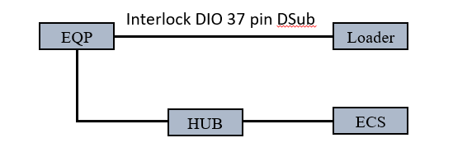

장비는 1개의 Stage와 1개의 Sub unit으로 구성되어 있다.

 | NAME | Note
EQP ID | PXCEPI0102
UNITID | 102
SUBUNITID | 100

전기적 인터페이스 및 통신 규약

Frame Type
IEEE 802.3u - Fast Ethernet (100Mbps)

Connector
RJ-45 (8-pin)

Ethernet Media
100 Base TX (Twisted Pair)

Signal Pins
Following table shows each pin of Connector functions(Pin 1,2,3,6 used only.)

Pin | Signal | Description
1 | Transmit + | Transmit Positive Signal
2 | Transmit - | Transmit Negative Signal
3 | Receive + | Receive Positive Signal
4 | Not used | -
5 | Not used | -
6 | Receive - | Receive Negative Signal
7 | Not used | -
8 | Not used | -

[Process] [ECS]
1----------------------------------------------------------1
2----------------------------------------------------------2
3----------------------------------------------------------3
6----------------------------------------------------------6

HSMS Message Format

Message Format
Maximum Message Length is 2 Mbytes.

Number of Bytes | Description
4 Bytes | Message Length. MSB First.
10 Bytes | Message Header
0 – n Bytes | Message Text

Message Header
Following table shows the message header structure,
and P type always uses "0"(SECS-II Encoding).

Bytes | Description
0~1 | Session ID (Device ID).
2 | Header Byte 2
3 | Header Byte 3
4 | P type
5 | S type
6~9 | System Bytes

Following table shows the selectable value in S type.
Deselect and Reject Procedure is not used.

Value | Description
0 | Data Message
1 | Select.req
2 | Select.rsp
5 | Linktest.req
6 | Linktest.rsp
9 | Separate.req

The method of communication

통신연결
TCP/IP (Transmission Control Protocol/Internet Protocol)

Parameter 설정
HSMS 구현은 반드시 아래의 parameters에 대한 시간정보 설정에 대비해야 한다. Protocol Parameter의 범위 및 해결방안은 최소한 아래 표와 같이 나타나야 한다. 각각의 설정치는 사용자에 의해 장비에서 수시로 변경 가능하도록 한다.
단 connect mode는 항상 장비가 ACTIVE 이고, ECS가 PASSIVE이다.

Symbol | Parameter Name | Typical Value | Value Range
DEVID | Device ID(Session ID) | 0 | 0 ~ 32767
T3 | Reply Timeout | 90 sec | 1 ~ 120 sec
T5 | Separation Timeout | 10 sec | 1 ~ 240 sec
T6 | Transaction Timeout | 5 sec | 1 ~ 240 sec
T7 | NOT SELECTED Timeout | 10 sec | 1 ~ 240 sec
T8 | Intercharacter Timeout | 5 sec | 1 ~ 120 sec
CT | Conversation Timeout | 180 sec | 0 ~ 600 sec
Connect Mode | Connect Mode (Active/Passive) | - | -
Local Entity | Local Entity IP Address & Port Number | - | -
Remote Entity | Remote Entity IP Address & Port Number | - | -

Transaction
Transaction allowed in states.

Transaction | Allowed in State | Who initiates Transaction?
Select | HSMS Not Selected | Active Entity
Linktest | HSMS Selected | Either Entity
Separate | HSMS Selected | Either Entity

Procedures Description

2.2.4.1 “Select”(선택 절차)
선택 절차는 컨트롤 상태에서 선택 요청(Select req) 메시지를 사용하는 TCP/IP 연결상의 HSMS통신을 설정 할 때 사용된다. 선택 절차는 반드시 “NOT SELECTED” 상태에서만 가능하다. 성공적으로 0 선택 상태로 전환되지 못한 선택 절차는 반드시 TCP/IP 통신을 닫고, “Not CONNECTED” 상태로 전환되어야 한다.

2.2.4.2 “Linktest”(연결테스트 절차)
링크 테스트는 TCP/IP와 HSMS 통신의 동작상의 완결성을 결정짓는데 사용된다. “CONNECTED” 에서 이것의 사용은 언제라도 허용된다. 링크 테스트는 반드시 장비 연결 테스트에 적용된다.
- SELECTED’상태에서 장비 (Active)는 ECS (Passive)로 반드시 주기적으로 ‘Linktest req’를 보내야 한다.
- ‘SELECTED’상태, 그리고 (Active)로부터 120초 동안 아무런 메시지를 받지 못했을 때, ECS (Passive)는 장비 (Active)로 반드시 ‘Linktest req’를 보내야 한다.

2.2.4.3 “Separate”(분리 절차)
분리 절차는 TCP/IP 통신이 끊어지기 전에 갑자기 HSMS 통신이 끊어졌을 때 사용된다. HSMS는 연결 상태가 ‘SELECTED’ 상태에서 분리를 사용했을 때 요구한다. 실제 응답을 보내지 않고, 로컬 상태인지의 여부와는 상관없이 통신의 중단을 요구한다.
- 상태가 ‘SELECTED’에서 ‘NOT SELECTED’로 변경이 될 때, EQP는 반드시 ‘Separate.req’를 ECS로 보낸다.

SECS - II

Abort Transaction (S*FO)
Function 0은 모든 Stream에 존재하며 각각의 Stream에서 같은 특별한 의미를 가진다. Function 0 Message는 Transaction Timeout이 발생하는 것을 기다리지 않기 위해 Transaction을 종료한다. Function 0 은 Transaction Error 나 다른 몇 가지의 원인으로 인해 해석기가 기대되는 응답을 보낼 수 없을 때 그것을 대신하여 보내 짐. 해석기가 Transaction을 종료하기 위해 Function 0을 보내는 것은 요구가 아니다.

Conversation Timeout
CT (Conversation Timeout)는 ECS로부터 적정한 시간 내에 기대하는 응답을 받지 못했을 때 발생하는 일종의 timeout 메시지이다.

Interleaved Requests Interaction
비 동시적인 메시지의 상호작용은 작업 중 동시에 하나이상의 요청을 포함할 수도 있다. 예를 들어, ECS가 장비로부터 여러 가지의 동작 (응답 메시지)를 요구한다. 장비는 그 행동을 수행하고, 독립적으로 결과를 보내준다. ECS가 두 개(혹은 그 이상)의 Primary 메시지를 순서대로 보낼 때, 장비는 반드시 모든 Primary 메시지에 대해 Secondary 메시지를 보내야 한다. ECS는 응답 메시지를 결정되지 않은 순서대로 받는다. 평행적인 요구에 대한 이 메커니즘은 분산처리 수행과 스레드 안전 프로그래밍의 복잡한 요구가 아닌 비 동시적인 메시지의 자연스러운 사용이다.

Interface

Communication Protocol

지원되는 Steam Function

S | F  (Primary) | F  (Secondary) | Primary Direction | Name of Function
* | 0 | - | ECS ↔ EQP | Abort Transaction
1 | 1 | 2 | ECS ↔ EQP | Are You There Request
1 | 61 | 62 | ECS ← EQP | All Equipment Status Report
1 | 63 | 64 | ECS → EQP | All Equipment Status Request
1 | 67 | 68 | ECS ← EQP | All Glass Position Data Report
1 | 75 | 76 | ECS ← EQP | Ionizer Status Report
2 | 17 | 18 | ECS ← EQP | Date and Time Request
2 | 25 | 26 | ECS ↔ EQP | Loopback Diagnostic Request
2 | 31 | 32 | ECS → EQP | Date and Time Data Send
2 | 61 | 62 | ECS ← EQP | Control State Change Request
2 | 63 | 64 | ECS ← EQP | Equipment Operation Mode Report
2 | 65 | 66 | ECS ← EQP | Local LOT Status Change Request
2 | 67 | 68 | ECS ← EQP | Cycle Stop Status Report
2 | 69 | 70 | ECS → EQP | Unload Glass Data Request
2 | 75 | 76 | ECS ← EQP | Chemical Change Status Report
2 | 79 | 80 | ECS ← EQP | Glass Data Request
2 | 87 | 88 | ECS → EQP | Load Glass Data Send
2 | 95 | 96 | ECS ← EQP | Chemical Change Enable Request
2 | 97 | 98 | ECS → EQP | Chemical Change Enable Send
5 | 1 | 2 | ECS ← EQP | Alarm Report
6 | 61 | 62 | ECS ← EQP | Load Glass Data Request
6 | 63 | 64 | ECS ← EQP | Unload Glass Data Report
6 | 65 | 66 | ECS → EQP | LOT End Data Send
6 | 67 | 68 | ECS ← EQP | Glass Move Request
6 | 69 | 70 | ECS ← EQP | Cassette Map Request
6 | 71 | 72 | ECS ← EQP | Sampling Slot Request
6 | 73 | 74 | ECS ← EQP | Glass Actual Processing Data Report
6 | 83 | 84 | ECS ← EQP | LOT Actual Processing Data Report
6 | 85 | 86 | ECS ← EQP | Dummy Lot Request
6 | 89 | 90 | ECS ← EQP | Rework Request
6 | 91 | 92 | ECS ← EQP | Equipment Status Change Report
6 | 93 | 94 | ECS ← EQP | Scrap Data Report
6 | 95 | 96 | ECS ← EQP | OCR( VCR ) Status Report
7 | 19 | 20 | ECS → EQP | Current EPPD Request
7 | 61 | 62 | ECS → EQP | Recipe ID Confirm Request
7 | 63 | 64 | ECS ← EQP | Sampling Data Report
7 | 67 | 68 | ECS → EQP | Current Recipe Group List Request
7 | 69 | 70 | ECS → EQP | Current Recipe ID List Request by Group
7 | 77 | 78 | ECS → EQP | Recipe Body Request
9 | 1 | - | ECS ← EQP | Unrecognized Device ID
9 | 3 | - | ECS ← EQP | Unrecognized Stream Type
9 | 5 | - | ECS ← EQP | Unrecognized Function Type
9 | 7 | - | ECS ← EQP | Illegal Data
9 | 9 | - | ECS ← EQP | Transaction Timer Timeout
9 | 11 | - | ECS ← EQP | Data Too Long
9 | 13 | - | ECS ← EQP | Conversation Timeout
10 | 3 | 4 | ECS → EQP | Terminal Display, Single

Message 구조

Standard Message Structure

Sn,F0 | Abort transaction | ECS↔EQP
Description | Function 0 exists in all streams and has the same special meaning in each stream. The function 0 message closes a transaction, so that the originator will not have to wait for a transaction timeout to proceed. Function 0 is sent in lieu of the expected secondary message when the interpreter cannot, because of a transmission error or some other reasons, respond with the expected reply. It is not a requirement that the interpreter send function 0 to close a transaction
Structure
Notice
Exception
S1,F1 | Are You There Request | ECS↔EQP
Description | If the equipment turn to online mode, Function 0 response to this message means the communication is inoperative. In the equipment, a function 0 is equivalent to a timeout on the receive timer after issuing S1,F1 to ECS
Structure | Header Only
Notice
Exception

S1,F2 | On Line Data | ECS↔EQP
Description | Data signifying that the equipment is alive.
Structure | <L,2>  <A[8],PXCEPI >MDLN PXCEPI Fixed  <A[6],V100 >SoftRev V100 fixed
Notice | <MDLN> : Equipment Model Type  <SOFTREV> : Software revision code
Exception | The ECS sends a zero-length list to the equipment

S1,F61 | All Equipment Status Report | ECS←EQP | reply
Description | When equipment is initialized or control state is changed to Online, the equipment reports this message
Structure | <L,2>  <L,1>  <L,4>  <U2,102>UNITID 102 fixed  <A[1], >EQPSTATUS  <A[10], >ALID  <A[120], … >ALTX  <L,3> IONIZER number is fixed to 3  <L,2>  <U1,1>IONIZERID1 ID fixed 1  <A[1], >IONIZERSTATUS1  <L,2>  <U1,2>IONIZERID2 ID fixed 2  <A[1], >IONIZERSTATUS2  <L,2>  <U1,3>IONIZERID3 ID fixed 3  <A[1], >IONIZERSTATUS3
Notice | <UNITID>Unit ID  <EQPSTATUS> Equipment Status  R : RUN E : Experiment V : Development C : Model Change  M : Monitoring I : IDLE D : DOWN P : Process Down  <ALID> Alarm Identification  If <EQPSTATUS> is ‘R’ or ‘I’,  then <ALID> is fixed by ‘0’  <ALTX> Alarm Message  <IONIZERID> Ionizer ID  <IONIZERSTATUS> Ionizer Status  R : RUN D : DOWN
Exception

S1,F62 | All Equipment Status Report Acknowledge | ECS→EQP
Description | Acknowledge
Structure | <L,1>  <U2,102>UNITID 102 fixed  <U1,>ACKC1
Notice | <UNITID> Unit ID  <ACKC1>  0 = Accepted  1 = Not Accepted
Exception

S1,F63 | All Equipment Status Report | ECS→EQP | reply
Description | ECS requests the status of all units of the Equipment.
Structure | Header Only
Notice
Exception

S1,F64 | All Equipment Status Data | ECS←EQP | reply
Description | When equipment is initialized or control state is changed to Online, the equipment reports this message
Structure | <L,1>  <L,4>  <U2,102>UNITID 102 fixed  <A[1], >EQPSTATUS  <A[10], >ALID  <A[120], … >ALTX  <L,3> IONIZER number is fixed to 3  <L,2>  <U1,1>IONIZERID1 ID fixed 1  <A[1], >IONIZERSTATUS1  <L,2>  <U1,2>IONIZERID2 ID fixed 2  <A[1], >'IONIZERSTATUS2  <L,2>  <U1,3>IONIZERID3 ID fixed 3  <A[1], >'IONIZERSTATUS3
Notice | <UNITID>Unit ID  <EQPSTATUS> Equipment Status  R : RUN E : Experiment V : Development C : Model Change  M : Monitoring I : IDLE D : DOWN P : Process Down  <ALID> Alarm Identification  If <EQPSTATUS> is ‘R’ or ‘I’,  then <ALID> is fixed by ‘0’  <ALTX> Alarm Message  <IONIZERID> Ionizer ID  <IONIZERSTATUS> Ionizer Status  R : RUN D : DOWN
Exception

S1,F67 | All Glass Position Data Report | ECS←EQP | reply
Description | This message is used for tracking of glasses which moved in among sub units
Structure | <L,2>  <L,3>  <U2,102>UNITID 102 fixed  <U2,100>SUNITID 100 fixed  <L,n> if Glass Exist n = 2, Glass Not Exist n = 0  <U2, >GLSCODE1  <U2, >GLSCODE2
Notice | <UNITID> Unit ID  <SUNITID> Sub Unit ID  <GLSCODE> Unique Glass Code defined by ECS. Equipment must keep this code, while glass is in equipment.
Exception

S1,F68 | All Glass Position Data Report Acknowledge | ECS→EQP
Description | Acknowledge
Structure | <L,2>  <U2,102>UNITID 102 fixed  <U1, >ACKC1
Notice | <UNITID> Unit ID  <ACKC1>  0 = Accepted  1 = Not Accepted
Exception

S1,F75 | Ionizer Status Report | ECS←EQP | reply
8Description | Acknowledge
Structure | <L,2>  <U2,102>UNITID 102 fixed  <L,3> IONIZER number is fixed to 3  <L,2>  <U1,1>IONIZERID1 ID fixed 1  <A[1], >IONIZERSTATUS1  <L,2>  <U1,2>IONIZERID2 ID fixed 2  <A[1], >'IONIZERSTATUS2  <L,2>  <U1,3>IONIZERID3 ID fixed 3  <A[1], >'IONIZERSTATUS3
Notice | <UNITID>Unit ID  <IONIZERID> Ionizer ID  <IONIZERSTATUS> Ionizer Status  R : RUN D : DOWN
Exception

S1,F76 | All Glass Position Data Report Acknowledge | ECS→EQP
Description | Acknowledge
Structure | <L,2>  <U2,102>UNITID 102 fixed  <U1, >ACKC1
Notice | <UNITID> Unit ID  <ACKC1>  0 = Accepted  1 = Not Accepted
Exception

S2,F17 | Date and Time Request | ECS←EQP | reply
Description | This message is Useful, when ECS checks the equipment time base or the equipment to  synchronize with ECS time base.  Normal flow에 의거하여 Send
Structure | <U2,102>UNITID 102 fixed
Notice | <UNITID> Unit ID
Exception

S2,F18 | Date and Time Data | ECS→EQP
Description | Actual time data.
Structure | <A[14], >TIME
Notice | <TIME> : Current Time “YYYYMMDDhhmmss”
Exception

S2,F25 | Loopback Diagnostic Request | ECS↔EQP | reply
Description | This is the diagnostic message for checkout of protocol and communication circuits.  When the binary string is sent, the same data is echoed back.  CIM에서 Button을 눌러 Send 가능하도록 구현
Structure | <U10, >ABS
Notice | <ABS> Any binary string
Exception

S2,F26 | Loopback Diagnostic Data | ECS↔EQP
Description | The echoed binary string
Structure | <U10, >ABS
Notice | <ABS> Any binary string
Exception

S2,F31 | Date and Time Data Send | ECS→EQP | reply
Description | Actual time data Send  EQP에서 Time value 수신 후 PC의 Time set 가능 하도록 구현
Structure | <L,2>  <U2,102> UNITID 102 fixed  <A[14], >TIME
Notice | <UNITID> Unit ID  <TIME>: Current Time “YYYYMMDDhhmmss”
Exception

S2,F32 | Date and Time Acknowledge | ECS←EQP
Description | Acknowledge
Structure | <L,2>  <U2,102> UNITID 102 fixed  <U1, >ACKC2
Notice | <UNITID> Unit ID  <ACKC2>  0 = Accepted  1 = Not Accepted
Exception

S2,F61 | Control State Change Request | ECS←EQP | reply
Description | This message is used when requesting the control state change.
Structure | <L,2>  <U2,102>UNITID 102 fixed  <A[1], >RCS
Notice | <UNITID> Unit ID  <RCS> Remote Control State  0 = Online-Remote  1 = Online-Local  2 = Offline
Exception

S2,F62 | Control State Change Request Acknowledge | ECS→EQP
Description | Reply for the control state change of the equipment
Structure | <L,2>  <U2,102>UNITID 102 fixed  <U1, >ACKC2A
Notice | <UNITID> Unit ID  <ACKC2A> Acknowledge code, 1 byte  0 = Mode Change Accept  1 = Mode Change not Allowed  2 = Equipment Already Changed Mode
Exception

S2,F63 | Equipment Operation Mode Report | ECS←EQP | reply
Description | Change operation mode of the equipment
Structure | <L,2>  <U2,102>UNITID 102 fixed  <A[1], 1>OPMODE 1 fixed
Notice | <UNITID> Unit ID  <OPMODE> Operation Mode Code  The following OPMODE values define the case of operate to Online(Remote or Local)  1 = Normal / Load & Process / Auto / Remote / Operation / Automatic Mode  2 = Sequence Transfer / Online Local / Local / Semi-Auto Mode  3 = Cleanout / Recovery Mode  4 = Test / Atmospheric Transfer Mode  5 = Transfer / Vacuum Transfer Mode  6 = Particle Check / Pass Mode  7 = Reverse Mode  8 = Repair Mode  9 = Manual  A = Restoration  OPMODE는 현재 1로 고정하였음. UI를 통해서 수정 가능함.
Exception | The operation mode to operate Offline dose not define OPMODE  (ex. Manual / Maintenance / Offline / Local / etc…)

S2,F64 | Equipment Operation Mode Report Acknowledge | ECS→EQP
Description | Reply for Change operation mode of the equipment
Structure | <L,2>  <U2,102>UNITID 102 fixed  <U1, >ACKC2A
Notice | <UNITID> Unit ID  <ACKC2A> Acknowledge code, 1 byte  0 = Mode Change Accept  1 = Mode Change not Allowed  2 = Equipment Already Changed Mode  3 - 63 Reversed
Exception

S2,F65 | Local LOT Status Change Request | ECS←EQP | reply
Description | This message is used when sending Lot End Data under Online Local Control state
Structure | <L,4>  <U2,102>UNITID 102 fixed  <U1, >PORTID  <A[16], >LOTID  <A[1], >ENDFLAG
Notice | <UNITID> Unit ID  <PORTID> Port ID  <LOTID> LOT ID  <ENDFLAG> End Flag  N : Normal End  P : Operator End
Exception

S2,F66 | Local LOT Status Change Request Acknowledge | ECS→EQP
Description | Acknowledge
Structure | <L,2>  <U2,102>UNITID 102 fixed  <U1, >ACKC2
Notice | <UNITID> Unit ID  <ACKC2>  0 = Accepted  1 = Not Accepted
Exception

S2,F67 | Cycle Stop Status Report | ECS←EQP | reply
Description | Change cycle stop status of the equipment
Structure | <L,2>  <U2,102>UNITID 102 fixed  <U1, >CSSTATUS
Notice | <UNITID> Unit ID  <CSSTATUS>  0 = Cycle Stop Release  1 = Cycle Stop Set
Exception

S2,F68 | Cycle Stop Status Report Acknowledge | ECS→EQP
Description | Reply for Change cycle stop status of the equipment
Structure | <L,2>  <U2,102>UNITID 102 fixed  <U1, >ACKC2
Notice | <UNITID> Unit ID  <ACKC2>  0 = Accepted  1 = Not Accepted  2 – 63 Reserved
Exception

S2,F69 | Unload Glass Data Request | ECS→EQP | reply
Description | This message is used when ECS Request Unload Glass Data from the Equipment
Structure | <L,3>  <U2,102>UNITID 102 fixed  <U1, >STAGEID  <A[80], … >HOSTMSG
Notice | <UNITID> Unit ID  <STAGEID> Stage ID  <HOSTMSG> Host message in Korean and English
Exception

S2,F70 | Unload Glass Data Request Acknowledge | ECS←EQP
Description | Acknowledge
Structure | <L,2>  <U2,102>UNITID 102 fixed  <U1, >ACKC2
Notice | <UNITID> Unit ID  <ACKC2>  0 = Accepted  1 = Not Accepted  2 = Unload Glass Not Exist  3 – 63 Reserved
Exception

S2,F79 | Glass Data Request | ECS←EQP | reply
Description | The Equipment only can use this control sequence in its manual operation.  It can be use when equipment lost ‘Glass Data’, but equipment still have Glass ID or Glass code
Structure | <L,4>  <U2,102>UNITID 102 fixed  <A[16], >GLSID  <U2, >GLSCODE  <A[1], >REQOPTION
Notice | <UNITID> Unit ID  <GLSID> Glass ID  <REQOPTION> Request Option  C : Glass Code  I : Glass ID  A : Glass Code and Glass ID
Exception

S2,F80 | Glass Data | ECS→EQP | reply
Description | The Equipment (manual operation) sends S2F79 and then ECS sends ‘Glass Load Data’ as reply. ‘Glass Load Data’ is data about injected glass when glass inject to equipment
Structure | <L,3>  <U2,102>UNITID 102 fixed  <U1, >ACKC2  <L,1>  <L,21> GLSSTATUS = 0, 0 / GLSSTATUS = 1, 21  <A[16], >LOTID  <A[14], >CSTID  <A[3], >SLOTID  <A[24], >RECIPEID  <A[8], >'PRCID  <A[1], >GLSODR  <A[16], >GLSID  <A[2], >GLSJUDGE  <A[2000], … >PNLIF  <A[2000], … >SUBMDLIF  <U1, >'PORTID  <U2, >GLSCODE  <U1, >REINPUT  <A[5], >GLSTHICK  <A[14], >PARTNUM  <A[12], >PRODTYPE  <A[12], >ATTRIBUTE  <A[1], >GLSTYPE  <A[32], >KEYID  <L,n> n = number of LSD  <L,2>  <A[24], >LSDITEM1  <A[40], … >LSDVALUE1  ….  <L,2>  <A[24], >LSDITEMn  <A[40], … >LSDVALUEn  <L,m> m = number of GSD  <L,2>  <A[24], >GSDITEM1  <A[40], … >GSDVALUE1  ….  <L,2>  <A[24], >GSDITEMm  <A[40], … >GSDVALUEm
Notice | <UNITID> Unit ID  <ACKC2>  0 = Accepted  1 = Not Accepted (Unknown GLSID or GLSCODE)  2 – 63 Reserved  <LOTID> LOT ID  <CSTID> Cassette ID  <SLOTID> Slot ID  <RECIPEID> Recipe ID  <PRCID> Processing Code  <GLSODR> Glass Order 0 = The first glass  1 = All glasses except the first glass and the last glass  2 = The Last glass( In this case, this value may not be delivered for Scrap or reason of LOT Abort )  3 = the only glass, when there is just one in a LOT.  <GLSID> Glass ID  <GLSJUDGE> Glass Grade Code  <PNLIF> Panel Judge Information  <SUBMDLIF> Sub Panel Information  <PORTID> Port ID  <GLSCODE> Glass ID Code.  <REINPUT> Glass Re-input Flag  0 = Not Re-input  1 = Re-input  <GLSTHICK> Glass’s Thickness  <PARTNUM> Part Number  <PRODTYPE> Type of Producing  <ATTRIBUTE> LOT Attribute  <GLSTYPE> Glass Type  N = Normal Glass  D = Dummy Glass  <KEYID> Glass Key ID  <LSDITEM> LOT Specific Data Item defined by LG Display  <LSDVALUE> LOT Specific Data Value defined by LG Display  <GSDITEM> Glass Specific Data Item defined by LG Display  <GSDVALUE> Glass Specific Data Value defined by LG Display
Exception

S2,F87 | Load Glass Data Send | ECS→EQP | reply
Description | This is the Glass data that would be loaded into the equipment.
Structure | <L,4>  <U2,102>UNITID 102 fixed  <U1, >STAGEID  <A[1], >GLSSTATUS  <L,2>  <L,21>A CUT GLASS GLSSTATUS = 0, 0 / GLSSTATUS = 1, 21  <A[16], >LOTID  <A[14], >CSTID  <A[3], >SLOTID  <A[24], >RECIPEID  <A[8],PRCID >PRCID  <A[1], >GLSODR  <A[16], >GLSID  <A[2], >GLSJUDGE  <A[2000], … >PNLIF  <A[2000], … >SUBMDLIF  <U1, >PORTID  <U2, >GLSCODE  <U1, >REINPUT  <A[5], >GLSTHICK  <A[14], >PARTNUM  <A[12], >PRODTYPE  <A[12], >ATTRIBUTE  <A[1], >GLSTYPE  <A[32], >KEYID  <L,n> n = number of LSD  <L,2>  <A[24], >LSDITEM1  <A[40], … >LSDVALUE1  ….  <L,2>  <A[24], >LSDITEMn  <A[40], … >LSDVALUEn  <L,m> m = number of GSD  <L,2>  <A[24], >GSDITEM1  <A[40], … >GSDVALUE1  ….  <L,2>  <A[24], >GSDITEMm  <A[40], … >GSDVALUEm  <L,21>B CUT GLASS  <A[16], >LOTID  <A[14], >CSTID  <A[3], >SLOTID  <A[24], >RECIPEID  <A[8], >PRCID  <A[1], >GLSODR  <A[16], >GLSID  <A[2], >GLSJUDGE  <A[2000], … >PNLIF  <A[2000], … >SUBMDLIF  <U1, >PORTID  <U2, >GLSCODE  <U1, >REINPUT  <A[5], >GLSTHICK  <A[14], >PARTNUM  <A[12], >PRODTYPE  <A[12], >ATTRIBUTE  <A[1], >GLSTYPE  <A[32], >KEYID  <L,n> n = number of LSD  <L,2>  <A[24], >LSDITEM1  <A[40], … >LSDVALUE1  ….  <L,2>  <A[24], >LSDITEMn  <A[40], … >LSDVALUEn  <L,m> m = number of GSD  <L,2>  <A[24], >GSDITEM1  <A[40], … >GSDVALUE1  ….  <L,2>  <A[24], >GSDITEMm  <A[40], … >GSDVALUEm
Notice | <UNITID> Unit ID  <STAGEID> Stage ID  <GLSSTATUS> Status of the glass that would be loaded  0 = Not Exist  1 = Exist  <LOTID> LOT ID  <CSTID> Cassette ID  <SLOTID> Slot ID  <RECIPEID> Recipe ID  <PRCID> Processing Code  <GLSODR> Glass Order 0 = The first glass  1 = All glasses except the first glass and the last glass  2 = The Last glass( In this case, this value may not be delivered for Scrap or reason of LOT Abort )  3 = the only glass, when there is just one in a LOT.  <GLSID> Glass ID  <GLSJUDGE> Glass Grade Code  <PNLIF> Panel Judge Information  <SUBMDLIF> Sub Panel Information  <PORTID> Port ID  <GLSCODE> Glass ID Code.  <REINPUT> Glass Re-input Flag  0 = Not Re-input  1 = Re-input  <GLSTHICK> Glass’s Thickness  <PARTNUM> Part Number  <PRODTYPE> Type of Producing  <ATTRIBUTE> LOT Attribute  <GLSTYPE> Glass Type  N = Normal Glass  D = Dummy Glass  <KEYID>Glass Key ID  <LSDITEM> LOT Specific Data Item defined by LG Display  <LSDVALUE> LOT Specific Data Value defined by LG Display  <GSDITEM> Glass Specific Data Item defined by LG Display  <GSDVALUE> Glass Specific Data Value defined by LG Display  <--GSD Item/Value Define->  <CUT_TYPE> Glass Cut Type  A : A Cut  DA : Dummy A Cut  B : B Cut  DB : Dummy B Cut  <PAIRINFO> A,B Cut Glass Pair Information  Y : Paired  N : Unpaired  <PAIR_GLASS_CODE> Matching Pair Glass Code Glass Code  <ROUTE_CHAMBER> Chamber Route Information Chamber Route Information
Exception

S2,F88 | Load Glass Data Send Acknowledge | ECS←EQP
Description | Acknowledge
Structure | <L,3>  <U2,102>UNITID 102 fixed  <U1, >STAGEID  <U1, >ACKC2
Notice | <UNITID> Unit ID  <STAGEID> Stage ID  <ACKC2>  0 = Accept  1 = Process Condition is not ready  2 = The recipe is not exist in equipment’s recipe list  3 = Glass data is not accepted  4 = Process is not ready to load this glass  5 = A, B Cut Recipe Mismatching  6~63 = Reserved
Exception

S5,F1 | Alarm Report | ECS←EQP | reply
Description | This message reports the alarm condition changes inside EQP or of the previous step.  One message will be issued when the alarm is set and the other will be issued when cleared.  Irrecoverable errors and attention flags may not have the clear message corresponding to them
Structure | <L,4>  <U2,102>UNITID 102 fixed  <U1, >ALCD  <A[10], >ALID  <A[120], … >ALTX
Notice | <UNITID> Unit ID  <ALCD>Alarm Code  bit8 = 1 Alarm set  bit 8 = 0 Alarm Reset  bit 7~1 is Alarm category (0~127)  0 = Not Used  1 = Personal safety  2 = Equipment safety  3 = Parameter control warning  4 = Parameter control error  5 = Irrecoverable error  6 = Equipment status warning  7 = Attention flags  8 = Data integrity  <ALID> Alarm Identification  <ALTX>Alarm Message
Exception

S5,F2 | Alarm Report Acknowledge | ECS→EQP
Description | Acknowledge or Error
Structure | <L,2>  <U2,102>UNITID 102 fixed  <U1,0>ACKC5
Notice | <ACKC5> Acknowledge code, 1 byte  0 = Accepted (Fixed)
Exception

S6,F61 | Load Glass Data Request | ECS←EQP | reply
Description | This message is used in Load Glass Data Request
Structure | <L,2>  <U2,102>UNITID 102 fixed  <U1, >STAGEID
Notice | <UNITID> Unit ID  <STAGEID> Stage ID
Exception

S6,F62 | Load Glass Data Request Acknowledge | ECS→EQP
Description | Acknowledge
Structure | <L,3>  <U2,102>UNITID 102 fixed  <U1, >STAGEID  <U1, >ACKC6
Notice | <UNITID> Unit ID  <STAGEID> Stage ID  <ACKC2>  0 = Accept  1 = Not Accept
Exception

S6,F63 | Unload Glass Data Report | ECS←EQP | reply
Description | This message is used in Unload Glass Data Report
Structure | <L,3>  <U2,102>UNITID 102 fixed  <U1, >STAGEID  <L,2>  <L,21>A CUT GLASS  <A[1], >GLSODR  <A[16], >LOTID  <A[14], >CSTID  <A[3], >SLOTID  <A[16], >GLSID  <A[2000], … >PNLIF  <A[2000], … >SUBMDLIF  <A[8], >PRCID  <U1, >DICODE  <U1, >PORTID  <A[24], >RECIPEID  <A[2], >GLSJUDGE  <A[14], >PARTNUM  <A[12], >PRODTYPE  <A[12], >ATTRIBUTE  <A[1], >GLSTYPE  <A[1], >GLSPROC  <U2, >GLSCODE  <U2, >DEST  <A[32], >KEYID  <L,n> n = number of GSD  <L,2>  <A[24], >GSDITEM1  <A[40], … >GSDVALUE1  ….  <L,2>  <A[24], >GSDITEMn  <A[40], … >GSDVALUEn  <L,21>B CUT GLASS  <A[1], >GLSODR  <A[16], >LOTID  <A[14], >CSTID  <A[3], >SLOTID  <A[16], >GLSID  <A[2000], … >PNLIF  <A[2000], … >SUBMDLIF  <A[8], >PRCID  <U1, >DICODE  <U1, >PORTID  <A[24], >RECIPEID  <A[2], >GLSJUDGE  <A[14], >PARTNUM  <A[12], >PRODTYPE  <A[12], >ATTRIBUTE  <A[1], >GLSTYPE  <A[1], >GLSPROC  <U2, >GLSCODE  <U2, >DEST  <A[32], >KEYID  <L,m> m = number of GSD  <L,2>  <A[24], >GSDITEM1  <A[40], … >GSDVALUE1  ….  <L,2>  <A[24], >GSDITEMm  <A[40], … >GSDVALUEm
Notice | <UNITID> Unit ID  <STAGEID> Stage ID  <GLSODR> Glass Order 0 = The first glass  1 = All glasses except the first glass and the last glass  2 = The Last glass  3 = the only glass, when there is just one in a LOT.  <LOTID> LOT ID  <CSTID> Cassette ID  <SLOTID> Slot ID  <GLSID> Glass ID  <PNLIF> Panel Information  <SUBMDLIF> Sub Panel Information  <PRCID> Processing Code  <DICODE> Different Code  0 : All GLS IDs are completely matching with GLS IDs from ECS.  1 : Any GLS ID is not matching with GLS ID from ECS  2 : When each ID of glass is not checked by VCR or OCR in the equipment has VCR or OCR  <PORTID> Port ID  <RECIPE ID> Recipe ID  <GLSJUDGE> Glass Grade Code  <PARTNUM> Part Number  <PRODTYPE> Type of Producing  <ATTRIBUTE> LOT Attribute  <GLSTYPE> Glass Type  N = Normal Glass  D = Dummy Glass  <GLSPROC> Glass Process Status  0 : Unprocessed  1 : Processing  2 : Processed  3 : Rejected  <GLSCODE> Glass ID Code  <DEST> Glass Next Destination  0 = ECS determine destination of glass.  >0 = Equipment determine destination of glass.  The value of <DEST> will be decided later through conversation  <KEYID> Glass Key ID  <GSDITEM> Glass Specific Data Item defined by LG Display  <GSDVALUE> Glass Specific Data Value defined by LG Display  <--GSD Item/Value Define->  <CUT_TYPE> Glass Cut Type  A : A Cut  DA : Dummy A Cut  B : B Cut  DB : Dummy B Cut  <PAIRINFO> A,B Cut Glass Pair Information  Y : Paired  N : Unpaired  <PAIR_GLASS_CODE> Matching Pair Glass Code Glass Code  <ROUTE_CHAMBER> Chamber Route Information Chamber Route Information
Exception | When <GSDITEM>, <GSDVALUE> is not necessary, n is 0.

S6,F64 | Unload Glass Data Report Acknowledge | ECS→EQP
Description | Acknowledge
Structure | <L,2>  <U2,102>UNITID 102 fixed  <U1, >ACKC6
Notice | <UNITID> Unit ID  <ACKC6>  0 = Accepted  >0 = Error, not accepted  1 – 63 Reserved
Exception

S6,F65 | LOT End Data Send | ECS→EQP | reply
Description | This message is used in Lot End Data Send
Structure | <L,9>  <U2,102>UNITID 102 fixed  <U1,1>PORTID  <A[16], >LOTID  <A[14], >CSTID  <A[24], >RECIPEID  <A[8], >PRCID  <A[1], >ENDFLAG  <A[1], >MULTIFLAG  <L,n> n = number of slot  <L,10>  <A[1], >GLSODR  <A[3], >SLOTID  <A[16], >GLSID  <A[24], >RECIPEID  <U1, >GLSEXIST1  <U1, >GLSSELECTED  <U2,102>PROCUNITID  <A[2], >GLSJUDGE  <A[2000], … >PNLIF  <A[2000], … >SUBMDLIF  …..  <L,10>  <A[1], >GLSODR  <A[3], >SLOTID  <A[16], >GLSID  <A[24], >RECIPEID  <U1, >GLSEXIST1  <U1, >GLSSELECTED  <U2,102>PROCUNITID  <A[2], >GLSJUDGE  <A[2000], … >PNLIF  <A[2000], … >SUBMDLIF
Notice | <UNITID> Unit ID  <PORTID> Port ID  <LOTID> LOT ID  <CSTID> Cassette ID  <RECIPE ID> Recipe ID  <PRCID> Processing Code  <ENDFLAG> End Flag  N : Normal End  P : Operator End  E : Last processed unit  R : Last processed unit for rework  <MULTIFLAG>  T : True(Multi Recipe ID)  F : False(Single Recipe ID)  <GLSODR> Glass Order  0 = The first glass  1 = All glasses except the first glass and the last glass  2 = The Last glass  3 = the only glass, when there is just one in a LOT  <SLOTID> Slot ID  <GLSID> Glass ID  <GLSEXIST> Glass Existence  0 = Not exist  1 = Exist  <GLSSELECTED> Glass Selection  0 = Not selected  1 = selected  <PROCUNITID> Unit ID to process Glass  <GLSJUDGE> Glass Grade Code  <PNLIF> Panel Information  <SUBMDLIF> Sub Panel Information
Exception | If n=0, this means ‘Lot Judge Report’ facility is not used.  If n≠0, this means ‘Lot Judge Report’ facility is used.

S6,F66 | LOT End Data Send Acknowledge | ECS←EQP
Description | Acknowledge
Structure | <L,4>  <U2,102>UNITID 102 fixed  <U1, >PORTID  <A[16], >LOTID  <U1, >ACKC6
Notice | <UNITID> Unit ID  <PORTID> Port ID  <LOTID> Lot ID  <ACKC6> Acknowledge code, 1 byte  0 = Accepted  1 = Wait Lot Actual Processing Data  2 = Lot End without Lot Actual Processing Data  >3 = Error , not accepted  1 – 63 Reserved
Exception

S6,F67 | Glass Move Request | ECS←EQP | reply
Description | This message is used in Load Request, Unload Request from Equipment.
Structure | <L,7>  <A[2], >GLSMVSTATUS  <U2,102>UNITID 102 fixed  <U1, >STAGEID  <U2, >LDGLSCODE_A  <U2, >LDGLSCODE_B  <U2, >UDGLSCODE_A  <U2, >UDGLSCODE_B
Notice | <GLSMVSTATUS> Glass Move Status  LW : Glass Load Wait Request  UW : Glass Unload Wait Request  LR : Glass Load Request  UR : Glass Unload Request  ER : Glass Exchange Request  CR : Cancel Request  <UNITID> Unit ID  <STAGEID> Stage ID  <LDGLSCODE_A> A Cut Load Glass Code  <LDGLSCODE_B> B Cut Load Glass Code  <UDGLSCODE_A> A Cut Unload Glass Code  <UDGLSCODE_B> B Cut Unload Glass Code  GLSCODE는 보고 할 data가 없을시 0으로 보고 (ex. <U2, 0>LDGLSCODE_A)
Exception

S6,F68 | Glass Move Request Acknowledge | ECS→EQP
Description | Acknowledge
Structure | <L,2>  <U2,102>UNITID 102 fixed  <U1, >ACKC6
Notice | <UNITID>Unit ID  <ACKC6>  0 = Accepted  1 = Not Accepted
Exception

S6,F69 | Cassette Map Request | ECS←EQP | reply
Description | The Equipment requests Cassette Map(Online Local Control state only)
Structure | <L,1>  <U2,102>UNITID 102 fixed
Notice | <UNITID>Unit ID
Exception

S6,F70 | Cassette Map Request Acknowledge | ECS→EQP
Description | Cassette Map Data Send
Structure | <L,2>  <U2,102>UNITID 102 fixed  <L,n> n = Cassette port number  <L,5>  <A[16], >LOTID1  <A[14], >CSTID1  <U1, >PORTID1  <A[40], … >MAP1  <A[1], >CSTREADY1  <L,5>  <A[16], >LOTID2  <A[14], >CSTID2  <U1, >PORTID2  <A[40], … >MAP2  <A[1], >CSTREADY2  ….  <L,n>  <A[16], >LOTIDn  <A[14], >CSTIDn  <U1, >PORTIDn  <A[40], … >MAPn  <A[1], >CSTREADYn
Notice | <UNITID>Unit ID  <LOTID>LOT ID  <CSTID>Cassette ID  <PORTID> Port ID  <MAP> Cassette Mapping Information  e.g. In case there are 2 glassed in Slot 1 and Slot 20. Then  MAP = “1000000000000000000100000000000000000000”  - : Glass Not Exist  - : Glass Exist  <CSTREADY> Cassette State  0 : Cassette Not Exist  1 : Cassette Exist (LC)
Exception

S6,F71 | Sampling Slot Request | ECS←EQP | reply
Description | The Equipment requests the specific glass selected by the equipment from ECS on Online Local State
Structure | < L,3>  <U2,102>UNITID 102 fixed  <U1, >STAGEID  <L,4>  <A[16], >LOTID  <A[14], >CSTID  <U1, >PORTID  <A[3], >SLOTID
Notice | <UNITID> Unit ID  <STAGEID> Stage ID  <LOTID> LOT ID  <CSTID> Cassette ID  <PORTID> Port ID  <SLOTID> Slot ID
Exception

S6,F72 | Sampling Slot Request Acknowledge | ECS→EQP
Description | Acknowledge or error
Structure | < L,2>  <U2,102>UNITID 102 fixed  <U1, >ACKC6A
Notice | <ACKC6A> Acknowledge code, 1byte  0 = Accept  1 = Glass not exist  2 = Cassette not exist  3 = Invalid LOT ID  4 = Busy, Try later  5 – 63 Reserved
Exception

S6,F73 | Glass Actual Processing Data Report | ECS←EQP | reply
Description | The purpose of this message is for the equipment to send the glass processing data  보고 순서는 A → B 이다.
Structure | <L,8>  <A[16], >LOTID  <A[14], >CSTID  <A[24], … >RECIPEID  <A[8], >PRCID  <A[3], >SLOTID  <U2,102>UNITID 102 fixed  <L,7>  <A[16], >GLSID  <A[2], >GLSJUDGE  <A[2000], … >PNLIF  <A[2000], … >SUBMDLIF  <U2, >GLSCODE  <A[32], >KEYID  <L,1> n = number of GSD  <L,2>  <A[24], >GSDITEM1  <A[40], … >GSDVALUE1  …  <L,2>  <A[24], >GSDITEMn  <A[40], … >GSDVALUEn  <L,3> n = number of parameter  <L,2>  <A[14], >DVNAME11  <A[14], >DVVAL11  …  <L,2>  <A[14], >DVNAME1n  <A[14], >DVVAL1n
Notice | <LOTID> LOT ID  <CSTID> Cassette ID  <RECIPE ID> Recipe ID  <PRCID> Processing Code  <SLOTID> Slot ID  <UNITID>Unit ID  <GLSID> Glass ID  <GLSJUDGE> Glass Judge Code  <PNLIF> Panel Information  <SUBMDLIF>Sub Panel Information  <GLSCODE> Glass Code  <KEYID> Glass Key ID  <GSDITEM> Glass Specific Data Item defined by LG Display  <GSDVALUE> Glass Specific Data Value defined by LG Display  <DVNAME> APD Data Name defined by LG Display  <DVVALUE> APD Data Value defined by LG Display
Exception | When <GSDITEM>, <GSDVALUE> is not necessary, p is 0

S6,F74 | Glass Actual Processing Data Report Acknowledge | ECS→EQP
Description | Acknowledge
Structure | <L,2>  <U2,102>UNITID 102 fixed  <U1, >ACKC6
Notice | <UNITID> Unit ID  <ACKC6>  0 = Accepted  1 = Not Accepted  2 ~ 63 Reserved
Exception

S6,F83 | LOT Actual Processing Data Report | ECS←EQP | reply
Description | The purpose of this message is that the equipment sends the Lot Actual processing data.  Only when ECS sends Lot End Data, the equipment sends this data
Structure | <L,9>  <A[16], >LOTID  <A[14], >CSTID  <A[24], >RECIPEID  <A[8], >PRCID  <U2,102>UNITID 102 fixed  <A[32], … >KEYID  <A[2], >LOTJUDGE  <L,n> n = number of LSD  <L,2>  <A[24], >LSDITEM1  <A[40], … >LSDVALUE1  …  <L,2>  <A[24], >LSDITEMn  <A[40], … >LSDVALUEn  <L,m> m = number of parameter  <L,2>  <A[14], >DVNAME11  <A[14], >DVVAL11  …  <L,2>  <A[14], >DVNAME1m  <A[14], >DVVAL1m
Notice | <LOTID> LOT ID  <CSTID> Cassette ID  <RECIPE ID> Recipe ID  <PRCID> Processing Code  <UNITID>Unit ID  <KEYID> Glass Key ID  <LOTJUDGE>Lot Judge  <LSDITEM> LOT Specific Data Item defined by LG Display  <LSDVALUE> LOT Specific Data Value defined by LG Display  <DVNAME> APD Data Name defined by LG Display  <DVVALUE> APD Data Value defined by LG Display
Exception

S6,F84 | LOT Actual Processing Data Report Acknowledge | ECS→EQP
Description | Acknowledge
Structure | <L,2>  <U2,102>UNITID 102 fixed  <U1, >ACKC6
Notice | <UNITID> Unit ID  <ACKC6>  0 = Accepted  1 = Not Accepted  2 ~ 63 Reserved
Exception

S6,F85 | Dummy Lot Request | ECS←EQP | reply
Description | This message is used to request Dummy Lot.
Structure | <U2,102>UNITID 102 fixed
Notice | <UNITID> Unit ID
Exception | .  3

S6,F86 | Dummy Lot Request Acknowledge | ECS→EQP
Description | Acknowledge.
Structure | <L,2>  <U2,102>UNITID 102 fixed  <U1, >ACKC6
Notice | <UNITID> Unit ID  <ACKC6>  0 = Accepted  1 = Not Accepted  2 ~ 63 Reserved
Exception

S6,F89 | Rework Request | ECS←EQP | reply
Description | This message is used to request rework
Structure | <L,4>  <U2,102>UNITID 102 fixed  <A[16], >LOTID  <A[1], >RESERVECD  <L,n> n = number of slot  <L,2>  <A[3], >SLOTID1  <A[1], >SELECTED1  ….  <L,2>  <A[3], >SLOTIDn  <A[1], >SELECTEDn
Notice | <UNITID> Unit ID  <LOTID> Lot ID  <RESERVECD> Rework reservation code  R : Reservation of rework  S : Rework Start  <SELECTED> Glass Selected Information.  0 : Not Selected  1 : Selected
Exception

S6,F90 | Rework Request Acknowledge | ECS→EQP
Description | Acknowledge
Structure | <L,4>  <U2,102>UNITID 102 fixed  <A[16], >LOTID  <A[1], >RESERVECD  <L,n> n = number of slot  <L,2>  <A[3], >SLOTID1  <A[1], >SELECTED1  …  <L,2>  <A[3], >SLOTIDn  <A[1], >SELECTEDn
Notice | <UNITID> Unit ID  <LOTID> Lot ID  <RESERVECD> Rework reservation code  R : Reservation of rework  S : Rework Start  <SELECTED> Glass Selected Information.  0 : Not Selected  1 : Selected
Exception

S6,F91 | Equipment Status Change Report | ECS←EQP | reply
Description | When the Equipment status is changed, the Equipment reports this message
Structure | <L,4>  <U2,102>UNITID 102 fixed  <A[1], >EQPSTATUS  <A[10], >ALID  <A[120], … >ALTX
Notice | <UNITID>Unit ID  <EQPSTATUS> Equipment status  R : RUN E : Experiment V : Development C : Model Change M : Monitoring  I : IDLE D : DOWN P : Process Down  <ALID> Alarm Identification  If <EQPSTATUS> is ‘R’ or ‘I’,  then <ALID> is fixed by ‘0’  <ALTX> Alarm Message
Exception

S6,F92 | Equipment Status Change Report Acknowledge | ECS→EQP
Description | Acknowledge
Structure | <L,2>  <U2,102>UNITID 102 fixed  <U1, >ACKC6
Notice | <UNITID> Unit ID  <ACKC6>  0 = Accepted  1 = Not Accepted  2 ~ 63 Reserved
Exception

S6,F93 | Scrap Data Report | ECS←EQP | reply
Description | When a glass or a panel is scrapped, the Equipment reports this message
Structure | <L,5>  <A[16], >LOTID  <A[16], >GLSID  <U2,102>UNITID 102 fixed  <A[1], >SCRPTYPE  <A[4], >SCRPCODE
Notice | <LOTID> LOT ID  <GLSID> Glass ID  <UNITID> Unit ID  <SCRPTYPE> Scrap Type  P = Panel Scarp  G = Glass Scrap  <SCRPCODE>Scrap Code defined by LG Display
Exception

S6,F94 | Scrap Data Report Acknowledge | ECS→EQP
Description | Acknowledge
Structure | <L,2>  <U2,102>UNITID 102 fixed  <U1, >ACKC6
Notice | <UNITID> Unit ID  <ACKC6>  0 = Accepted  1 = Not Accepted  2 ~ 63 Reserved
Exception

S7,F19 | Current EPPD Request | ECS→EQP | reply
Description | This message is used to request the transmission of the current equipment process program  directory. This is the list of all the RECIPE IDs of the process programs stored in the equipment
Structure | <U2,102>UNITID 102 fixed
Notice | <UNITID> Unit ID
Exception

S7,F20 | Current EPPD Request Acknowledge | ECS←EQP
Description | This message is used to transmit the current EPPD.
Structure | <L,2>  <U2,102>UNITID 102 fixed  <L,n> n = Recipe List Count  <A[24], >RECIPEID1  …  <A[24], >RECIPEIDn
Notice | <UNITID> Unit ID  <RECIPEID> Recipe ID
Exception

S7,F61 | Recipe ID Confirm Request | ECS→EQP | reply
Description | This message is used to ask the equipment whether the recipe ID is or not in the list,  which the equipment has
Structure | <L,14>  <A[16], >'LOTID  <A[14], >'CSTID  <A[24], >'RECIPEID  <A[8], >'PRCID  <U1,1>'PORTID  <U2,102>'UNITID 102 fixed  <A[5], >'GLSTHICK  <A[14], >'PARTNUM  <A[12], >'PRODTYPE  <A[12], >'ATTRIBUTE  <A[1], >'MODECODE  <A[1], >'MULTIFLAG  <L,n> n = number of LSD  <L,2>  <A[24], >'LSDITEM  <A[40], … >'LSDVALUE  ….  <L,2>  <A[24], >'LSDITEMn  <A[40], … >'LSDVALUEn  <L,m> m = number of slot  <L,10>  <A[3], >'SLOTID1  <A[16], >'SLTLOTID1  <A[16], >'GLSID1  <A[24], >'SRECIPEID1  <U1, >'GLSEXIST1  <A[2], >'GLSJUDGE1  <A[14], >'PARTNUM1  <A[2000], … >'PNLIF1  <A[2000], … > 'SUBMDLIF1  <L,n> j = number of GSD  <L,2>  <A[24], >'GSDITEM1  <A[40], … > 'GSDVALUE1  …  <L,2>  <A[24], >'GSDITEMj  <A[40], … > 'GSDVALUEj  ….  <L,10>  <A[3], >'SLOTIDm  <A[16], >'SLTLOTIDm  <A[16], >'GLSIDm  <A[24], >'SRECIPEIDm  <U1, >'GLSEXISTm  <A[2], >'GLSJUDGEm  <A[14], >'PARTNUMm  <A[2000], … >'PNLIFm  <A[2000], … > 'SUBMDLIFm  <L,k> k = number of GSD  <L,2>  <A[24], >'GSDITEM  <A[40], … > 'GSDVALUE  ….  <L,2>  <A[24], >'GSDITEMk  <A[40], … > 'GSDVALUEk
Notice | <UNITID> Unit ID  <LOTID> LOT ID  <CSTID> Cassette ID  <SLOTID> Slot ID  <RECIPEID> Recipe ID  <PRCID> Processing Code  <SLTLOTID> Each Slot LOT ID  <SRECIPEID> Each Slot Recipe ID  <GLSEXIST>Glass Existence  0 = Not exist  1 = Exist  <GLSID> Glass ID  <GLSJUDGE> Glass Grade Code  <PNLIF> Panel Information  <SUBMDLIF> Sub Panel Information  <PORTID> Port ID  <GLSTHICK> Glass’s Thickness  <PARTNUM> Part Number  <PRODTYPE> Type of Producing  <ATTRIBUTE> LOT Attribute  <MODECODE> Host Online / Offline Code  N : Recipe has downloaded by Host (Host Online Mode)  F : Recipe has inputted by Operator (Host Offline Mode)  <MULTIFLAG> Multi Flag  T : True(Multi Lot or Multi Recipe)  F : False(Single Lot and Single Recipe)  <KEYID>Glass Key ID  <LSDITEM> LOT Specific Data Item defined by LG Display  <LSDVALUE> LOT Specific Data Value defined by LG Display  <GSDITEM> Glass Specific Data Item defined by LG Display  <GSDVALUE> Glass Specific Data Value defined by LG Display
Exception

S7,F62 | Recipe ID Confirm and Sampling Data Request Acknowledge | ECS←EQP
Description | This message is used to transmit the confirm result of the recipe id and the sampling data of the equipment.
Structure | <L,7>  <U2,102>UNITID 102 fixed  <U1, >PORTID  <A[24], >RECIPEID  <A[16], >LOTID  <A[1], >SAMPLINGFLAG  <U1, >ACKC7M  <L,n> n = number of slot  <L,3>  <A[3], >SLOTID1  <A[24], >SRECIPEID1  <U1, >ACKC7S1  …  <L,3>  <A[3], > SLOTIDn  <A[24], > SRECIPEIDn  <U1, > ACKC7Sn
Notice | <UNITID> Unit ID  <PORTID> Port ID  <RECIPEID> Recipe ID ( This is recipe for LOT )  <LOTID> Lot ID  < SAMPLINGFLAG> Sampling Flag  W : Wait equipment’s Sampling Data  S : Lot start without equipment’s Sampling Data  <ACKC7M> Acknowledge code, 1 byte  0 = Accept  1 = Not accept  2 = Process Condition is not ready  3 – 63 Reserved  <SLOTID> Slot ID  <SRECIPEID> Each Slot Recipe ID  <ACKC7S>  0 = Accept  1 = Not accept  2 – 63 Reserved
Exception

S7,F63 | Sampling Data Report | ECS←EQP | reply
Description | This message is used to report the sampling data of the equipment
Structure | <L,5>  <U2,102>UNITID 102 fixed  <U1, >PORTID  <A[24], >RECIPEID  <A[16], >LOTID  <L,n> n = number of slot  <L,4>  <A[8], >SLOID1  <A[24], >SRECIPEID1  <U1, >ACKC7S1  <A[1], >SELECTED1  …  <L,4>  <A[8], > SLOIDn  <A[24], > SRECIPEIDn  <U1, > ACKC7Sn  <A[1], > SELECTEDn
Notice | <UNITID> Unit ID  <PORTID> Port ID  <RECIPEID> Recipe ID ( This is recipe for LOT )  <LOTID> Lot ID  <SELECTED>  0 : Not Selected 1 : Selected
Exception

S7,F64 | Sampling Data Report Acknowledge | ECS→EQP
Description | Acknowledge
Structure | <L,4>  <U2,102>UNITID 102 fixed  <U1, >PORTID  <A[16], >LOTID  <U1, >ACKC7
Notice | <UNITID> Unit ID  <PORTID> Port ID  <LOTID> Lot ID  <ACKC2>  0 = Accepted  >0 = Error, not accepted  1 – 63 Reserved
Exception

S7,F67 | Current Recipe Group List Request | ECS→EQP | reply
Description | This message is used to request the transmission of the current equipment process program group. This is the list of all the Groups of the process programs stored in the equipment
Structure | <U2,102>'UNITID 102 fixed
Notice | <UNITID> Unit ID
Exception

S7,F68 | Current Recipe Group List | ECS←EQP
Description | This message is used to transmit the current EPPG.
Structure | <L,2>  <U2,102>UNITID 102 fixed  <L,n> n = group list count  <A[12], >GROUPID1  <A[12], > GROUPID2  …  <A[12], > GROUPIDn
Notice | <UNITID> Unit ID  <GROUPID> Recipe Group ID
Exception

S7,F69 | Current Recipe ID List Request by Group | ECS→EQP | reply
Description | This message is used to request the transmission of the current equipment process program directory.  This is the list of all RECIPE IDs of the specified Recipe Group IDs in the equipment.
Structure | <L,2>  <U2,102>UNITID 102 fixed  <L,n> n = group list count  <A[12], >GROUPID1  <A[12], > GROUPID2  …  <A[12], > GROUPIDn
Notice | <UNITID> Unit ID  <GROUPID> Recipe Group ID
Exception | Equipment using Recipe Group needs This Message.  ‘n=0’ means all Recipe Group.

S7,F70 | Current Recipe ID List Request by Group Acknowledge | ECS←EQP
Description | This message is used to transmit all the RECIPE IDs of the specified Recipe Group IDs in the equipment
Structure | <L,2>  <U2,102>UNITID 102 fixed  <L,m> m = group ID count  <L,2>  <A[12], >GROUPID  <L,n> n = recipe list count  <A[24], >RECIPEID1  <A[24], >RECIPEID2  …  <A[24], >RECIPEIDn  <L,2>  <A[12], >GROUPID  <L,k> k = recipe list count  <A[24], >RECIPEID1  <A[24], >RECIPEID2  …  <A[24], >RECIPEIDk
Notice | <UNITID> Unit ID  <GROUPID> Recipe Group ID
Exception | Equipment using Recipe Group needs This Message.  ‘n=0’ means all Recipe Group.

S7,F77 | Recipe Body Request | ECS→EQP | reply
Description | Recipe Body List Request
Structure | <L,6>  <A[16], >'LOTID  <A[14], >'CSTID  <A[24], >'RECIPEID  <A[8], >'PRCID  <U1, >'PORTID  <U2,102>'UNITID 102 fixed
Notice | <LOTID> LOT ID  <CSTID> Cassette ID  <RECIPEID> Recipe ID  <PRCID> Processing Code  <PORTID> Port ID  <UNITID> Unit ID
Exception

S7,F78 | Recipe Body | ECS←EQP
Description | This message reports the recipe parameter of the equipment
Structure | <L,8>  <A[16], >LOTID  <A[14], >CSTID  <A[24], > RECIPEID  <A[12], >RECIPEIDVER  <A[8], >PRCID  <U1, >PORTID  <U2,102>UNITID 102 fixed  <L,1>  <L,6>  <U2,102>EUNITID 102 fixed  <A[24], >LOWERRECIPEID  <A[12], >LOWERRECIPEVER  <A[1], >LEVEL  <A[1],E>RECIPEIDTYPE fixed E  <L,n> n = number of step  <L,2>  <A[14],0 >STEPID1  <L,m> m = number of parameter  <L,2>  <A[24], >PARAMNAME1  <A[24], >PARAMVAL1  …  <L,2>  <A[24], > PARAMNAMEm  <A[24], > PARAMVALm  ….  <L,2>  <A[14],0 >STEPIDn  <L,m> m = number of parameter  <L,2>  <A[24], >PARAMNAME1  <A[24], >PARAMVAL1  …  <L,2>  <A[24], > PARAMNAMEm  <A[24], > PARAMVALm
Notice | <LOTID> LOT ID  <CSTID> Cassette ID  <PRCID> Processing Code  <RECIPEID> Recipe ID  <PORTID> Port ID  <UNITID> Unit ID  <EUNITID> Each Unit ID  <LOWERRECIPEID> Lower Recipe ID  <LOWERRECIPEIDVER> Lower Recipe ID Version  <LEVEL> Level of RECIPEID  1 : Level 1 RECIPEID  2 : Level 2 RECIPEID  3 : Level 3 RECIPEID  < RPARMNAME> Recipe Parameter Name  < RPARMVAL> Recipe Parameter Value  <RECIPEIDTYPE>Type of Recipe  E : Equipment Recipe / M : Machine Recipe / U : Unit Recipe 1,2,3,.. : Special Recipe (Defined with LG Display)  <STEP> Recipe Step  0 = Step Not Used, Another Number is Recipe Step
Exception

S9,F1 | Unrecognized Device ID | ECS←EQP
Description | The device ID in the message block header did not correspond to any known device ID in the  node detecting the error.
Structure | <MHEAD>
Notice
Exception

S9,F3 | Unrecognized Stream Type | ECS←EQP
Description | The equipment does not recognize the stream type in the message block header
Structure | <MHEAD>
Notice
Exception

S9,F5 | Unrecognized Function Type | ECS←EQP
Description | This message indicates that the function in the message ID is not recognized by the receiver
Structure | <MHEAD>
Notice
Exception

S9,F7 | Illegal Data | ECS←EQP
Description | This message indicates that the stream and function were recognized, but the associated data  format could not be interpreted
Structure | <MHEAD>
Notice
Exception

S9,F9 | Transaction Timer Timeout | ECS←EQP
Description | This message indicates that a transaction(receive) timer has timed out and that the corresponding transaction has been aborted. It is up to the host to respond to this error in an appropriate manner to keep the system operational.
Structure | <MHEAD>
Notice
Exception

S9,F11 | Data Too Long | ECS←EQP
Description | This message to the host indicates that the equipment has been sent more data than it can handle.
Structure | <MHEAD>
Notice
Exception

S9,F13 | Conversation Timeout | ECS←EQP
Description | Data were expected but none was received within a reasonable length of time. Resources have been cleared.
Structure | <L,2>  <A[6], >MEXP  <A[14], >EDID
Notice | <MEXP> Message Expected  The format is “SxxFyy”  Ex) S07F83, S02F41 etc.  <EDID> Expected Data ID  MAX 14 Byte  Case S7F83 : <EDID>= ‘<CSTID>’  Case S2F41 : <EDID>= ‘<CSTID>’
Exception

S10,F3 | Terminal Display, Single | ECS→EQP
Description | Data to be displayed
Structure | <L,2>  <U2,0>TID  <A[80], … >TEXT
Notice | <TID> Terminal Number Fixed as ‘0’  <TEXT> A single line of characters.
Exception

S10,F4 | Terminal Display, Single Acknowledge | ECS←EQP
Description | Acknowledge or Error
Structure | <U1, >ACKC10
Notice | <ACKC10> Acknowledge Code, 1 byte  0 = Accepted for display  1 = Message will not be displayed  2 = Terminal not available  3 – 63 Reserved
Exception

Exception Message Structure

S1,F69 | Change Glass Count Send | ECS→EQP | reply
Description | This message is used when ECS informs engaged glass’ quantity data to the Equipment
Structure | <L,2>  <U2,102>UNITID 102 fixed  <U1, >GLSCNT
Notice | <GLSCNT> Total glasses count for processing  <UNITID> Unit ID
Exception

S1,F70 | Change Glass Count Send Acknowledge | ECS←EQP
Description | Acknowledge
Structure | <L,2>  <U2,102>UNITID 102 fixed  <U1, >ACKC1
Notice | <UNITID> Unit ID  <ACKC1>  0 = Accepted  1 = Not Accepted
Exception

S1,F71 | Change Glass Count Send Acknowledge | ECS←EQP | reply
Description | The Equipment requests remained glass count from the lot.
Structure | <L,3>  <U2,102>UNITID 102 fixed  <U1, >PORTID  <A[16], >LOTID
Notice | <UNITID> Unit ID  <PORTID> Port ID  <LOTID> Lot ID
Exception

S1,F72 | Remained Glass Count Send | ECS→EQP
Description | Acknowledge
Structure | <L,4>  <U2,102>UNITID 102 fixed  <U1, >PORTID  <A[16], >LOTID  <U1, >REMAINGLSCNT
Notice | <UNITID> Unit ID  <PORTID> Port ID  <LOTID> Lot ID  <REMAINGLSCNT> Remained Glass Count of Requested Lot
Exception

S1,F73 | Monitoring Lot Status Data Send | ECS→EQP | reply
Description | This message sends monitoring lot status data.
Structure | <L,2>  <U2,102>UNITID 102 fixed  <A[1], >MLOTSTATUS
Notice | <UNITID> Unit ID  < MLOTSTATUS> Monitoring Lot Status  S = Start / E = End
Exception

S1,F74 | Monitoring Lot Status Data Send Acknowledge | ECS←EQP
Description | Acknowledge
Structure | <L,2>  <U2,102>UNITID 102 fixed  <U1, >ACKC1
Notice | <UNITID> Unit ID  <ACKC1>  0 = Accepted  1 = Not Accepted
Exception

S1,F77 | Equipment’s Part Data Report | ECS←EQP | reply
Description | This message is used for tracking of glasses which moved in among sub units
Structure | <L,1> sub UNIT count is fixed to 1  <L,3>  <U2,102>UNITID 102 fixed  <U1,100>SUNITID 100 fixed  <L,n> n = glass count  <L,2>  <A[6], >CRRID1  <U2, >GLSCODE1  …  <L,2>  < A[6], >CRRIDn  <U2, >GLSCODEn
Notice | <UNITID> Unit ID  <SUNITID> Sub Unit ID  <CRRID> Carrier ID  <GLSCODE> Unique Glass Code defined by ECS.  Equipment must keep this code, while glass is in equipment.
Exception | A one-to-one correspondence of UNITID and SUNITID depends on Equipment unit configuration

S1,F78 | Equipment’s Part Data Report Acknowledge | ECS→EQP
Description | Acknowledge
Structure | <L,2>  <U2,102>UNITID 102 fixed  <U1, >ACKC1
Notice | <UNITID> Unit ID  <ACKC1>  0 = Accepted  1 = Not Accepted
Exception

S1,F79 | Buffer Lot Status Data Send | ECS→EQP | reply
Description | This message sends Buffer lot status data.
Structure | <L,3>  <U2,102>UNITID 102 fixed  <A[1], >BLOTYPE  <A[1], >BLOSTATUS
Notice | <UNITID> Unit ID  <BLOTSTATUS> Buffer Lot Status  S = Start  E = End  <BLOTTYPE> Buffer Lot Type  L = Load to Buffer  U = Unload from Buffer
Exception

S1,F80 | Buffer Lot Status Data Send Acknowledge | ECS←EQP
Description | Acknowledge
Structure | <L,2>  <U2,102>UNITID 102 fixed  <U1, >ACKC1
Notice | <UNITID> Unit ID  <ACKC1>  0 = Accepted  1 = Not Accepted
Exception

S1,F81 | Port State Data Send | ECS→EQP | reply
Description | This message is used to transfer Port State Data and Map Data
Structure | <L,7>  <U2,102>UNITID 102 fixed  <A[14], >CSTID  <U1, >PORTID  <A[2], >PORTSTATE  <A[1], >LOTSTATE  <A[40], … >CSTMAP  <A[40], … >SELECTEDMAP
Notice | <UNITID> Controller ID  <CSTID> CST ID  <PORTID> Port ID  <PORTSTATE> Port State  LC : Cassette Load Complete  UC : Cassette Unload Complete  LR : Cassette Load Request  UR : Cassette Unload Request  <LOTSTATE> LOT State  R : Ready W : Wait P : Processing E : End G : Going  <CSTMAP> Cassette Mapping Information  <SELECTEDMAP> Selected glass in the Cassette Map  e.g. In case there are 2 glassed in Slot 1 and Slot 40. Then  MAP = “1000000000000000000000000000000000000001”  0 : Glass Not Exist  1 : Glass Exist
Exception | In case of PORTSTATE is UC, MAP is space.

S1,F82 | Port State Data Send Acknowledge | ECS←EQP
Description | Acknowledge
Structure | <L,2>  <U2,102>UNITID 102 fixed  <U1, >ACKC1
Notice | <UNITID> Unit ID  <ACKC1>  0 = Accepted  1 = Not Accepted
Exception

S1,F83 | Port State Data Report | ECS←EQP | reply
Description | This message is used to transfer Port State Data and Map Data
Structure | <L,5>  <U2,102>UNITID 102 fixed  <A[14], >CSTID  <U1, >PORTID  <A[2], >PORTSTATE  <A[1], >TRSMODE
Notice | <UNITID> Controller ID  <CSTID> CST ID  <PORTID> Port ID  <PORTSTATE> Port State  LC : Cassette Load Complete  UC : Cassette Unload Complete  LR : Cassette Load Request  UR : Cassette Unload Request  <TRSMODE> Transfer Mode  E : PIO Enable  D : PIO Disable
Exception

S1,F84 | Port State Data Report Acknowledge | ECS→EQP
Description | Acknowledge
Structure | <L,2>  <U2,102>UNITID 102 fixed  <U1, >ACKC1
Notice | <UNITID> Unit ID  <ACKC1>  0 = Accepted  1 = Not Accepted
Exception

S1,F85 | Port Status Change Data Report | ECS←EQP | reply
Description | This message is used when the Status (RUN, IDLE, DOWN) of Port in Equipment is changed.
Structure | <L,2>  <U2,102>UNITID 102 fixed  <L,n> n = number of Port  <L,2>  <U1, >PORTID1  <A[1], >PORTSTATUS1  …..  <L,2>  <U1, >PORTIDn  <A[1], >PORTSTATUSn
Notice | <UNITID> Controller ID  <PORTID> Port ID  <PORTSTATUS> Port Status  R : RUN  I : IDLE  D : DOWN
Exception

S1,F86 | Port Status Change Data Report Acknowledge | ECS→EQP
Description | Acknowledge
Structure | <L,2>  <U2,102>UNITID 102 fixed  <U1, >ACKC1
Notice | <UNITID> Unit ID  <ACKC1>  0 = Accepted  1 = Not Accepted
Exception

S1,F89 | Mask Data Report | ECS←EQP | reply
Description | This message is used after the RFID of Mask reading in EQP
Structure | <L,4>  <U2,102>UNITID 102 fixed  <A[14], >MASKID  <U1, >PORTID  <L,n> n = number of MaskSheet  <A[20], … >MASKSHEETID1  …  < A[20], … >MASKSHEETIDn
Notice | <UNITID> Controller ID  <MASKID> MASK ID  <PORTID> Port ID  <MASKSHEETID> MaskSheet ID
Exception

S1,F90 | Mask Data Report Acknowledge | ECS→EQP
Description | Acknowledge
Structure | <L,2>  <U2,102>UNITID 102 fixed  <U1, >ACKC1
Notice | <UNITID> Unit ID  <ACKC1>  0 = Accepted  1 = Not Accepted
Exception

S1,F91 | All Mask Position Data Report | ECS←EQP | reply
Description | This message is used for tracking of glasses which moved in among sub units
Structure | <L,1> SubUnit count is fixed to 1  <L,4>  <U2,102>UNITID 102 fixed  <U1,100>SUINTID 100 fixed  <A[14], >MASKID  <L,n> n = number of masksheet count  <A[20], … >MASKSHEETID1  …  <A[20], … >MASKSHEETIDn
Notice | <UNITID> Unit ID  <SUNITID> Sub Unit ID  <MASKID> Mask ID  <MASKSHEETID>Masksheet ID
Exception | A one-to-one correspondence of UNITID and SUNITID depends on Equipment unit configuration

S1,F92 | All Mask Position Data Report Acknowledge | ECS→EQP
Description | Acknowledge
Structure | <U1, >ACKC1
Notice | <ACKC1>  0 = Accepted  1 = Not Accepted
Exception

S2,F71 | Carrier Transfer Mode Change Report | ECS←EQP | reply
Description | This message is reported by equipment, when carrier transfer mode is changed
Structure | <L,2>  <U2,102>UNITID 102 fixed  <A[1], >CTMODE
Notice | <UNITID> Unit ID  <CTMODE> Carrier Transfer Mode  The following CTMODE values are defined.  1 = Normal Transferring  2 = Batch Transferring
Exception

S2,F72 | Carrier Transfer Mode Change Report Acknowledge | ECS→EQP
Description | Acknowledge
Structure | <L,2>  <U2,102>UNITID 102 fixed  <U1, >ACKC2
Notice | <UNITID> Unit ID  <ACKC2>  0 = Accepted  1 = Not Accepted  2 = Unload Glass Not Exist  3 – 63 Reserved
Exception

S2,F77 | Glass Call Request | ECS←EQP | reply
Description | This message is used when operator wants to inject glass into the process.
Structure | <L,3>  <U2,102>UNITID 102 fixed  <U1, >STAGEID  <U2, >TARGETID
Notice | <UNITID> Unit ID  <STAGEID>Stage ID  <TARGETID> Target Unit ID
Exception

S2,F78 | Glass Call Request Acknowledge | ECS←EQP
Description | Acknowledge
Structure | <L,2>  <U2,102>UNITID 102 fixed  <U1, >ACKC2
Notice | <UNITID> Unit ID  <ACKC2>  0 = Accepted  1 = Not Accepted  2 = Unload Glass Not Exist  3 – 63 Reserved
Exception

S2,F99 | Equipment PD Down Request | ECS→EQP | reply
Description | This message is used when requesting the PD Down state change.
Structure | <L,2>  <A[6], >RCMD  <A[80], … >RESUME
Notice | <UNITID>Unit ID  <RCMD>Remote command code or string – PAUSE / RESUME  <HOSTMSG> Host message in Korean and English
Exception

S2,F100 | Equipment PD Down Request Acknowledge | ECS←EQP
Description | Acknowledge
Structure | <L,2>  <U2,102>UNITID 102 fixed  <U1, >ACKC6
Notice | <UNITID> Unit ID  <ACKC6>s  0 = Accepted  1 = Not Accepted  2 = Already Release  3~ 63 Reserved
Exception

S7,F81 | Multi Recipe Information Send | ECS → EQP | reply
Description | This message is used to send each slot recipe ID to EQP.
Structure | <L,5>  <U2,102>UNITID 102 Fixed  <U1, >PORTID  <A[16],LOTID >LOTID  <U2, >LOTNUMBER  .<L,n> n = The Number of slot  . <L,4>  <A[3], >SLOTID  <B[1], >SELECTED  <A[24], >RECIPEID  <B[1], >SAMPLECODE  …  <L,4>  <A[3], >SLOTIDn  <B[1], >SELECTEDn  <A[24], >RECIPEIDn  <B[1], >SAMPLECODEn
Notice | <UNITID> Controller ID  <PORTID> Port ID  <LOTID> Lot ID  <LOTNUMBER> Lot Unique Number  <SLOTID> Slot ID  <SELECTED> Glass Injection Flag  0 : Not Injection  1 : Injection  <RECIPEID> Recipe ID  <SAMPLECODE> Glass Inspection flag  0 : Not Inspection  1 : Inspection

S7,F82 | Multi Recipe Information Send Acknowledge | ECS←EQP
Description | Acknowledge
Structure | <L,2>  <U2,102>UNITID 102 Fixed  <U1, >ACKC7
Notice | <UNITID> Controller ID  <ACKC7> Acknowledge code, 1byte  0 = Accepted  1 = Not Accepted  2 ~ 63 Reserved
Exception

S15,F71 | Recipe List Report Request | ECS→EQP | reply
Description | This message is used when ECS requests recipe list of the equipment
Structure | <L,4>  <U2,102>UNITID 102 fixed  <A[1],1>LEVEL  <A[1],E>RECIPEIDTYPE fixed E  <L,n> n = number of LSD  <L,2>  <A[24], >ESDITEM1  <A[40], … > ESDVALUE1  ….  <L,2>  <A[24], >ESDITEMn  <A[40], …>ESDVALUEn
Notice | <UNITID> Unit ID  <LEVEL> Level of RECIPEID  1 : Level 1 RECIPEID  2 : Level 2 RECIPEID  3 : Level 3 RECIPEID  <RECIPEIDTYPE>Type of Recipe  E : Equipment Recipe / M : Machine Recipe / U : Unit Recipe 1,2,3,.. : Special Recipe (Defined with LG Display)  <ESDITEM> EQP Specific Data Item defined by LG Display  <ESDVALUE> EQP Specific Data Value defined by LG Display
Exception

S15,F72 | Equipment Recipe List Report | ECS ←EQP
Description | Acknowledge
Structure | <L,2>  <L,n> n = number of Recipe ID  <L,5>  <U2,102>UNITID 102 fixed  <A[24], >'RECIPEID  <A[1], >LEVEL  <A[1],E>RECIPEIDTYPE fixed E  <L,1> number of version fixed to 1  <L,2>  <A[12], >RECIPEIDVER1  <A[1], >RECIPEIDSTATUS1  <L,5>  <U2,102>UNITID 102 fixed  <A[24], >RECIPEIDn  <A[1], >LEVELn  <A[1],E>RECIPEIDTYPEn fixed E  <L,1>  <L,2>  <A[12], >'RECIPEIDVERn  <A[1], >RECIPEIDSTATUSn  <L,m> m = number of ESD  <L,2>  <A[24], >ESDITEM1  <A[40], … >ESDVALUE1  …  <L,2>  <A[24], >ESDITEMm  <A[40], … >ESDVALUEm
Notice | <UNITID> Unit ID  <RECIPEIDTYPE>Type of Recipe  E : Equipment Recipe / M : Machine Recipe / U : Unit Recipe 1,2,3,.. : Special Recipe (Defined with LG Display)  <RECIPEID> Recipe ID  <LEVEL> Level of Recipe ID  <RECIPEIDVER> Recipe ID Version  <RECIPEIDSTATUS> Recipe ID Status  R : Running (using) I : Idle (Editable) D : Disable (Locked)  <ESDITEM> EQP Specific Data Item defined by LG Display  <ESDVALUE> EQP Specific Data Value defined by LG Display
Exception

S15,F73 | Lower Recipe List Report Request | ECS→EQP | reply
Description | This message is used when ECS requests lower recipe list of the equipment
Structure | <L,2>  <L,5>  <U2,102>'UNITID 102 fixed  <A[24], >'RECIPEID  <A[1], >LEVEL  <A[1],E>RECIPEIDTYPE fixed E  <A[12], >'RECIPEIDVER  <L,n> n = number of ESD  <L,2>  <A[24], >'ESDITEM  <A[40], … >'ESDVALUE  …  <L,2>  <A[24], >'ESDITEMn  <A[40], … > 'ESDVALUEn
Notice | <UNITID> Unit ID  <RECIPEID> Recipe ID  <LEVEL> Level of Recipe ID  <RECIPEIDVER> Recipe ID Version  <RECIPEIDTYPE>Type of Recipe  E : Equipment Recipe / M : Machine Recipe / U : Unit Recipe 1,2,3,.. : Special Recipe (Defined with LG Display)  <ESDITEM> EQP Specific Data Item defined by LG. Display  <ESDVALUE> EQP Specific Data Value defined by LG. Display
Exception

S15,F74 | Lower Recipe List Report | ECS ←EQP
Description | Acknowledge
Structure | <L,2>  <L,n> n = number of Recipe ID  <L,5>  <U2,102>UNITID 102 fixed  <A[24], … >RECIPEID1  <A[1], >LEVEL1  <A[1],E>RECIPEIDTYPE1 fixed E  <L,1> number of version fixed to 1  <L,2>  <A[12], >RECIPEIDVER1  <A[1], >RECIPEIDSTATUS1  …  <L,5>  <U2,102>UNITID 102 fixed  <A[24], … >RECIPEIDn  <A[1], >LEVELn  <A[1],E>RECIPEIDTYPEn fixed E  <L,1> number of version fixed to 1  <L,2>  <A[12], >RECIPEIDVERn  <A[1], >RECIPEIDSTATUSn  <L,m> m = number of ESD  <L,2>  <A[24], >'ESDITEM1  <A[40], … >ESDVALUE1  …  <L,2>  <A[24], >ESDITEMm  <A[40], … >ESDVALUEm
Notice | <UNITID> Unit ID  <RECIPEID> Recipe ID  <LEVEL> Level of Recipe ID  <RECIPEIDVER> Recipe ID Version  <RECIPEIDTYPE>Type of Recipe  E : Equipment Recipe / M : Machine Recipe / U : Unit Recipe 1,2,3,.. : Special Recipe (Defined with LG Display)  <ESDITEM> LOT Specific Data Item defined by LG. Display  <ESDVALUE> LOT Specific Data Value defined by LG. Display
Exception

S15,F75 | Recipe Parameter Report Request | ECS→EQP | reply
Description | This message is used when ECS requests recipe parameter of the equipment
Structure | <L,6>  <U2,102>UNITID 102 fixed  <A[24], >'RECIPEID  <A[1], >LEVEL  <A[1],E>RECIPEIDTYPE1 fixed E  <A[12], >'RECIPEIDVER  <L,m> m = number of ESD  <L,2>  <A[24], >'ESDITEM1  <A[40], … >ESDVALUE1  …  <L,2>  <A[24], >ESDITEMm  <A[40], … >ESDVALUEm
Notice | <UNITID> Unit ID  <RECIPEID> Recipe ID  <LEVEL> Level of Recipe ID  <RECIPEIDVER> Recipe ID Version  <RECIPEIDTYPE>Type of Recipe  E : Equipment Recipe / M : Machine Recipe / U : Unit Recipe 1,2,3,.. : Special Recipe (Defined with LG Display)  <ESDITEM> EQP Specific Data Item defined by LG. Display  <ESDVALUE> EQP Specific Data Value defined by LG. Display
Exception

S15,F76 | Recipe Parameter Report | ECS ←EQP
Description | This message reports the Recipe Parameter of the equipment
Structure | <L,2>  <L,6>  <U2,102>UNITID 102 fixed  <A[24], >'RECIPEID  <A[1], >LEVEL  <A[1],E>RECIPEIDTYPE1 fixed E  <A[12], >'RECIPEIDVER  <L,n> n = number of Step  <L,2>  <A[14], >'STEP  <L,m> m = number of Parameter  <L,2>  <A[24], >'RPARMNAME1  <A[24], >'RPARMVAL1  …  <L,2>  <A[24], >'RPARMNAMEm  <A[24], >'RPARMVALm  …  <L,2>  <A[14], >'STEPn  <L,m> m = number of Parameter  <L,2>  <A[24], >'RPARMNAME1  <A[24], >'RPARMVAL1  …  <L,2>  <A[24], >'RPARMNAMEm  <A[24], >'RPARMVALm <L,s> s = number of ESD  <L,2>  <A[24], >'ESDITEM  <A[40], … >ESDVALUE  …  <L,2>  <A[24], >'ESDITEMs  <A[40], … >ESDVALUEs
Notice | <UNITID> Unit ID  <RECIPEID> Recipe ID  <LEVEL> Level of Recipe ID  <RECIPEIDVER> Recipe ID Version  <RECIPEIDTYPE>Type of Recipe  E : Equipment Recipe / M : Machine Recipe / U : Unit Recipe 1,2,3,.. : Special Recipe (Defined with LG Display)  <RPARMNAME> Recipe Parameter Name  <RPARMVAL> Recipe Parameter Value  <ESDITEM> EQP Specific Data Item defined by LG. Display  <ESDVALUE> EQP Specific Data Value defined by LG. Display  <STEP> Recipe Step  0 = Step Not Used, Another Number is Recipe Step
Exception

S15,F77 | Recipe Parameter Change Send | ECS→EQP | reply
Description | This message commands Recipe Parameter change to the equipment
Structure | <L,8>  <U2,102>UNITID 102 fixed  <A[1], >RECIPEIDCMD1  <A[24], >RECIPEID  <A[1], >LEVEL  <A[12], >'RECIPEIDVER  <A[1],E>RECIPEIDTYPE1 fixed E  <L,3>  <L,2>  <L,n> n = number of Step  <L,2>  <A[14],0 >'STEP  <L,m> m = number of Parameter  <L,2>  <A[24], >'RPARMNAME1  <A[24], >'RPARMVAL1  …  <L,2>  <A[24], >'RPARMNAMEm  <A[24], >'RPARMVALm  …  <L,2>  <A[14],0 >'STEPn  <L,m> m = number of Parameter  <L,2>  <A[24], >'RPARMNAME1  <A[24], >'RPARMVAL1  …  <L,2>  <A[24], >'RPARMNAMEm  <A[24], >'RPARMVALm <L,s> s = number of ESD  <L,2>  <A[24], >'ESDITEM  <A[40], … >ESDVALUE  …  <L,2>  <A[24], >'ESDITEMs  <A[40], … >ESDVALUEs
Notice | <UNITID> Unit ID  <RECIPEIDCMD> RECIPEID Command  B : Built C : change D : Delete R : Rename  <RECIPEID> Recipe ID  <LEVEL> Level of RECIPEID  <RECIPEIDVER> RECIPEID Version  <RECIPEIDTYPE>Type of Recipe  E : Equipment Recipe / M : Machine Recipe / U : Unit Recipe 1,2,3,.. : Special Recipe (Defined with LG Display)  < RPARMNAME> Recipe Parameter Name  < RPARMVAL> Recipe Parameter Value  <ESDITEM> EQP Specific Data Item defined by LG. Display  <ESDVALUE> EQP Specific Data Value defined by LG. Display  <STEP> Recipe Step  0 = Step Not Used, Another Number is Recipe Step
Exception

S15,F78 | Recipe Change Command Acknowledge | ECS ←EQP
Description | Recipe Parameter change command acknowledge
Structure | <L,6>  <U2,102>UNITID 102 fixed  <A[24], >RECIPEID  <A[1], >LEVEL  <A[12], >RECIPEIDVER  <A[1],E>RECIPEIDTYPE1 fixed E  <U1, >REACK
Notice | <UNITID> Unit ID  <LEVEL> Level of RECIPEID  <RECIPEIDVER> RECIPEID Version  <RECIPEIDTYPE>Type of Recipe  E : Equipment Recipe / M : Machine Recipe / U : Unit Recipe 1,2,3,.. : Special Recipe (Defined with LG Display)  <REACK>  0 : Accepted  1 : Permission not granted 2 : RECIPEID using  3 : Equipment not responding  4 : Version not found (Roll back) 5 : RECIPEID not found  6 : Length error  7 : Parameter range error  8 : Same name of recipes exist
Exception

S15,F79 | Recipe Parameter Change Report | ECS ←EQP | reply
Description | This message reports Recipe Parameter change from equipment
Structure | <L,8>  <U2,102>UNITID 102 fixed  <A[1], >RECIPEIDCMD  <A[24], >'RECIPEID  <A[1], >LEVEL  <A[12], >RECIPEIDVER  <A[1],E>RECIPEIDTYPE1 fixed E  <L,n> n = number of Step  <L,2>  <A[14], >'STEP  <L,m> m = number of Parameter  <L,2>  <A[24], >'RPARMNAME1  <A[24], >'RPARMVAL1  …  <L,2>  <A[24], >'RPARMNAMEm  <A[24], >'RPARMVALm  …  <L,2>  <A[14], >'STEPn  <L,m> m = number of Parameter  <L,2>  <A[24], >'RPARMNAME1  <A[24], >'RPARMVAL1  …  <L,2>  <A[24], >'RPARMNAMEm  <A[24], >'RPARMVALm
Notice | <UNITID> Unit ID  <RECIPEIDCMD> RECIPEID Command  B : Built C : change D : Delete R : Rename  <RECIPEID> Recipe ID  <LEVEL> Level of RECIPEID  <RECIPEIDVER> RECIPEID Version  <RECIPEIDTYPE>Type of Recipe  E : Equipment Recipe / M : Machine Recipe / U : Unit Recipe 1,2,3,.. : Special Recipe (Defined with LG Display)  < RPARMNAME> Recipe Parameter Name  < RPARMVAL> Recipe Parameter Value  <ESDITEM> EQP Specific Data Item defined by LG. Display  <ESDVALUE> EQP Specific Data Value defined by LG. Display  <STEP> Recipe Step  0 = Step Not Used, Another Number is Recipe Step
Exception

S15,F80 | Recipe Change Report Acknowledge | ECS → EQP
Description | Recipe Parameter change acknowledge
Structure | <L,6>  <U2,102>UNITID 102 fixed  <A[24], >RECIPEID  <A[1], >LEVEL  <A[12], >RECIPEIDVER  <A[1],E>RECIPEIDTYPE1 fixed E  <U1, >REACK
Notice | <UNITID> Unit ID  <LEVEL> Level of RECIPEID  <RECIPEIDVER> RECIPEID Version  <RECIPEIDTYPE>Type of Recipe  E : Equipment Recipe / M : Machine Recipe / U : Unit Recipe 1,2,3,.. : Special Recipe (Defined with LG Display)  <REACK>  0 : Accepted  1 : Permission not granted 2 : RECIPEID using  3 : Equipment not responding  4 : Version not found (Roll back) 5 : RECIPEID not found  6 : Length error  7 : Parameter range error  8 : Same name of recipes exist
Exception

ECS 통신시 상태, 모드 시점

Alarm 발생 및 해제 시점
알람은 발생 즉시 보고되며, Main Program의 Alarm Clear 버튼을 이용해서 해지한다.
여러 개의 알람이 동시에 발생하는 경우 대표 알람 한 개만 보고한다.

장비상태
EQP STATUS | Reason
Idle | LOT END / Glass not exist in EQP
Run | After Glass In
Down

Glass 상태 보고
All Glass Position Data Report (S1F67)를 보고하는 시점은 아래와 같다.
- Offline에서 Online으로 상태 변경 시.
- Glass의 Loading, Exchange, Unloading 완료 후(Robot End=>On)

장비 상태 보고
Equipment Status Change Report(S6F91)를 보고하는 시점은 아래와 같다.
- Alarm 발생 / 해지 시
- Glass Load 완료 시(R 보고)
- Glass Unload 완료 시(I 보고)

시간 동기화(S2F17)
- Offline => Online 전환 시
- 사용자 요청 시(UI에 버튼 구성)

Loopback Test(S2F25)
- 사용자 요청 시(UI에 버튼 구성)

Conversation Timeout(S9F13)
다음의 경우에 Conversation Timeout을 발생시킨다
- Glass Data Request(S6F61) 후 Glass Data(S2F87)가 전송되지 않을 때.

Transaction Sequence

Glass Loading
Offline → Online으로 전환 시 All Glass Position Data Report (S1F67) 전송 후
장비가 LR, UR 상태라면 전송함. Online 상태에서 장비가 LR, UR 상태가 되면 전송.

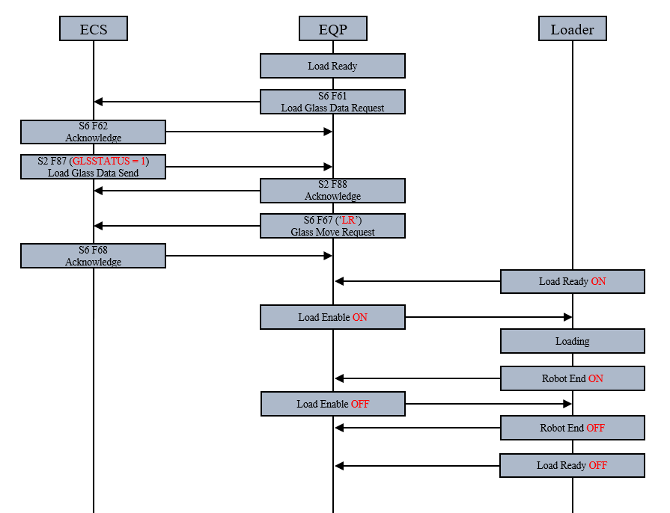

Glass Exchange

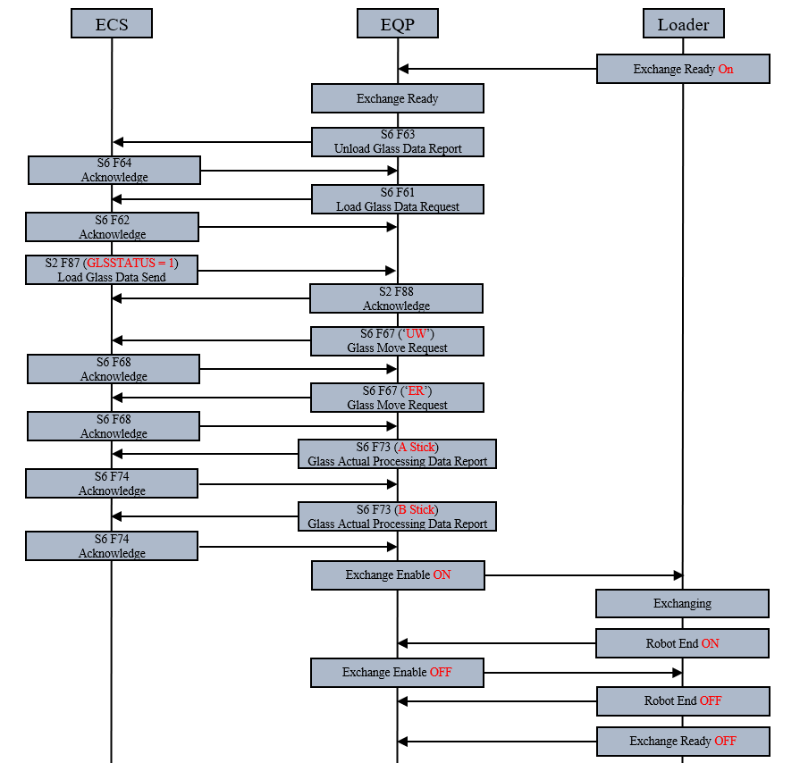

Glass Unloading

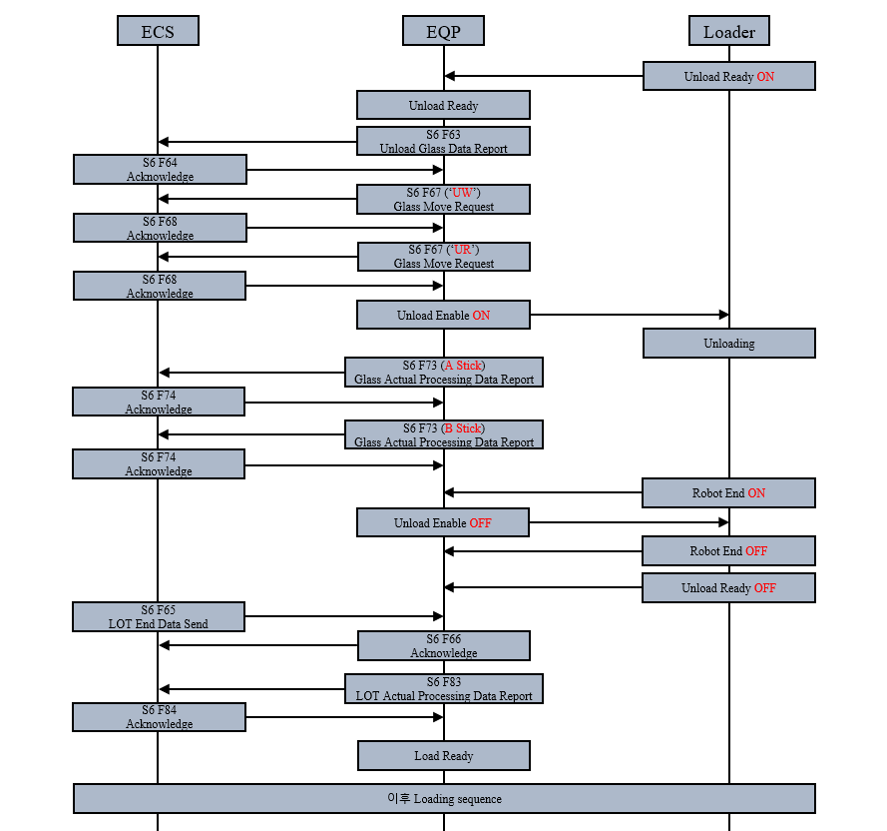

Alarm List
No | Name | Description | Alarm Code | Alarm State | Alarm Enabled
1 | LOADING (ROBOT) ALARM |  | 001 | Heavy Alarm
2 | UNLOADING (ROBOT) ALARM |  | 002 | Heavy Alarm
3 | LOADING (EQP) ALARM |  | 003 | Heavy Alarm
4 | UNLOADING (EQP) ALARM |  | 004 | Heavy Alarm
5 | EXCANGE (ROBOT) ALARM |  | 005 | Heavy Alarm
6 | EXCANGE (EQP) ALARM |  | 006 | Heavy Alarm
7 | ROBOT DOOR OPEN ALARM |  | 007 | Heavy Alarm
8 | ROBOT EMO ALARM |  | 008 | Heavy Alarm
9 | ERR_SPARE9 |  | 009 | Heavy Alarm
10 | SCAN START TIME OVER ALARM |  | 010 | Heavy Alarm
11 | SCAN END TIMVE OVER ALARM |  | 011 | Heavy Alarm
12 | GRAB START TIME OVER ALARM |  | 012 | Heavy Alarm
13 | GRAB END TIME OVER ALARM |  | 013 | Heavy Alarm
14 | CONSOLE PROGRAM 상태 이상 ALARM |  | 014 | Heavy Alarm
15 | CIM PROGRAM 상태 이상 ALARM |  | 015 | Heavy Alarm
16 | CONSOLE PARAMETER SETTING ALARM |  | 016 | Heavy Alarm
17 | CONTROL PARAMETER SETTING ALARM |  | 017 | Heavy Alarm
18 | UINT ALIGN CAMERA 상태 이상 ALARM |  | 018 | Heavy Alarm
19 | REVIW CAMERA 상태 이상 ALARM |  | 019 | Heavy Alarm
20 | SCAN CAMERA 상태 이상 ALARM |  | 020 | Heavy Alarm
21 | UINT ALIGN CAMERA 조명 상태 이상 ALARM |  | 021 | Heavy Alarm
22 | REVIW CAMERA 조명 상태 이상 ALARM |  | 022 | Heavy Alarm
23 | SCAN CAMERA 조명 상태 이상 ALARM |  | 023 | Heavy Alarm
24 | AUTORUN STOP ALARM |  | 024 | Heavy Alarm
25 | ERR_SPARE25 |  | 025 | Heavy Alarm
26 | ERR_SPARE26 |  | 026 | Heavy Alarm
27 | ERR_SPARE27 |  | 027 | Heavy Alarm
28 | ERR_SPARE28 |  | 028 | Heavy Alarm
29 | ERR_SPARE29 |  | 029 | Heavy Alarm
30 | ERR_SPARE30 |  | 030 | Heavy Alarm
31 | ERR_SPARE31 |  | 031 | Heavy Alarm
32 | ERR_SPARE32 |  | 032 | Heavy Alarm
33 | ERR_SPARE33 |  | 033 | Heavy Alarm
34 | ERR_SPARE34 |  | 034 | Heavy Alarm
35 | ERR_SPARE35 |  | 035 | Heavy Alarm
36 | ERR_SPARE36 |  | 036 | Heavy Alarm
37 | ERR_SPARE37 |  | 037 | Heavy Alarm
38 | ERR_SPARE38 |  | 038 | Heavy Alarm
39 | ERR_SPARE39 |  | 039 | Heavy Alarm
40 | ERR_SPARE40 |  | 040 | Heavy Alarm
41 | ERR_SPARE41 |  | 041 | Heavy Alarm
42 | ERR_SPARE42 |  | 042 | Heavy Alarm
43 | ERR_SPARE43 |  | 043 | Heavy Alarm
44 | ERR_SPARE44 |  | 044 | Heavy Alarm
45 | ERR_SPARE45 |  | 045 | Heavy Alarm
46 | ERR_SPARE46 |  | 046 | Heavy Alarm
47 | ERR_SPARE47 |  | 047 | Heavy Alarm
48 | ERR_SPARE48 |  | 048 | Heavy Alarm
49 | ERR_SPARE49 |  | 049 | Heavy Alarm
50 | ELECTRIC PANEL DOOR SW OPEN ALARM |  | 050 | Heavy Alarm
51 | ELECTRICITY BOX HIGH TEMP ALARM |  | 051 | Heavy Alarm
52 | DOOR 1 LOCK SWITCH (FRONT TOP) ALARM |  | 052 | Heavy Alarm
53 | DOOR 2 LOCK SWITCH  (FRONT LEFT TOP) ALARM |  | 053 | Heavy Alarm
54 | DOOR 3 LOCK SWITCH (FRONT CENTER TOP) ALARM |  | 054 | Heavy Alarm
55 | DOOR 4 LOCK SWITCH  (FRONT RIGHT TOP) ALARM |  | 055 | Heavy Alarm
56 | DOOR 5 LOCK SWITCH  (REAR RIGHT TOP) ALARM |  | 056 | Heavy Alarm
57 | DOOR 6 LOCK SWITCH  (REAR CENTER TOP) ALARM |  | 057 | Heavy Alarm
58 | DOOR 7 LOCK SWITCH  (REAR LEFT TOP) ALARM |  | 058 | Heavy Alarm
59 | DOOR 8 LOCK SWITCH  (FRONT LEFT BOTTOM) ALARM |  | 059 | Heavy Alarm
60 | DOOR 9 LOCK SWITCH  (FRONT CENTER BOTTOM) ALARM |  | 060 | Heavy Alarm
61 | DOOR 10 LOCK SWITCH  (FRONT RIGHT BOTTOM) ALARM |  | 061 | Heavy Alarm
62 | DOOR 11 LOCK SWITCH  (REAR RIGHT BOTTOM) ALARM |  | 062 | Heavy Alarm
63 | DOOR 12 LOCK SWITCH  (REAR CENTER BOTTOM) ALARM |  | 063 | Heavy Alarm
64 | 비상탈출 스위치1 ALARM |  | 064 | Heavy Alarm
65 | 비상탈출 스위치2 ALARM |  | 065 | Heavy Alarm
66 | EMS SW 1 ALARM |  | 066 | Heavy Alarm
67 | EMS SW 2 ALARM |  | 067 | Heavy Alarm
68 | EMS SW 3 ALARM |  | 068 | Heavy Alarm
69 | EMS SW 4 ALARM |  | 069 | Heavy Alarm
70 | EMS SW 5 ALARM |  | 070 | Heavy Alarm
71 | TEACHING PANDENT  EMO BYPASS ON ALARM |  | 071 | Heavy Alarm
72 | ELEC FAN ALARM 1 |  | 072 | Heavy Alarm
73 | ELEC FAN ALARM 2 |  | 073 | Heavy Alarm
74 | ELEC FAN ALARM 3 |  | 074 | Heavy Alarm
75 | ELEC FAN ALARM 4 |  | 075 | Heavy Alarm
76 | ELEC FAN ALARM 5 |  | 076 | Heavy Alarm
77 | ELEC FAN ALARM 6 |  | 077 | Heavy Alarm
78 | ELEC FAN ALARM 7 |  | 078 | Heavy Alarm
79 | ELEC FAN ALARM 8 |  | 079 | Heavy Alarm
80 | KEY RELEASE DOOR 1 ALARM |  | 080 | Heavy Alarm
81 | KEY RELEASE DOOR 2 ALARM |  | 081 | Heavy Alarm
82 | KEY RELEASE DOOR 3 ALARM |  | 082 | Heavy Alarm
83 | KEY RELEASE DOOR 4 ALARM |  | 083 | Heavy Alarm
84 | KEY RELEASE DOOR 5 ALARM |  | 084 | Heavy Alarm
85 | KEY RELEASE DOOR 6 ALARM |  | 085 | Heavy Alarm
86 | KEY RELEASE DOOR 7 ALARM |  | 086 | Heavy Alarm
87 | GLASS1 CLAMP ALARM |  | 087 | Heavy Alarm
88 | GLASS2 CLAMP ALARM |  | 088 | Heavy Alarm
89 | GLASS1 DETECT ALARM |  | 089 | Heavy Alarm
90 | GLASS2 DEFECT ALARM |  | 090 | Heavy Alarm
91 | EFU ALARM |  | 091 | Heavy Alarm
92 | ISOLATOR 공급1 (FRAME) ALARM |  | 092 | Heavy Alarm
93 | ISOLATOR 공급2 (FRAME) ALARM |  | 093 | Heavy Alarm
94 | ISOLATOR 공급1 (COVER) ALARM |  | 094 | Heavy Alarm
95 | ISOLATOR 공급2 (COVER) ALARM |  | 095 | Heavy Alarm
96 | CDA1 압력계 ALARM |  | 096 | Heavy Alarm
97 | CDA2 압력계 ALARM |  | 097 | Heavy Alarm
98 | CDA3 압력계 ALARM |  | 098 | Heavy Alarm
99 | CDA4 압력계 ALARM |  | 099 | Heavy Alarm
100 | CDA5 압력계 ALARM |  | 100 | Heavy Alarm
101 | CDA6 압력계 ALARM |  | 101 | Heavy Alarm
102 | CDA7 압력계 ALARM |  | 102 | Heavy Alarm
103 | VAC1 압력계 ALARM |  | 103 | Heavy Alarm
104 | VAC2 압력계 ALARM |  | 104 | Heavy Alarm
105 | ERR_SPARE105 |  | 105 | Heavy Alarm
106 | ERR_SPARE106 |  | 106 | Heavy Alarm
107 | ERR_SPARE107 |  | 107 | Heavy Alarm
108 | ERR_SPARE108 |  | 108 | Heavy Alarm
109 | ERR_SPARE109 |  | 109 | Heavy Alarm
110 | CONTACT X4-AXIS 위치 이상 ALARM |  | 110 | Heavy Alarm
111 | CONTACT X5-AXIS 위치 이상 ALARM |  | 111 | Heavy Alarm
112 | CAMERA Y-AXIS 위치 이상 ALARM |  | 112 | Heavy Alarm
113 | CAMERA X2-AXIS 위치 이상 ALARM |  | 113 | Heavy Alarm
114 | CAMERA X3-AXIS 위치 이상 ALARM |  | 114 | Heavy Alarm
115 | REVIEW Y3-AXIS 위치 이상 ALARM |  | 115 | Heavy Alarm
116 | REVIEW Y4-AXIS 위치 이상 ALARM |  | 116 | Heavy Alarm
117 | WORKTABLE X1-AXIS 위치 이상 ALARM |  | 117 | Heavy Alarm
118 | CONTACT Y2-AXIS 위치 이상 ALARM |  | 118 | Heavy Alarm
119 | CONTACT Z-AXIS 위치 이상 ALARM |  | 119 | Heavy Alarm
120 | STAGE U-AXIS 위치 이상 ALARM |  | 120 | Heavy Alarm
121 | STAGE V-AXIS 위치 이상 ALARM |  | 121 | Heavy Alarm
122 | STAGE W-AXIS 위치 이상 ALARM |  | 122 | Heavy Alarm
123 | STAGE T-AXIS 위치 이상 ALARM |  | 123 | Heavy Alarm
124 | CAMER TURN-AXIS 위치 이상 ALARM |  | 124 | Heavy Alarm
125 | CONTACT X4-AXIS LIMIT 감지 ALARM |  | 125 | Heavy Alarm
126 | CONTACT X5-AXIS LIMIT 감지 ALARM |  | 126 | Heavy Alarm
127 | CAMERA Y-AXIS LIMIT 감지 ALARM |  | 127 | Heavy Alarm
128 | CAMERA X2-AXIS LIMIT 감지 ALARM |  | 128 | Heavy Alarm
129 | CAMERA X3-AXIS LIMIT 감지 ALARM |  | 129 | Heavy Alarm
130 | REVIEW Y3-AXIS LIMIT 감지 ALARM |  | 130 | Heavy Alarm
131 | REVIEW Y4-AXIS LIMIT 감지 ALARM |  | 131 | Heavy Alarm
132 | WORKTABLE X1-AXIS LIMIT 감지 ALARM |  | 132 | Heavy Alarm
133 | CONTACT Y2-AXIS LIMIT 감지 ALARM |  | 133 | Heavy Alarm
134 | CONTACT Z-AXIS LIMIT 감지 ALARM |  | 134 | Heavy Alarm
135 | STAGE U-AXIS LIMIT 감지 ALARM |  | 135 | Heavy Alarm
136 | STAGE V-AXIS LIMIT 감지 ALARM |  | 136 | Heavy Alarm
137 | STAGE W-AXIS LIMIT 감지 ALARM |  | 137 | Heavy Alarm
138 | STAGE T-AXIS LIMIT 감지 ALARM |  | 138 | Heavy Alarm
139 | CAMER TURN-AXIS LIMIT 감지 ALARM |  | 139 | Heavy Alarm
140 | CONTACT X4-AXIS 축 상태 점검 ALARM |  | 140 | Heavy Alarm
141 | CONTACT X5-AXIS 축 상태 점검 ALARM |  | 141 | Heavy Alarm
142 | CAMERA Y-AXIS 축 상태 점검 ALARM |  | 142 | Heavy Alarm
143 | CAMERA X2-AXIS 축 상태 점검 ALARM |  | 143 | Heavy Alarm
144 | CAMERA X3-AXIS 축 상태 점검 ALARM |  | 144 | Heavy Alarm
145 | REVIEW Y3-AXIS 축 상태 점검 ALARM |  | 145 | Heavy Alarm
146 | REVIEW Y4-AXIS 축 상태 점검 ALARM |  | 146 | Heavy Alarm
147 | WORKTABLE X1-AXIS 축 상태 점검 ALARM |  | 147 | Heavy Alarm
148 | CONTACT Y2-AXIS 축 상태 점검 ALARM |  | 148 | Heavy Alarm
149 | CONTACT Z-AXIS 축 상태 점검 ALARM |  | 149 | Heavy Alarm
150 | STAGE U-AXIS 축 상태 점검 ALARM |  | 150 | Heavy Alarm
151 | STAGE V-AXIS 축 상태 점검 ALARM |  | 151 | Heavy Alarm
152 | STAGE W-AXIS 축 상태 점검 ALARM |  | 152 | Heavy Alarm
153 | STAGE T-AXIS 축 상태 점검 ALARM |  | 153 | Heavy Alarm
154 | CAMER TURN-AXIS 축 상태 점검 ALARM |  | 154 | Heavy Alarm
155 | ERR_SPARE155 |  | 155 | Heavy Alarm
156 | ERR_SPARE156 |  | 156 | Heavy Alarm
157 | ERR_SPARE157 |  | 157 | Heavy Alarm
158 | ERR_SPARE158 |  | 158 | Heavy Alarm
159 | ERR_SPARE159 |  | 159 | Heavy Alarm
160 | ERR_SPARE160 |  | 160 | Heavy Alarm
161 | ERR_SPARE161 |  | 161 | Heavy Alarm
162 | ERR_SPARE162 |  | 162 | Heavy Alarm
163 | ERR_SPARE163 |  | 163 | Heavy Alarm
164 | ERR_SPARE164 |  | 164 | Heavy Alarm
165 | ERR_SPARE165 |  | 165 | Heavy Alarm
166 | ERR_SPARE166 |  | 166 | Heavy Alarm
167 | ERR_SPARE167 |  | 167 | Heavy Alarm
168 | ERR_SPARE168 |  | 168 | Heavy Alarm
169 | ERR_SPARE169 |  | 169 | Heavy Alarm
170 | ERR_SPARE170 |  | 170 | Heavy Alarm
171 | ERR_SPARE171 |  | 171 | Heavy Alarm
172 | ERR_SPARE172 |  | 172 | Heavy Alarm
173 | ERR_SPARE173 |  | 173 | Heavy Alarm
174 | ERR_SPARE174 |  | 174 | Heavy Alarm
175 | ERR_SPARE175 |  | 175 | Heavy Alarm
176 | ERR_SPARE176 |  | 176 | Heavy Alarm
177 | ERR_SPARE177 |  | 177 | Heavy Alarm
178 | ERR_SPARE178 |  | 178 | Heavy Alarm
179 | ERR_SPARE179 |  | 179 | Heavy Alarm
180 | ERR_SPARE180 |  | 180 | Heavy Alarm
181 | ERR_SPARE181 |  | 181 | Heavy Alarm
182 | ERR_SPARE182 |  | 182 | Heavy Alarm
183 | ERR_SPARE183 |  | 183 | Heavy Alarm
184 | ERR_SPARE184 |  | 184 | Heavy Alarm
185 | ERR_SPARE185 |  | 185 | Heavy Alarm
186 | ERR_SPARE186 |  | 186 | Heavy Alarm
187 | ERR_SPARE187 |  | 187 | Heavy Alarm
188 | ERR_SPARE188 |  | 188 | Heavy Alarm
189 | ERR_SPARE189 |  | 189 | Heavy Alarm
190 | ERR_SPARE190 |  | 190 | Heavy Alarm
191 | ERR_SPARE191 |  | 191 | Heavy Alarm
192 | ERR_SPARE192 |  | 192 | Heavy Alarm
193 | ERR_SPARE193 |  | 193 | Heavy Alarm
194 | ERR_SPARE194 |  | 194 | Heavy Alarm
195 | ERR_SPARE195 |  | 195 | Heavy Alarm
196 | ERR_SPARE196 |  | 196 | Heavy Alarm
197 | ERR_SPARE197 |  | 197 | Heavy Alarm
198 | ERR_SPARE198 |  | 198 | Heavy Alarm
199 | ERR_SPARE199 |  | 199 | Heavy Alarm
200 | ERR_SPARE200 |  | 200 | Heavy Alarm

Recipe

Scenario

Control State and Equipment Operation Mode Change

Are You There Request
장비의 운영이 시작되고 초기화 될 때, 장비는 ECS와 연결한 후 ECS로 ‘Are You There Request’ 메시지를 보내야 한다

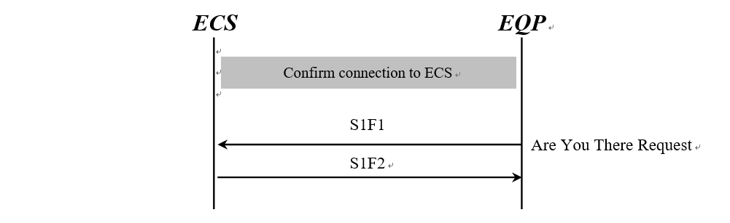
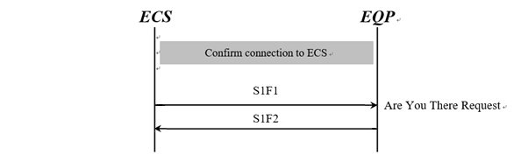

Offline → Online Remote
- Offline 에서 Online Remote 로 상태 변경은 아래의 Scenario를 따른다
- 만약 응답이 없거나 통신 에러가 발생하면, Offline 상태를 계속 유지된다.

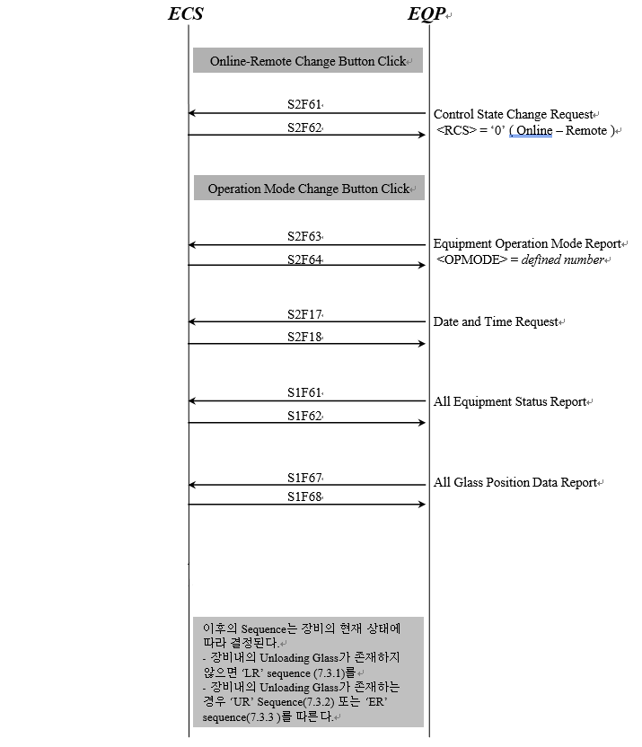

Offline → Online Local
- Offline 에서 Online Local로 상태 변경은 아래의 Scenario를 따른다.
- 만약 응답이 없거나 통신 에러가 발생하면, Offline 상태를 계속 유지된다.

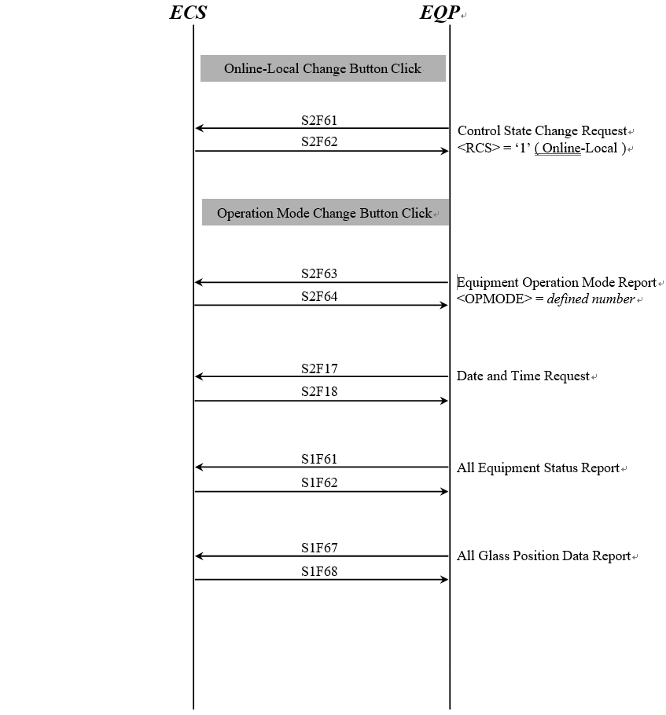

Online Remote → Online Local
- Online Remote에서 Online Local로 상태 변경은 아래의 Scenario를 따른다.

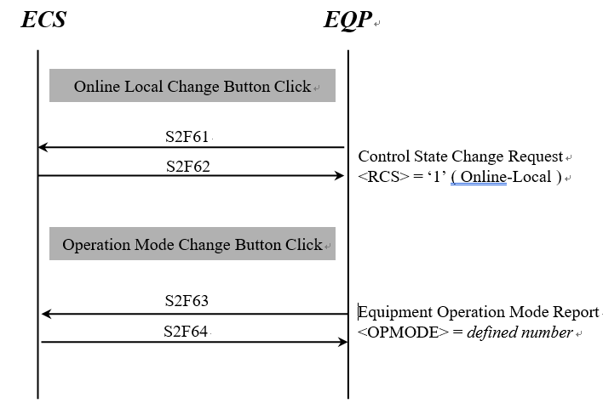

Online Local → Online Remote
- Online Local 에서 Online Remote 로 상태 변경은 아래의 Scenario를 따른다.

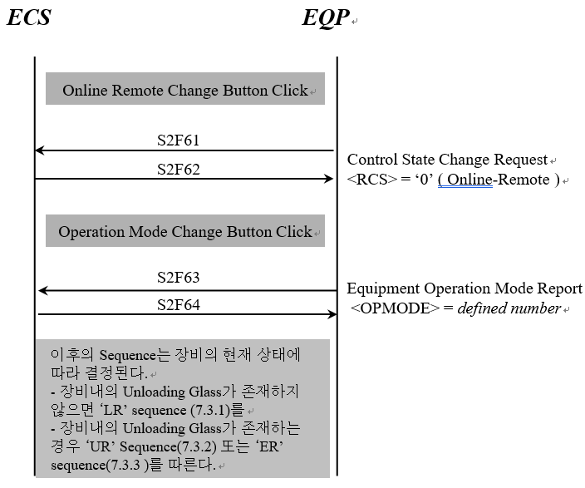

Online(Remote or Local) → Offline
- Online Remote 에서 Offline으로 상태 변경은 아래의 Scenario를 따른다.
- Online 에서 Offline으로 전환 시, 응답이 없거나 통신 에러가 발생하더라도 off-line으로 전환된다.

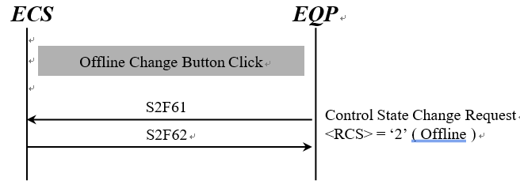

Equipment Operation Mode Change (Under same Control State)
- 같은 통제 상태 하에서 운영모드의 변경은 다음 Scenario를 따른다. 이 경우, 장비는 통제 상태를 보내지 않는다.
- 만약 응답이 없거나 통신 에러가 발생하면, 현재의 모드를 유지한다.

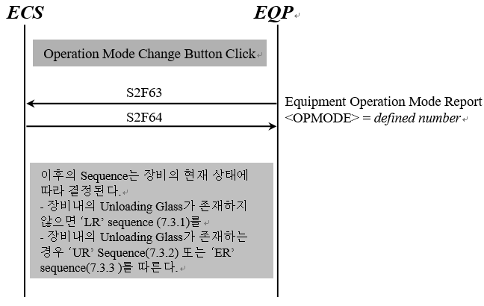

ECS Restart
- ECS 재기동시, 장비와 ECS간의 통제 상태는 다음 Scenario에 의해 변경된다.

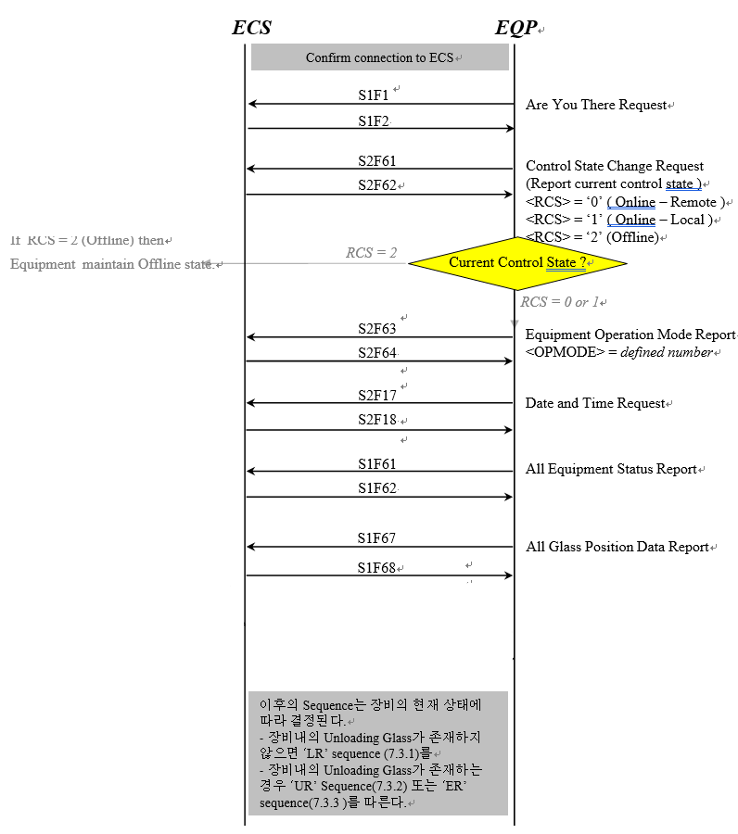

Loop Back Diagnostics

Equipment initiates Loop Back Test (ECS ← EQP)



ECS initiates Loop Back Test (ECS → EQP)



Glass Transfer Sequence

Glass Move State ‘LR’ Request(Load Request)
‘Load Glass Data Request(S6F61)’는 장비에서 실제 Glass Load (‘LR’)가 발생하기
5 ~ 10초 이전에 보낼 수 있어야 한다.
장비의 특성에 따라 더 많은 시간이 요구될 때는 LG측과 협의가 필요하다.

Load Glass Data Accepted

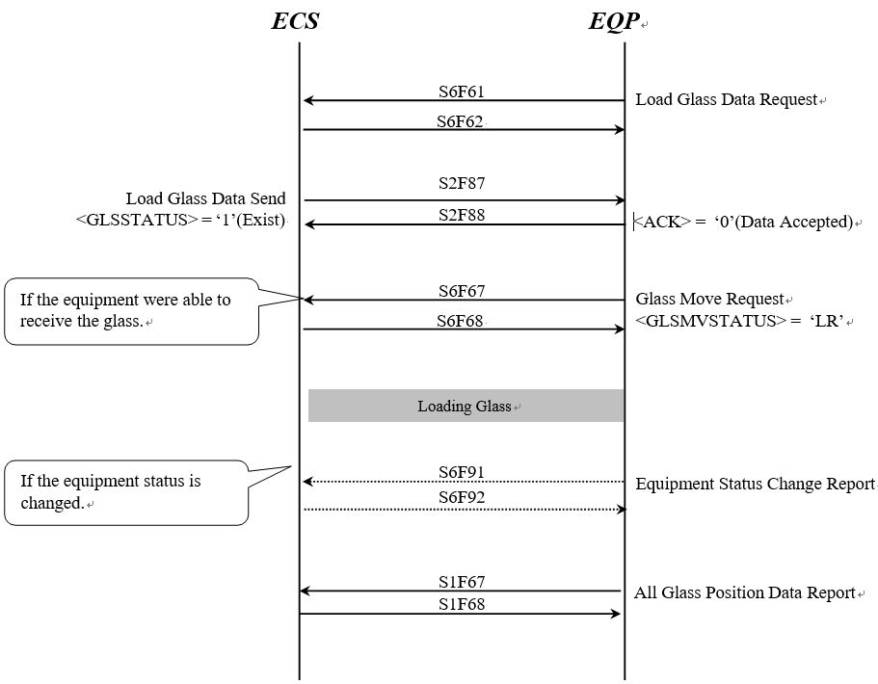

Load Glass Data Not Accepted

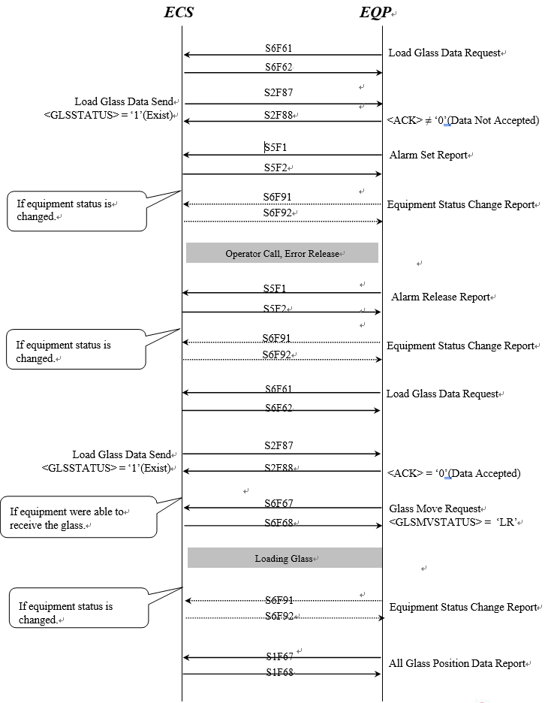

Glass Move State ‘UR’ Request - Only Unload Stage Type
‘UW(S6F67)’는 장비에서 실제 Glass Unload (‘UR’)가 발생하기 5 ~ 10초 이전에 보낼 수 있어야 한다. 장비의 특성에 따라 더 많은 시간이 요구될 때는 LG측과 협의가 필요하다.

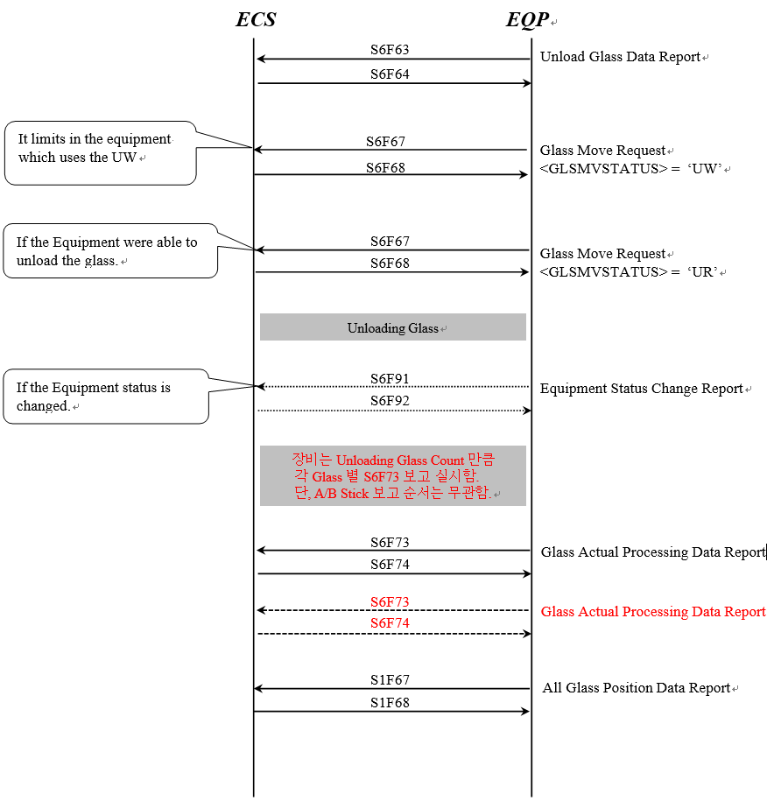

Glass Move State ‘ER’ Request
‘UW(S6F67)’는 장비에서 실제 Glass Exchange (‘ER’)가 발생하기 5 ~ 10 초 이전에 보낼 수 있어야 한다. 장비의 특성에 따라 더 많은 시간이 요구될 때는 LG측과 협의가 필요하다.

11.3.3.1 Load Glass Data Accepted

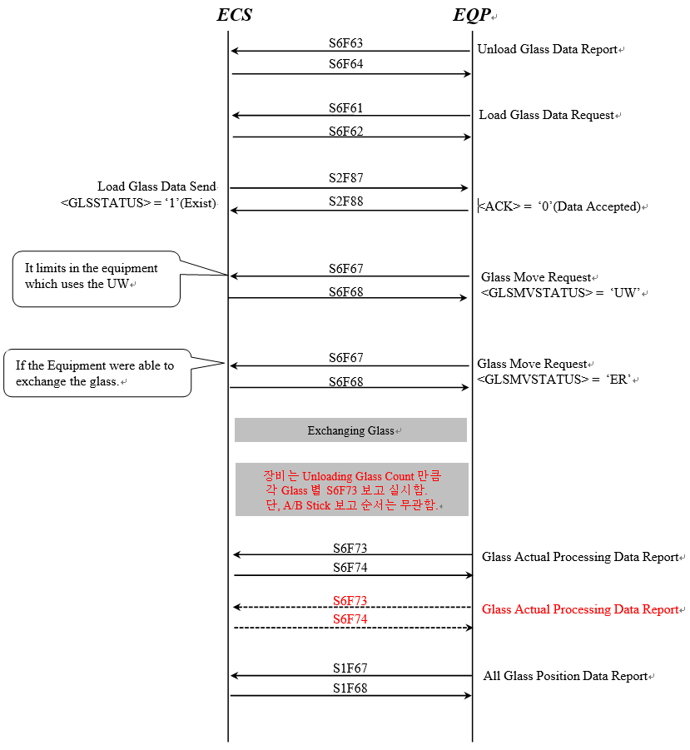

11.3.3.2 Load Glass Data Not Accepted – Glass Unloading Sequence after data not accept error release

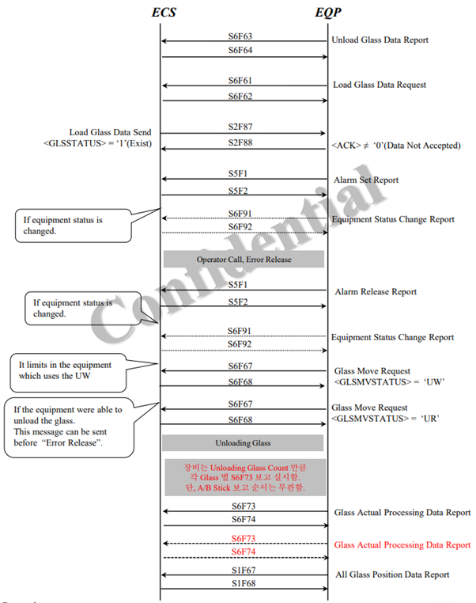

11.3.3.3 Load Glass Data Not Accepted – Glass Exchange Sequence after data not accept error release

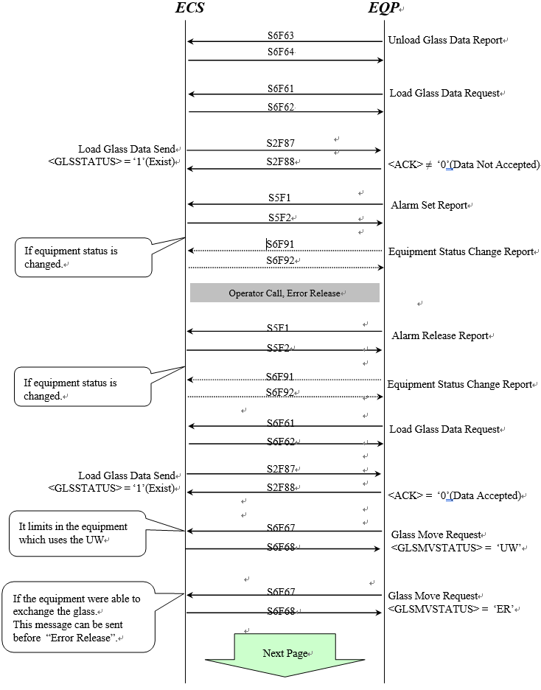

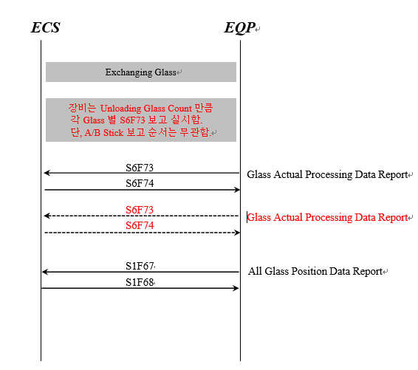

11.3.3.4 Load Glass Not Exist

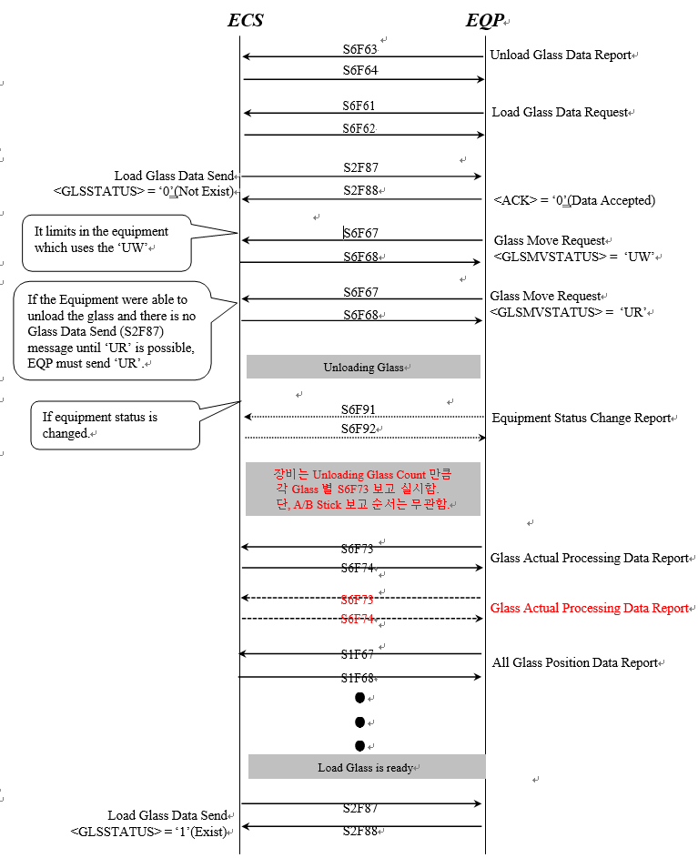

Glass Move State ‘CR’ Request(Cancel Request)
- 세부 사항은 LG CNS, LG Display와의 협의가 필요하다

11.3.4.1 Case of Unload Glass Not Exist
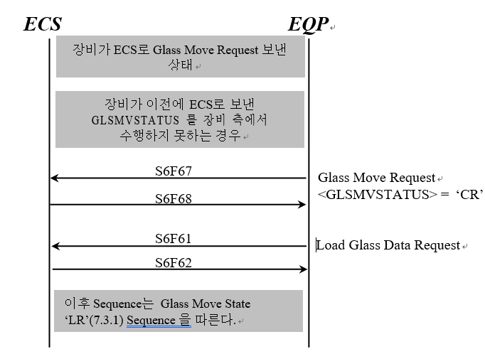

11.3.4.2 Case of Unload Glass Exist

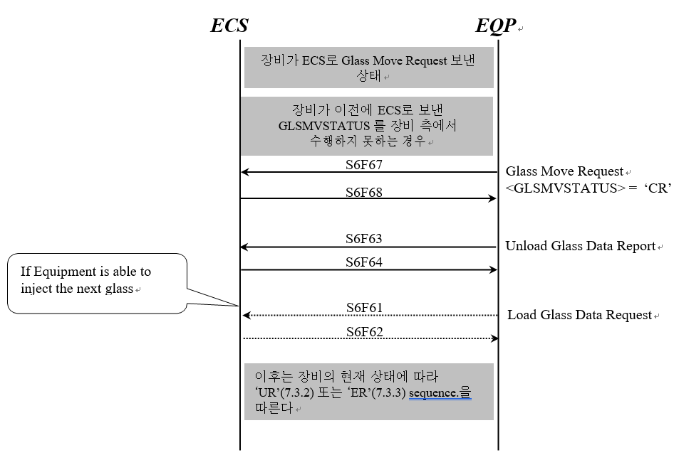

Load Glass Data Change Case
- 장비로 투입될 Glass의 정보가 변경되었을 때, ECS는 장비로 이 순서를 보낸다.
- Glass data change message는 언제라도 보내질 수 있다.
- 장비는 ECS가 전송하는 S2F87 수신 후 Glass 존재 여부에 따라 S6F67 송신 여부를 판단한다.
- 세부 사항은 LG CNS, LG Display 와의 협의가 필요하다.

11.3.5.1 Change form Not Exist to Exist

1) Unload Glass Not Exist

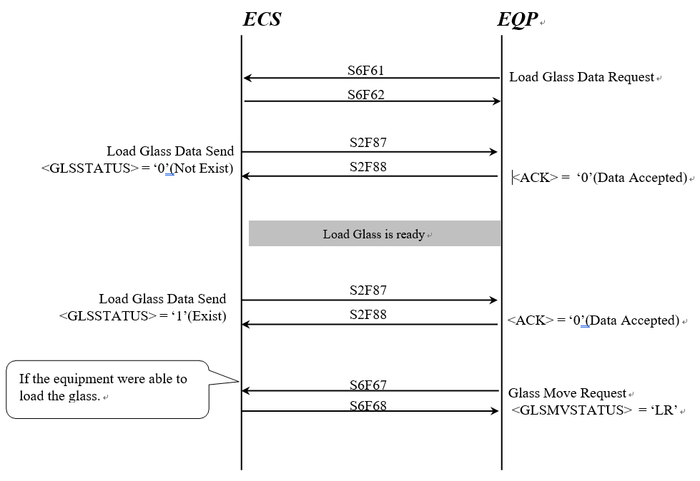

2) Unload Glass Exist
- Case A : Glass Data Change Send (S2F87) before ‘UW’

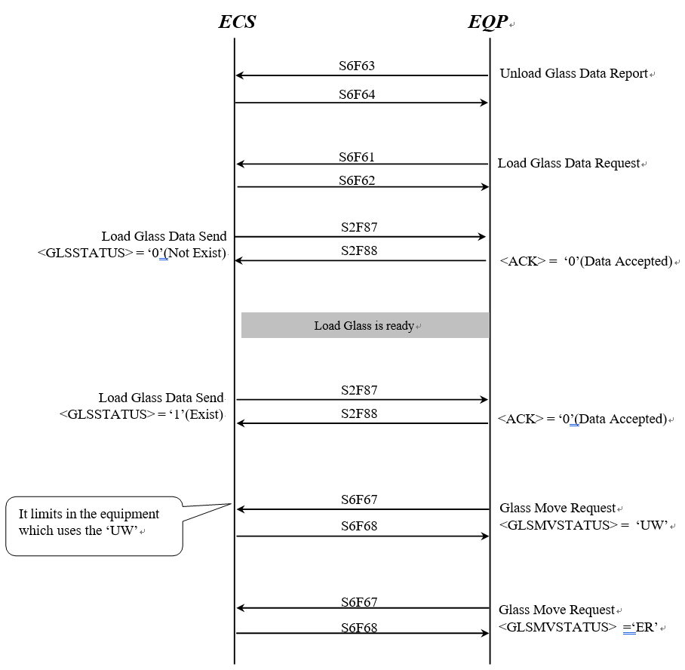

2) Unload Glass Exist
- Case B : Glass Data Change Send ( S2F87 ) after ‘UW’

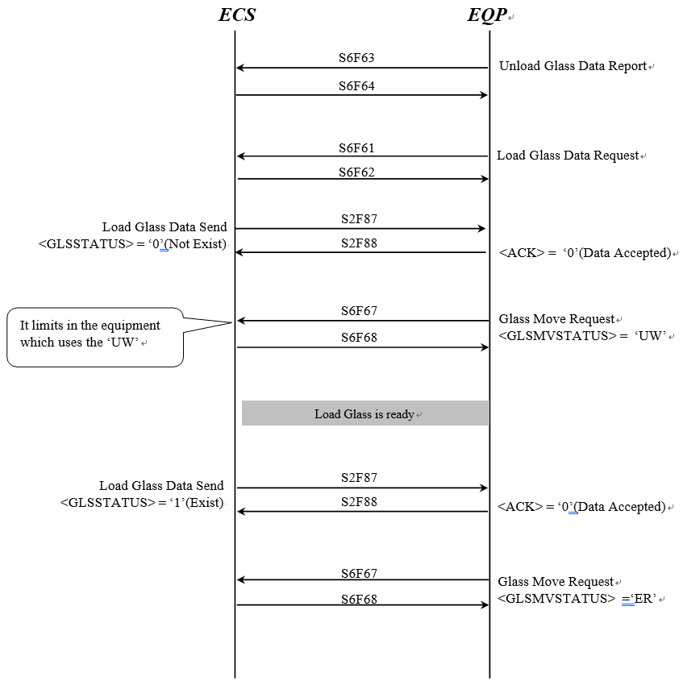

2) Unload Glass Exist
- Case C : Glass Data Change Send (S2F87) after ‘UR’
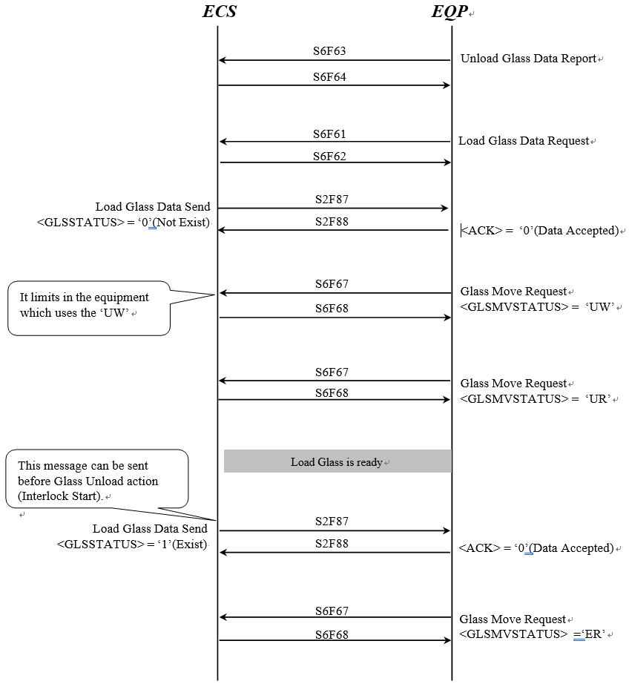

11.3.5.2 Change form Exist to Not Exist

1) Unload Glass Not Exist

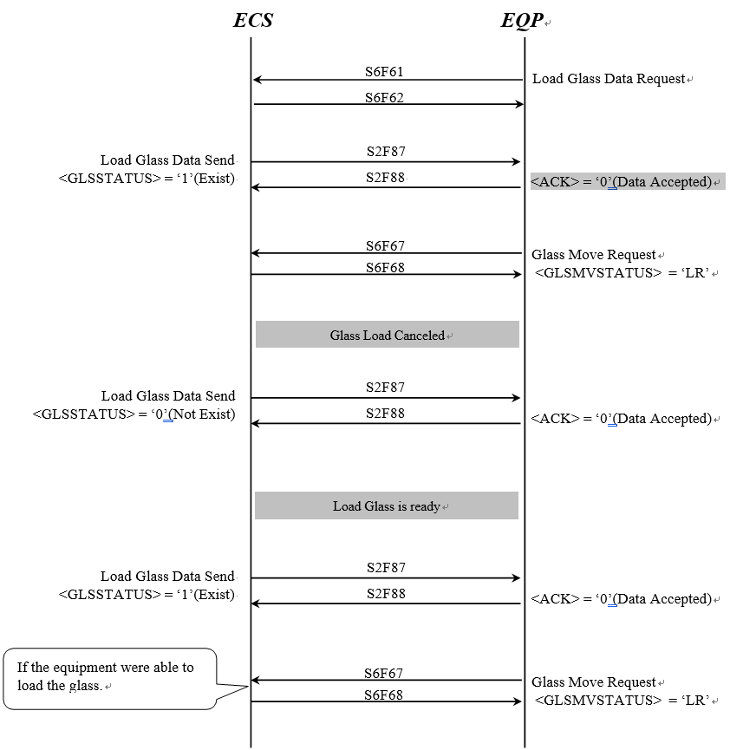

2) Unload Glass Exist
- Case A : Glass Data Change Send ( S2F87 ) before ‘UW’

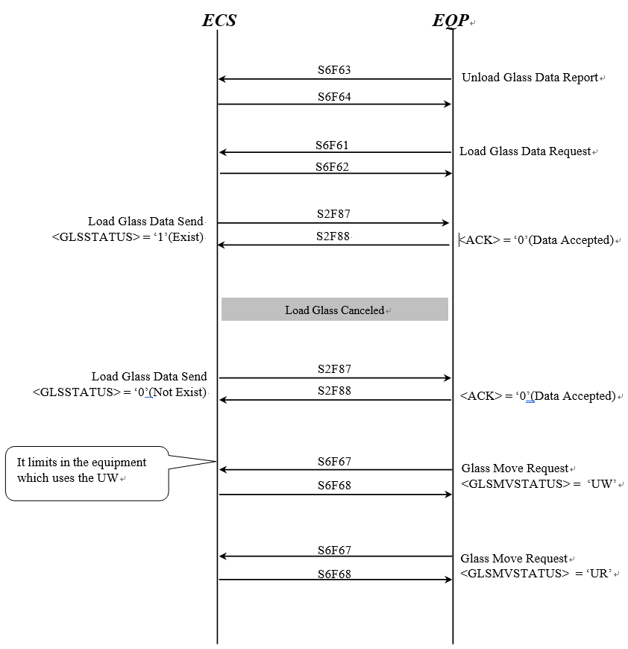

2) Unload Glass Exist
- Case B : Glass Data Change Send ( S2F87 ) after ‘UW’

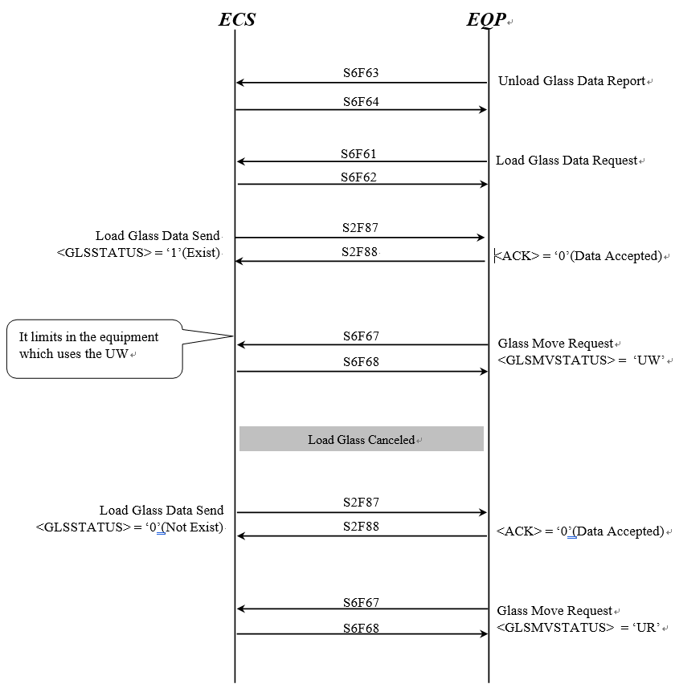

2) Unload Glass Exist
- Case C : Glass Data Change Send ( S2F87 ) after ‘ER’

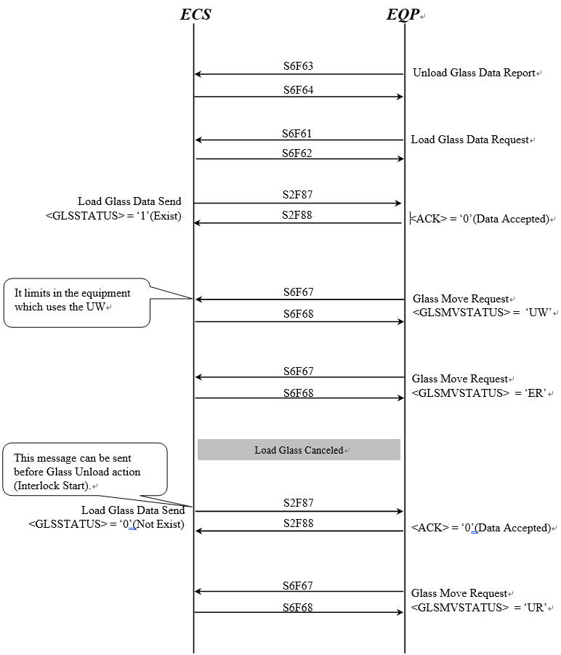

11.3.5.3 Change form Exist to Exist

1) Unload Glass Not Exist

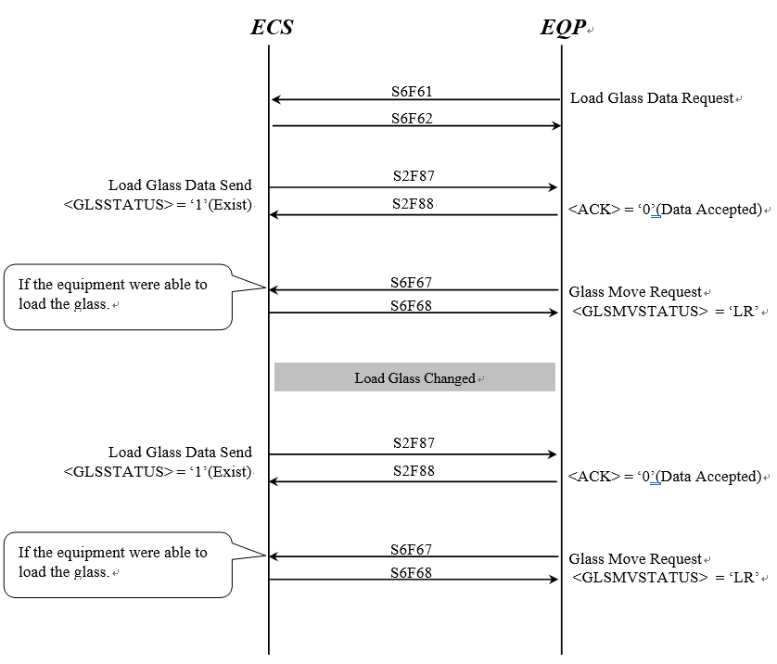

2) Unload Glass Exist
Case A : Glass Data Change Send ( S2F87 ) before ‘UW’

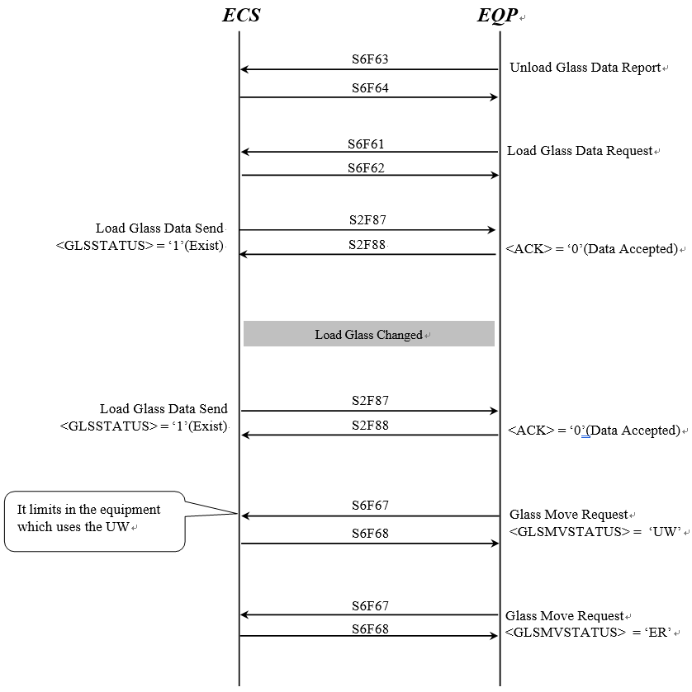

2) Unload Glass Exist
- Case B : Glass Data Change Send ( S2F87 ) after ‘UW’

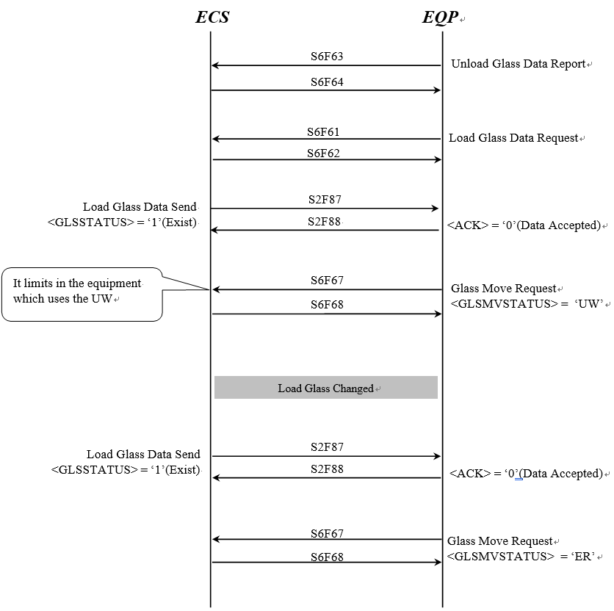

2) Unload Glass Exist
- Case C : Glass Data Change Send (S2F87 ) after ‘ER’

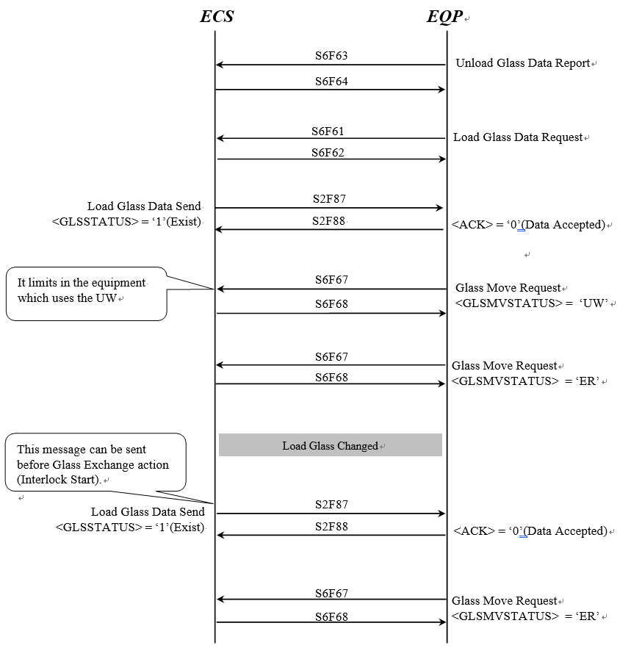

11.3.5.4 Unload Glass Data Request
- 이 메시지는 ECS가 ‘unload glass data report’를 받지 못했을 때 사용된다.
- 세부적인 사용에 대해서는 LG CNS, LG Display와의 협의가 필요하다

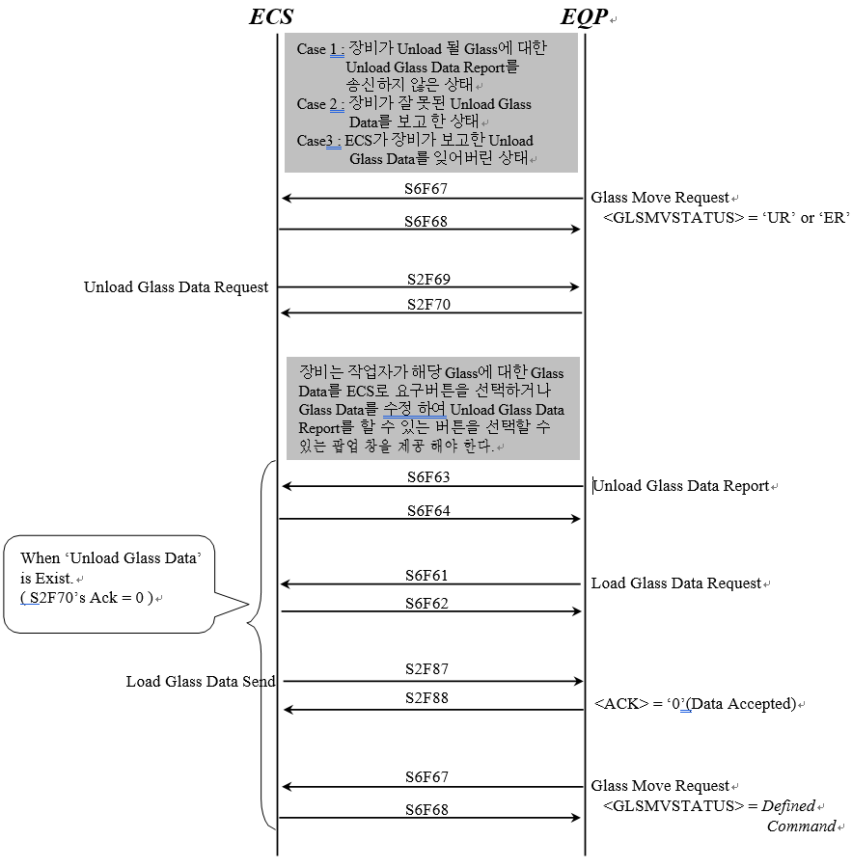

Glass Transfer In Online Local Control State
- 다음 Scenario는 Online Local 시 첫 번째 Glass를 장비에 투입할 때를 보여준다.

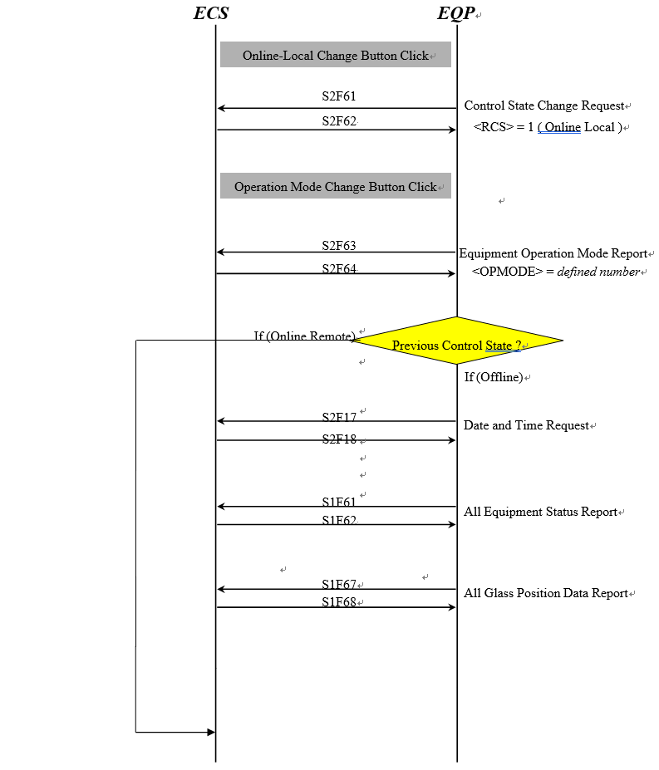

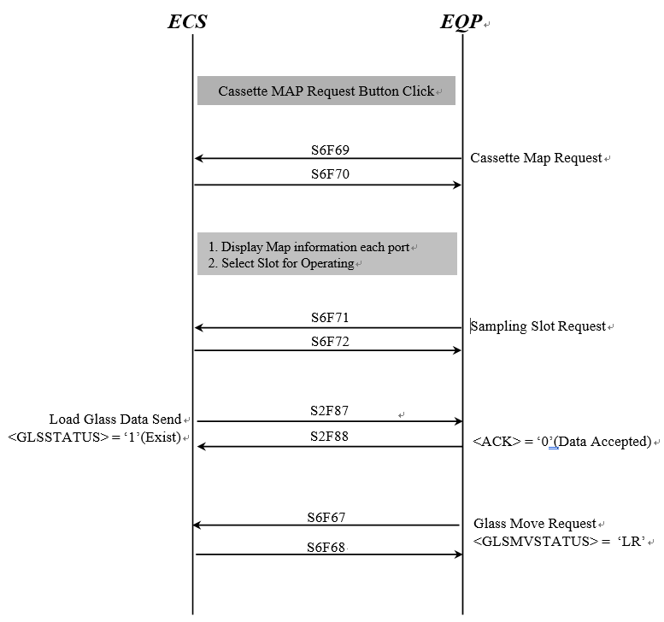

LOT Control Sequence

LOT End Data Send To Equipment

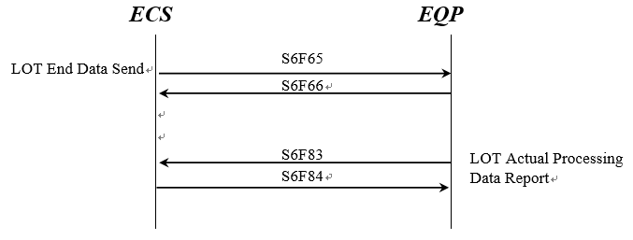

Local LOT Status Change Request on Online Local Control State
- Online local state 하에서 Lot end process 는 아래의 순서를 따른다

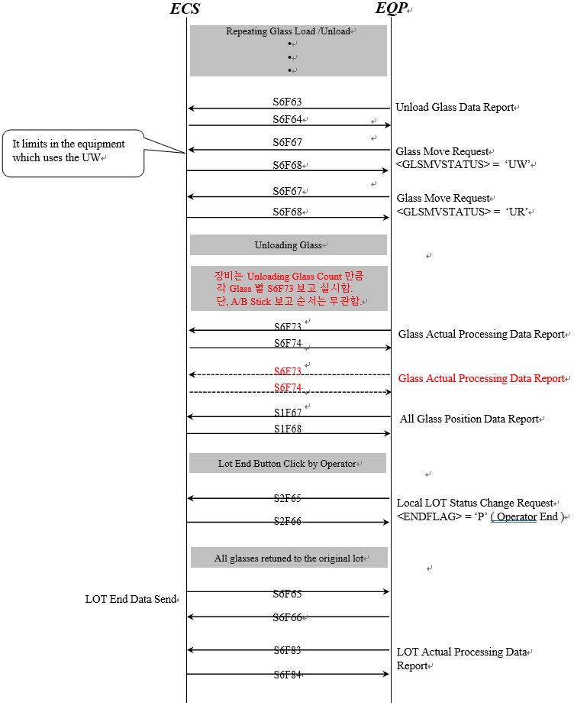

Status Report

Equipment Status Change Report
- Unit의 상태가 변할때마다 수행한다.

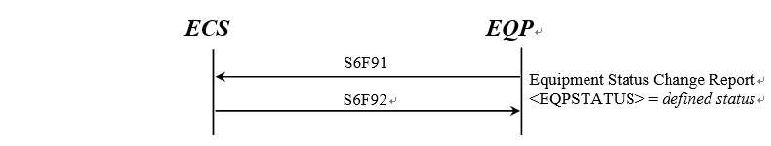

All Equipment Status Report
- ECS가 재시작하거나 Offline에서 Online으로 전환되는 경우에 모든 장비 상태를 보고한다(Remote or Local).



All Equipment Status Request
- 모든 장비 상태를 요청 시 수행한다.



OCR( or VCR ) Status Report

Ionizer Status Report
- Ionizer의 상태를 보고한다.



Recipe Management

Recipe ID List Request



Current Recipe ID Group List Request



Current Recipe ID List Request by Group
- 특정 Group에 속하는 Recipe ID List를 요청할 시 사용한다.



Recipe ID Confirm Request

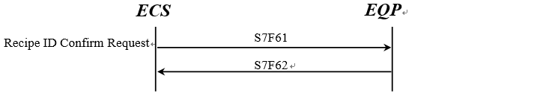

Recipe Body Request



Recipe ID Confirm & Sampling Data Send
- 이 Scenario는 각 Slot별 모든 Recipes를 즉시 확인할 때 사용되고, 이 메시지는 Lot Recipe (cassette recipe) 인 하나의 Recipe에만 사용될 수 있다.
- 만약 EQP가 샘플링과 < Recipe ID Confirm >의 사용이 가능하다.면, 장비는 Sampling Data Report (S7F63) 를 반드시 ECS로 보내야 한다.

11.6.6.1 Recipe Accept (Single LOT)

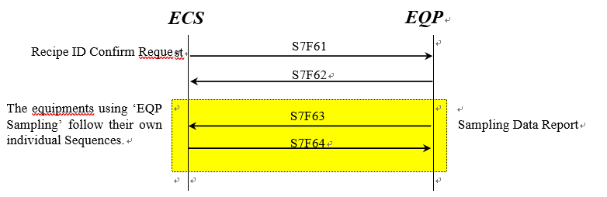

11.6.6.2 Recipe Accept(Multi LOT)

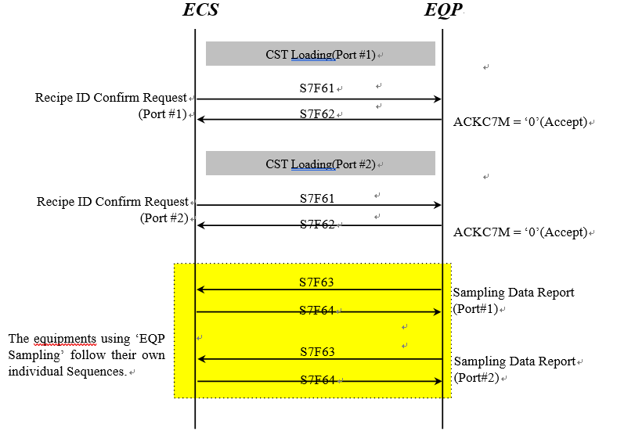

11.6.6.3 Recipe Accept(Multi LOT)

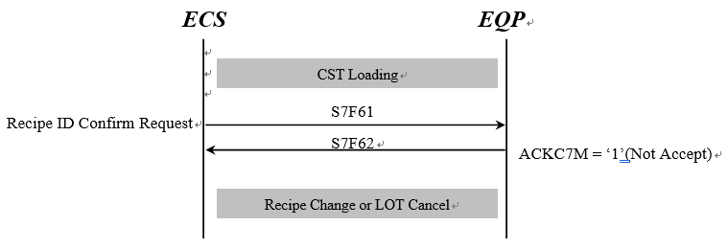

Date and Time Data Send

Date and Time Request



Date and Time Set



Alarm Occurrence and Clear

Heavy Alarm

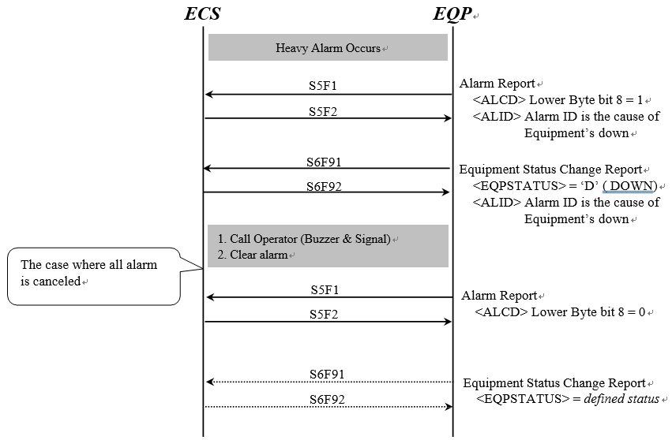

Light Alarm

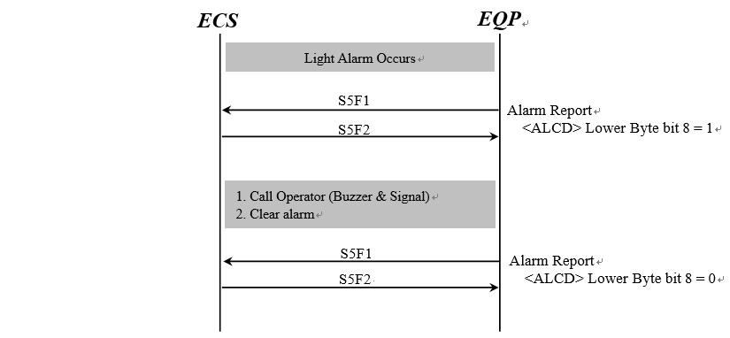

Scrap Occurrence and Report
- 일반적으로 Scrap 보고는 장비에서 Glass 파손이 확인되는 즉시 ECS로 보고 해야 한다.
- 부득이한 경우는 Lot End 이전에는 보고 해야 한다.

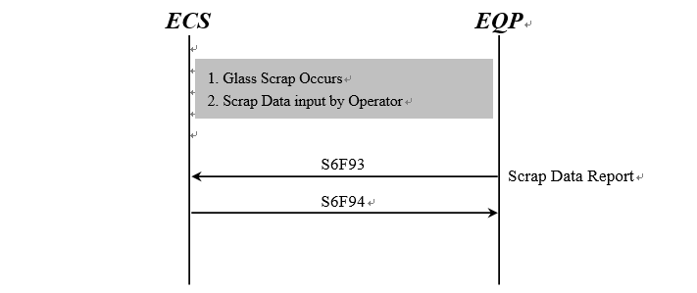

All Glass Position Data Report
- Online으로 전환되는 경우
- 각 Sub unit간 glass가 이동하는 경우



Cycle Stop Status Report

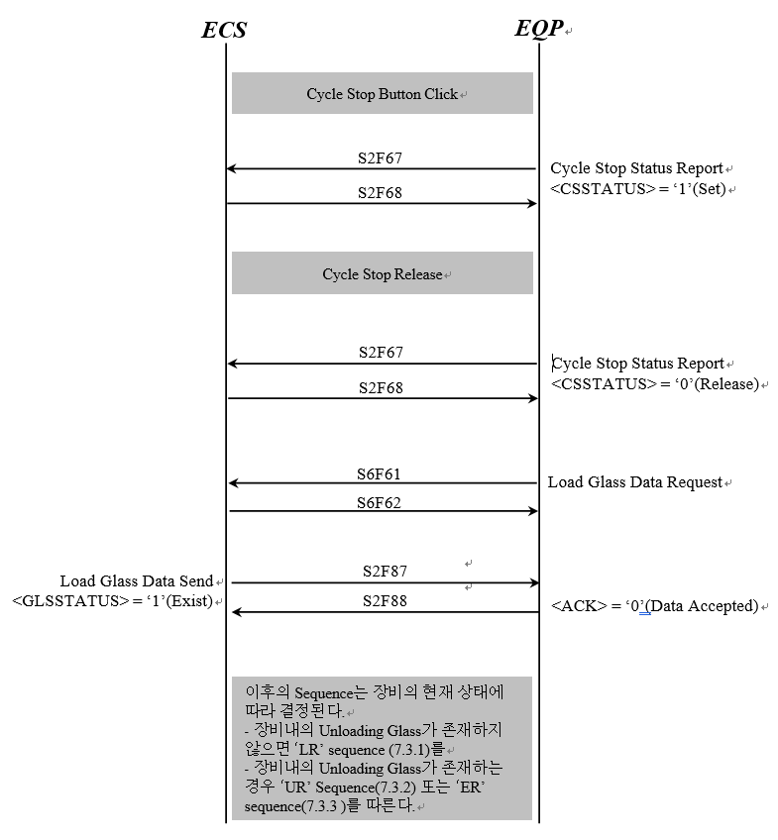

Rework Request
- Operator가 Rework flag code를 설정하면 장비는 ECS에게 rework 요청을 한다.

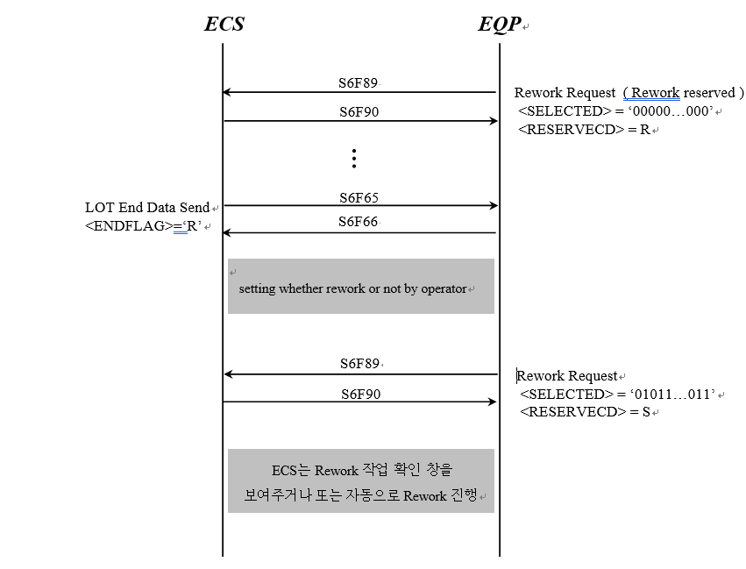

Dummy Lot Request
- 만약 장비가 Dummy Lot을 사용해야 한다면 Dummy Lot이 필요한 시점에 ECS에게 요청한다.

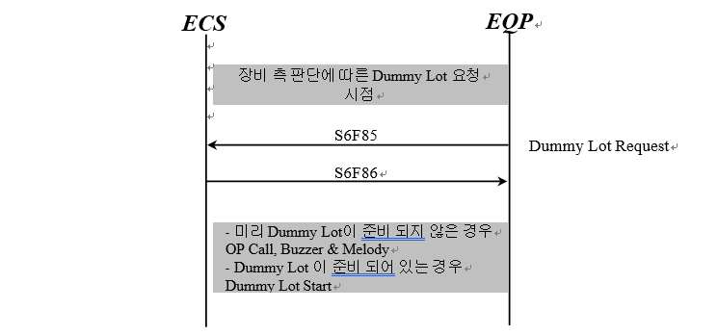

Glass Data Request
- Operator가 Glass ID 또는 Glass Code로 Glass Data를 재 요청 시 사용한다.
- 세부적인 사용에 대해서는 LG CNS, LG Display의 협의가 필요하다.

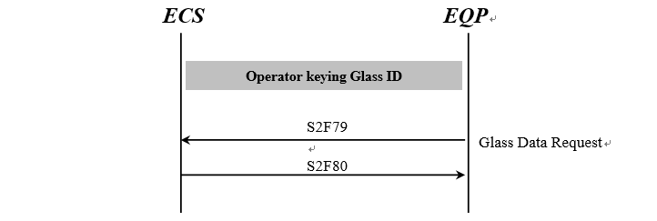

Chemical Change

Normal Operation
- In case of 1 lot sequence (from lot start to end)

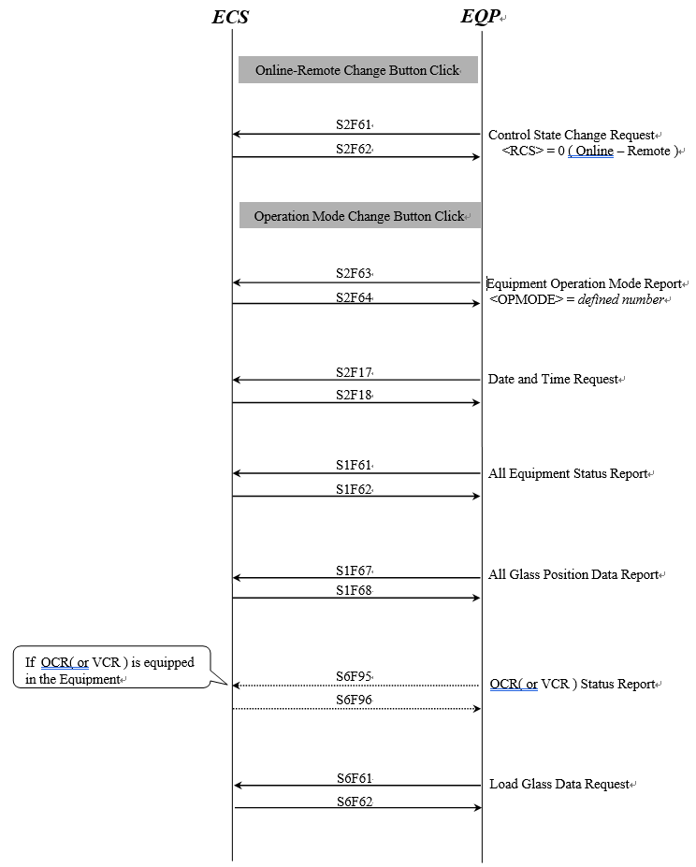

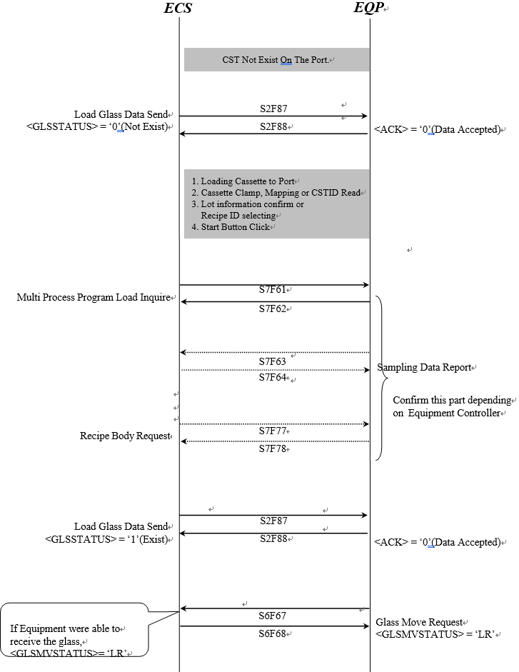

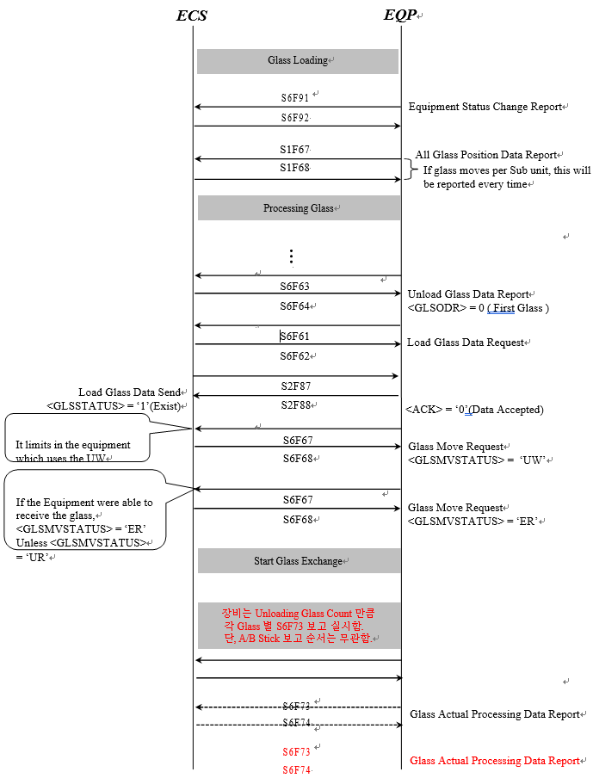

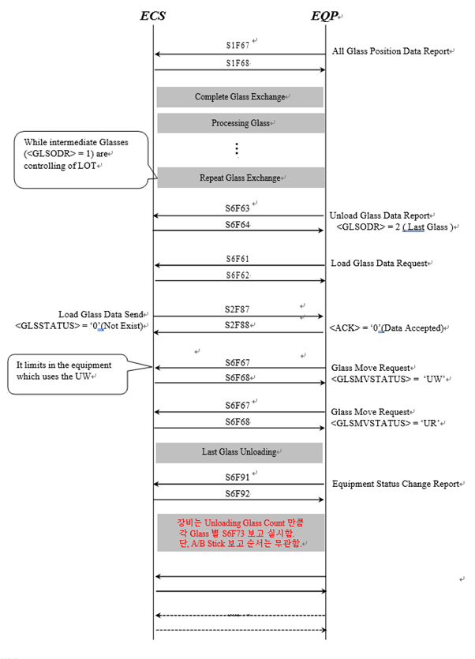
Glass Actual Processing Data
Report
Glass Actual Processing Data
Report
S6F74
S6F73
S6F74
S6F73

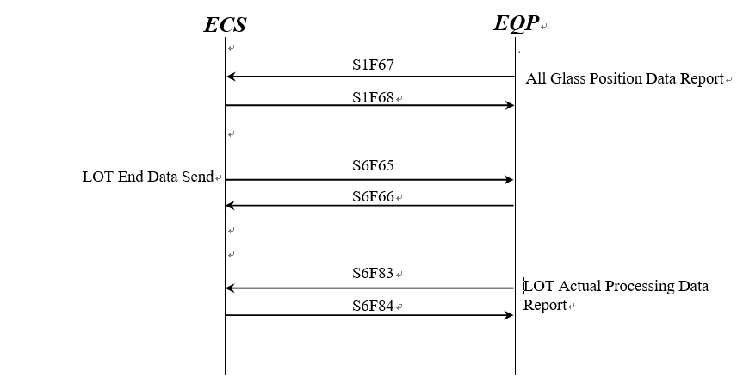

Lot Abort Scenario

The case where glass would be loaded is exist

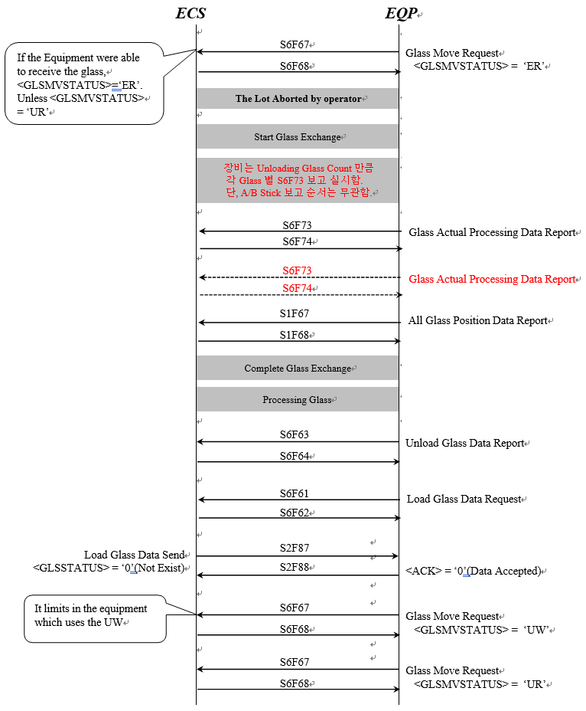

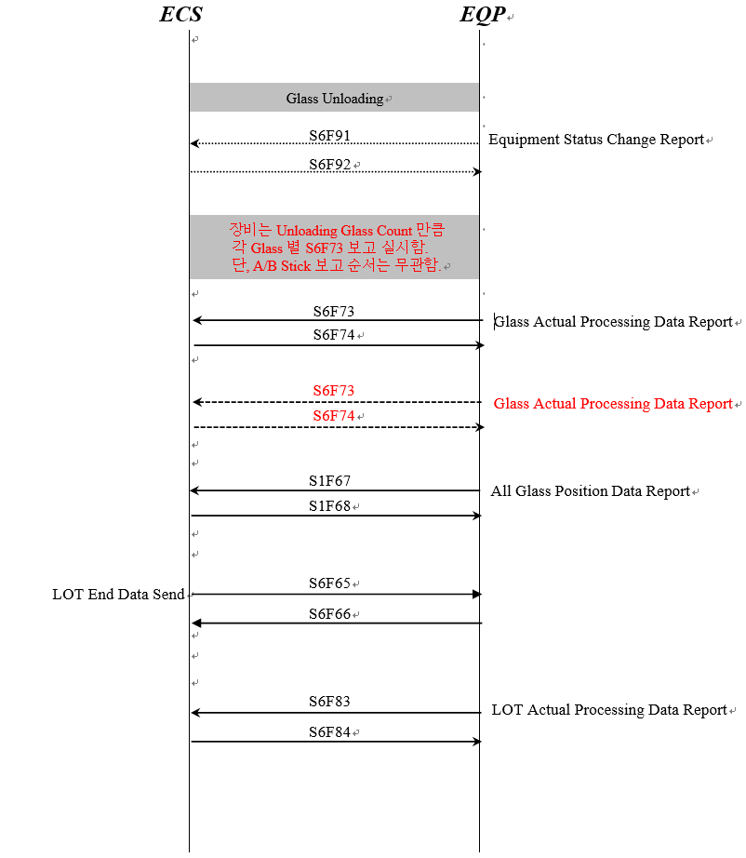

The case where glass would be loaded is not exist

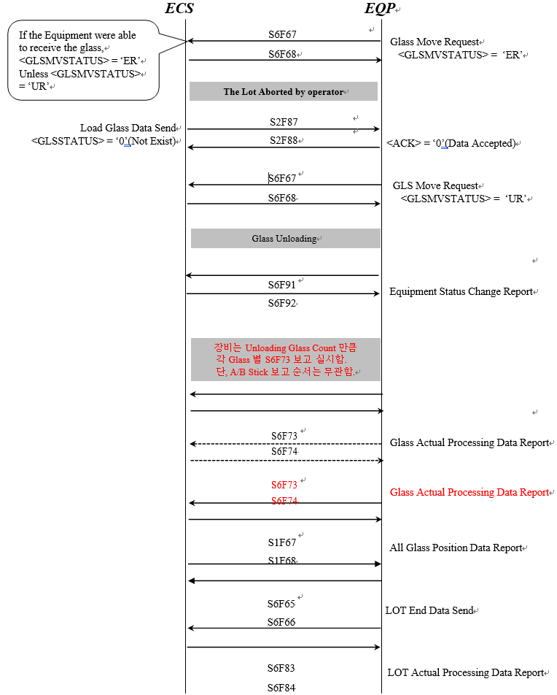

Error Messages

Message fault due to unrecognized Device ID



Message fault due to unrecognized Stream Type



Message fault due to unrecognized Function Type

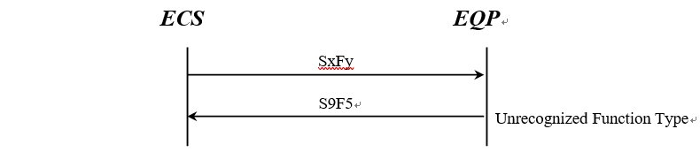

Message fault due to Illegal Data Format



Message fault due to Transaction Timer Timeout
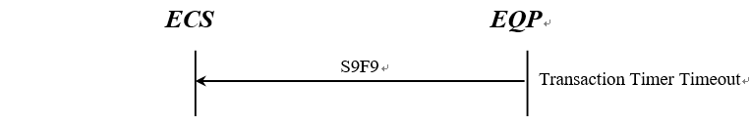

Message fault due to data too long

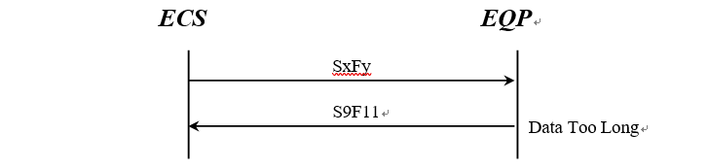

Message fault due to Conversation Timeout

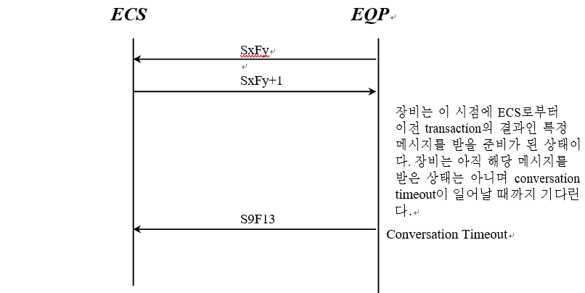

Equipment Terminal Service

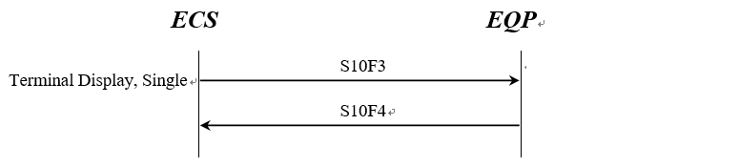

Exception Scenario

Inform processing glass count change scenario
장비로 투입될 Glass 수량이 변경되었을 경우 ECS는 해당 메시지를 장비로 송신한다.
- Cassette Loading 시
- Offline에서 Online 전환 시
- Cassette가 port에 로딩되고 작업준비가 된 후, 해당 Cassette가 cancel 되었을 시



Monitoring Lot Status Send
- 모니터링 Lot의 시작과 종료를 장비로 전달한다.
- 상세 사용은 LG CNS와 LG Display와 협의한다.

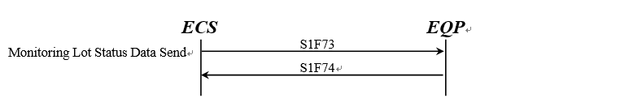

Equipment’s Part Data Report
- 온라인 전환 시 사용
- Glass 또는 장비의 Part가 Unit 또는 Sub Unit간에 이동이 있을 경우 장비는 보고한다.



Special Case of Glass Judge Report

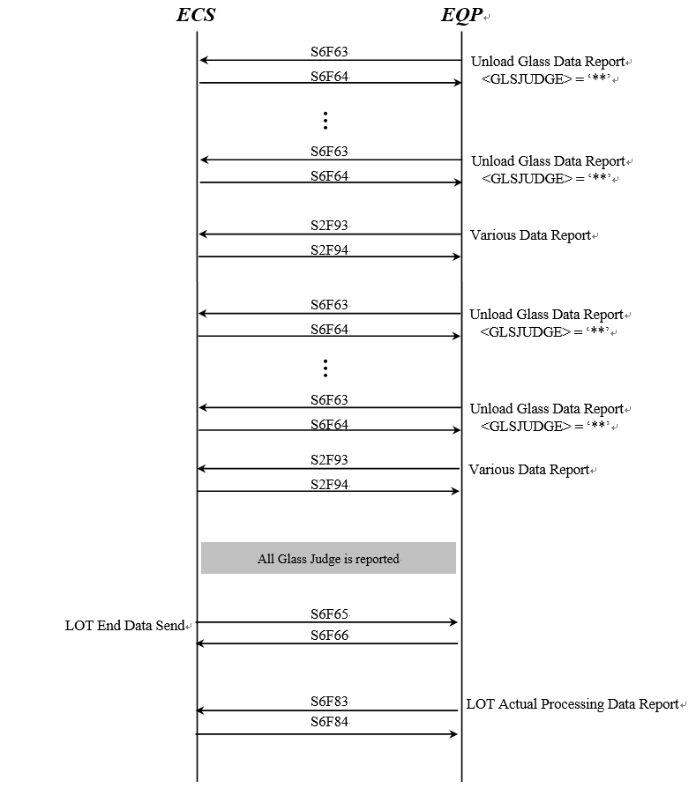

Chamber Status Change Report

Recipe Management Sequence

Equipment Recipe List Request
- ECS가 장비의 recipe list를 조회 시 사용한다.



Equipment Lower Recipe List Request
- ECS가 장비의 하위 recipe list를 조회 시 사용한다.



Equipment Recipe Parameter Request
- 장비의 Recipe Parameter를 조회 시 사용한다.



Equipment Recipe Parameter Change Send
- 장비의 Recipe Parameter를 변경할 경우 사용한다.



Equipment Recipe Change Report
- 장비의 Recipe Parameter를 변경할 경우 사용한다.


Equipment Operation Reference Data Send
- 장비로 Operation Reference Data를 전송할 경우 사용한다.



Equipment Operation Reference Data Apply Report
- 장비가 operation reference data를 적용하면 장비는 이 메시지를 전송한다.



Current Recipe ID List Request
- 현재 장비 process program directory의 전송을 요청 시
- 장비에 등록된 process program의 모든 Recipe ID 와 Recipe ID Version 목록이다.



Equipment Constant Recipe Request



Equipment Constant Recipe Parameter Request



Equipment Constant Recipe Parameter Change Command

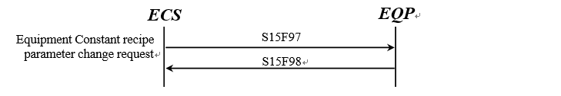

Equipment Constant Recipe Parameter Change Report

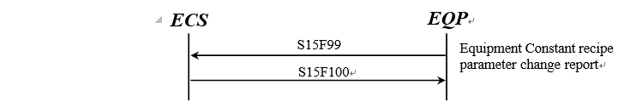

Buffer Lot Status Send
- Buffer Lot 상태를 전달할 경우 사용한다.
- 상세 사용은 LG CNS와 LG Display와 협의한다.



Remained Glass Count Request
- 장비가 해당 Glass가 속한 Lot의 투입 대기 Glass의 수량을 요청할 경우 사용한다.
- 상세 사용은 LG CNS와 LG Display와 협의한다.



Glass Call Request
- 수동으로 장비에 glass를 투입할 때 사용한다.
- 만약 장비에서 이를 사용하려면 추후 ECS와 상세 협의가 필요하다.

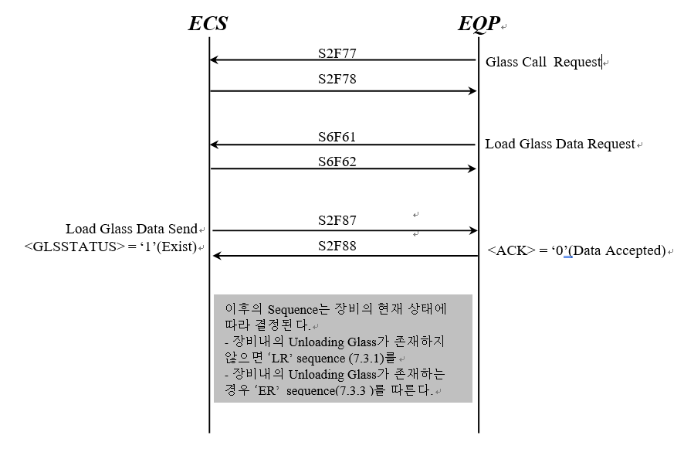

Carrier Transfer Mode Change Report
장비의 Carrier 반송 모드가 변경 보고 용도로 사용한다.
- 본 메시지는 장비의 Carrier 반송 모드가 변경이 되었을 경우 장비에서 보고한다.
- 장비의 보고에 대한 ECS 응답이 없는 경우 현재 상태를 유지한다.
- 상세 사용 및 용도는 LG CNS 및 LG Display 와 협의한다.



장비의 온라인 상태로 변경
( ECS Restart 포함 )중에 Carrier 반송 모드 변경 보고
- 장비는 Online 변경 중 Operation Mode 변경 보고 이후에 Carrier 반송 모드 상태를 보고한다.

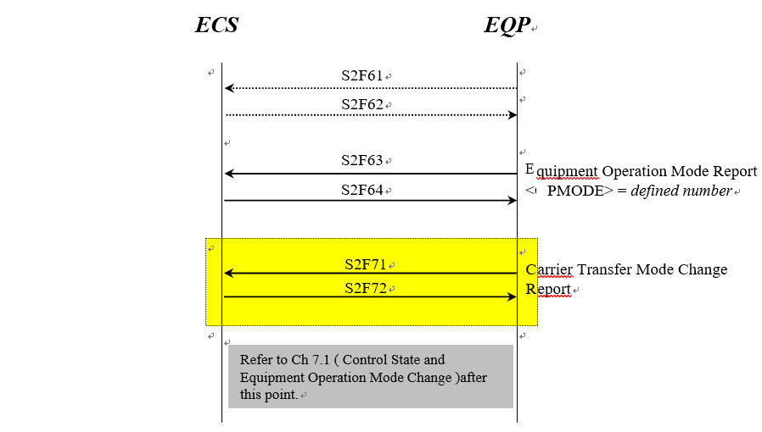

PD Down Request
- 장비에 Pause를 요청할 때 사용한다.
- PD Request 시나리오는 Machine/Unit 단에서 Glass Hold 가 가능한 장비에 한해서 적용한다.
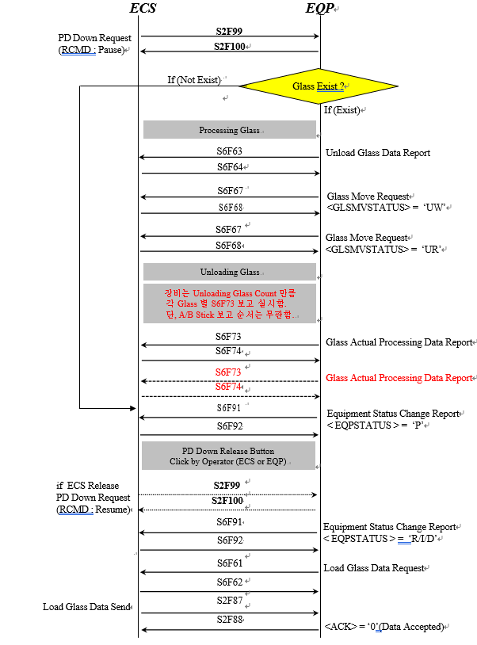

LOT End Glass Injection Send
- This Message is used when the last glass of LOT was injected in Equipment

In case the normal sequence
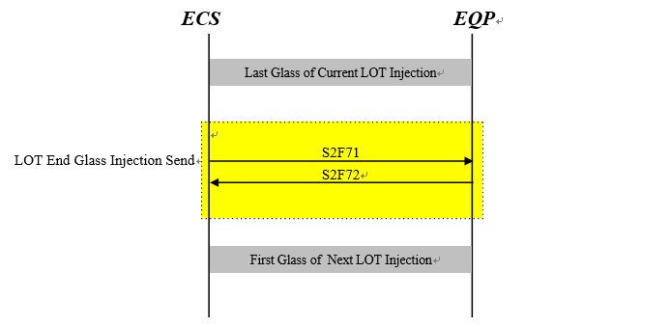

In case the abnormal sequence

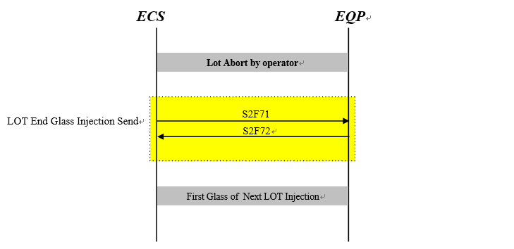

Multi Recipe Information Send
- This message is used when equipment requires recipe and sampling codes for each slots
- If equipment want to use this sequence, it needs detailed conference later with ECS.

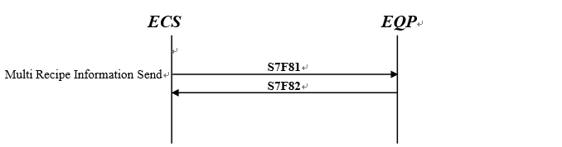

Port State and Cassette Map Data Send Scenario
- This message is used when equipment requires the map data for specific port.
- ECS informs the map data to equipment when Port state is changed

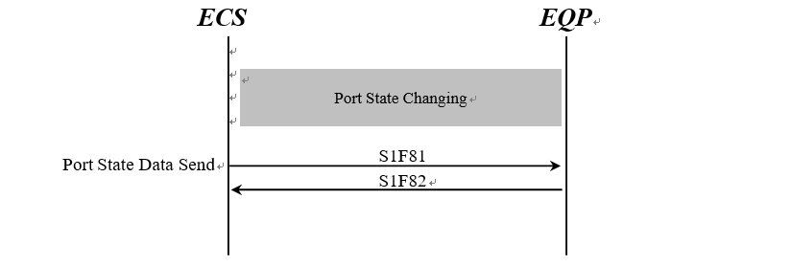

Batch Job (Glass Injection) End Data Send
- This message is used when the last glass of Batch Job is injected in Equipment.
- If equipment want to use this sequence, it needs detailed conference later with ECS.

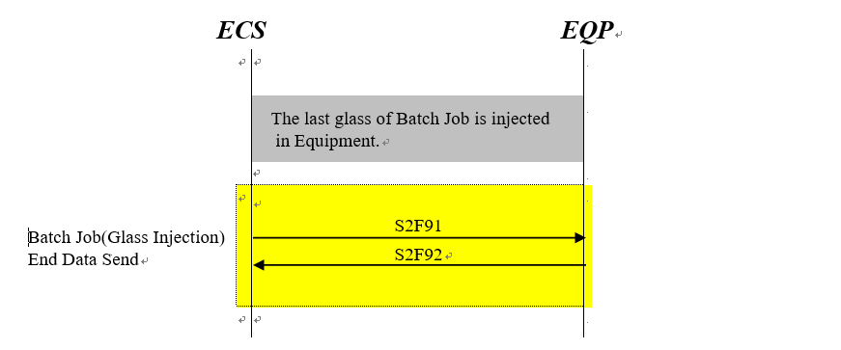

Injecting Glass Data Request
- This message is used when the glass is injecting in Equipment.
- If equipment want to use this sequence, it needs detailed conference later with ECS.

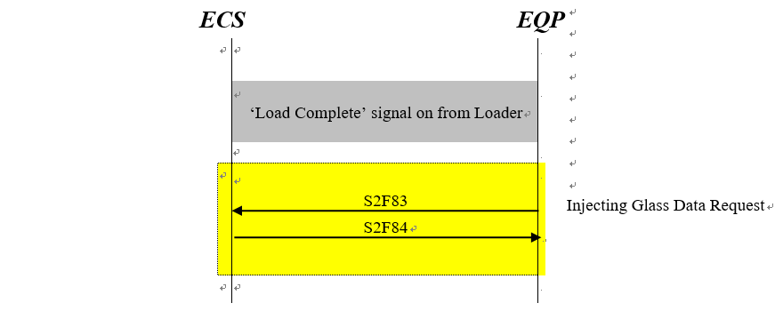

Port State Data Report
- This message is used when the State (LR, LC, UR, UC) of Port in Equipment is changed.
- If equipment want to use this sequence, it needs detailed conference later with ECS.

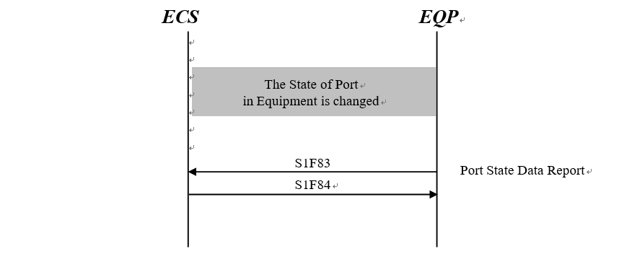

Port Status Change Data Report
- This message is used when the Status (RUN, IDLE, DOWN) of Port in Equipment is changed.
- If equipment want to use this sequence, it needs detailed conference later with ECS.

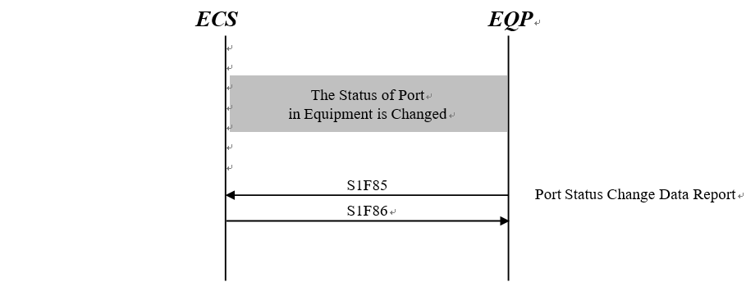

Lot State Change Report
- This message is used when the Lot State (R, W, P, E) of port in Equipment is changed.
- If equipment want to use this sequence, it needs detailed conference later with ECS.

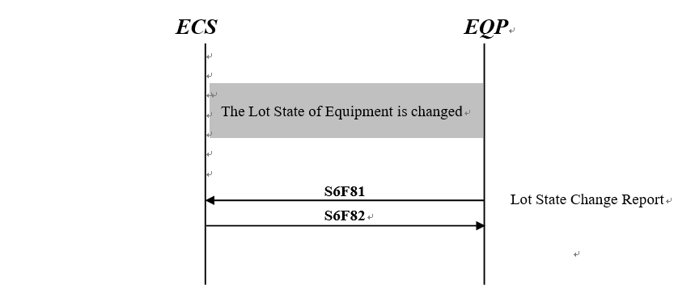

Mask Data Report
- This message is used after the ID of Mask reading in EQP .
- If equipment want to use this sequence, it needs detailed conference later with ECS.

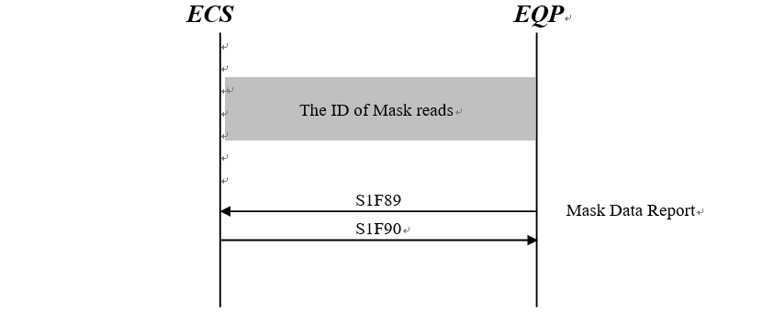

All Mask Position Data Report
- In case of changing to Online
- In case of mask moving between each sub unit.

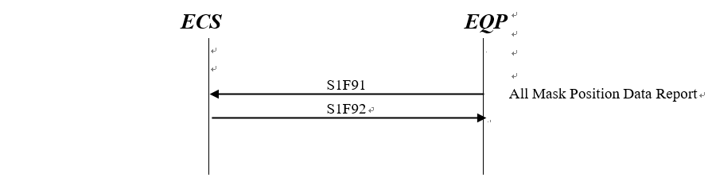

Unload Process Report
- Equipment performs this scenario when unit’s status is changed.

Unload Start & End
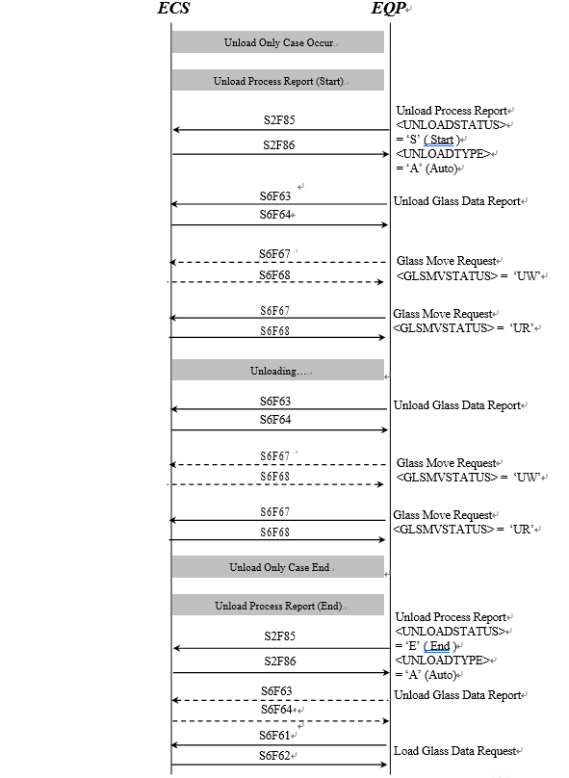

Unload Start & End (EQP Restart After Unload Start) 1/2

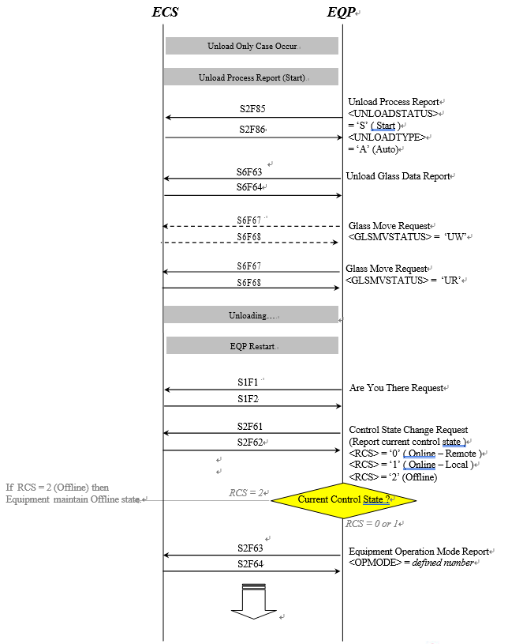

Unload Start & End (EQP Restart After Unload Start) 2/2

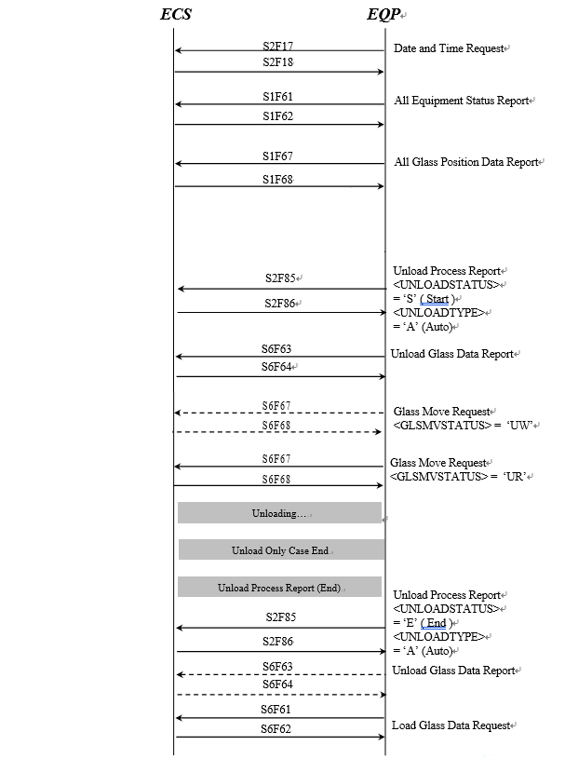

Unload Start & End (ECS Restart After Unload Start) 1/2

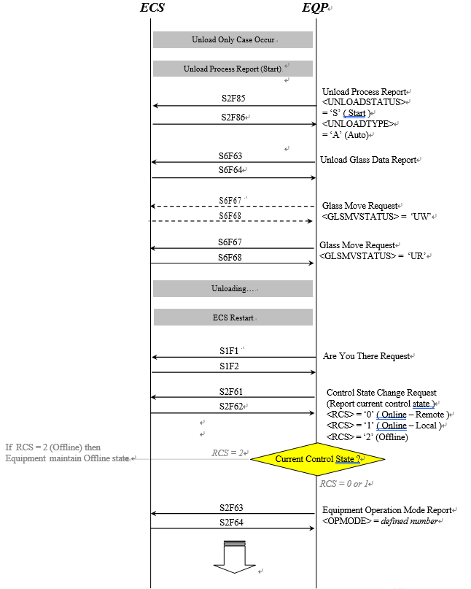

Unload Start & End (ECS Restart After Unload Start) 2/2

